Grade 6
Unit 2Lesson 15CC BY NC Illustrative Mathematics, based on IM 6–8 Math, CC BY Open Up Resources.
Unit 2, Lesson 15

Part-Part-Whole Ratios
Let’s look at situations where you can add the quantities in a ratio together.
Grade 6
Unit 2Lesson 15CC BY NC Illustrative Mathematics, based on IM 6–8 Math, CC BY Open Up Resources.

15.1Math Talk: A Whole Number and a Unit Fraction
Decide mentally whether each statement is true.
- $\frac{1}{5}⋅45=\frac{45}{5}$
- $\frac{1}{5}⋅20=\frac{1}{4}⋅24$
- $42⋅\frac{1}{6}=\frac{1}{6}⋅42$
- $486⋅\frac{1}{12}=\frac{480}{12}+\frac{6}{12}$
Grade 6
Unit 2Lesson 15CC BY NC Illustrative Mathematics, based on IM 6–8 Math, CC BY Open Up Resources.

15.2Cubes of Paint
A recipe for maroon paint says, “Mix 5 ml of red paint with 3 ml of blue paint.”
- Use snap cubes to represent the amounts of red and blue paint in the recipe. Then draw a sketch of your snap-cube representation of the maroon paint.
  - What amount does each cube represent?
  - How many milliliters of maroon paint will there be?

  - Suppose each cube represents 2 ml. How much of each color paint is there?
  - Red: _______ ml
  - Blue: _______ ml
  - Maroon: _______ ml
  - Suppose each cube represents 5 ml. How much of each color paint is there?
  - Red: _______ ml
  - Blue: _______ ml
  - Maroon: _______ ml

  - Suppose you need 80 ml of maroon paint. How much red and blue paint would you mix? Be prepared to explain your reasoning.
  - Red: _______ ml
  - Blue: _______ ml
  - Maroon: 80 ml
  - If the original recipe is for one batch of maroon paint, how many batches are in 80 ml of maroon paint?
Grade 6
Unit 2Lesson 15CC BY NC Illustrative Mathematics, based on IM 6–8 Math, CC BY Open Up Resources.

15.3Seasoning, Sneakers, and Concrete
Solve each of the following problems and show your thinking. If you get stuck, consider drawing a tape diagram to represent the situation.
- Elena makes taco seasoning using 4 parts chili powder, 1 part garlic powder, and 2 parts ground cumin. If Elena uses 20 teaspoons of ground cumin, how much taco seasoning will she have?
- 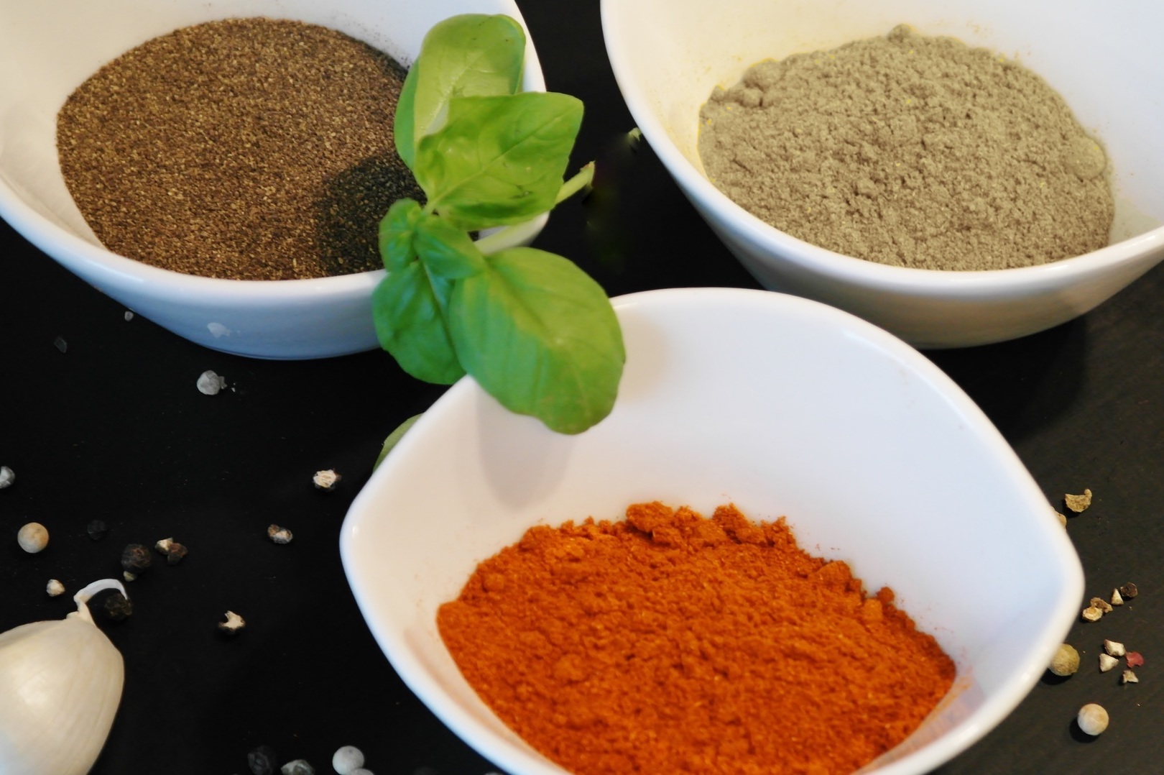
- The ratio of students wearing sneakers to those wearing boots is 5 to 6. If there are 33 students in the class, and all of them are wearing either sneakers or boots, how many of them are wearing sneakers?
- A recipe for concrete says, “Mix 3 parts gravel with 2 parts sand and 1 part cement.” If a project needs 42 gallons of concrete in all, how much of each ingredient is needed?

Are you ready for more?
Using the recipe from earlier, how much taco seasoning can you make if you have 32 teaspoons of chili powder, 9 teaspoons of garlic powder, and 15 teaspoons of cumin? Explain or show your reasoning.
Grade 6
Unit 2Lesson 15CC BY NC Illustrative Mathematics, based on IM 6–8 Math, CC BY Open Up Resources.

15.4Invent Your Own Ratio Problem
- Invent another ratio problem that can be solved with a tape diagram and solve it. If you get stuck, consider looking back at the problems you solved in the earlier activity.
- Create a visual display that includes:
  - The new problem that you wrote, without the solution.
  - Enough work space for someone to show a solution.
- Trade your display with another group, and solve each other’s problem. Include a tape diagram as part of your solution. Be prepared to share the solution with the class.
- When the solution to the problem you invented is being shared by another group, check their answer for accuracy.

Lesson 15 Summary
A tape diagram is another way to represent a ratio. All the parts of the diagram that are the same size have the same value.
For example, this tape diagram represents the ratio of ducks to swans in a pond, which is $4:5$.
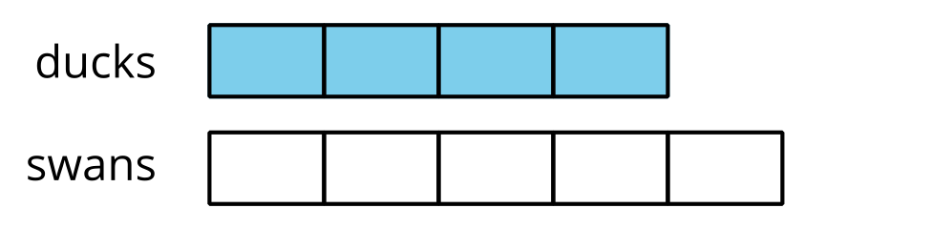
The first tape represents the number of ducks. It has 4 parts.
The second tape represents the number of swans. It has 5 parts.
There are 9 parts in all, because $4+5=9$.
Suppose we know there are 18 of these birds in the pond, and we want to know how many are ducks.
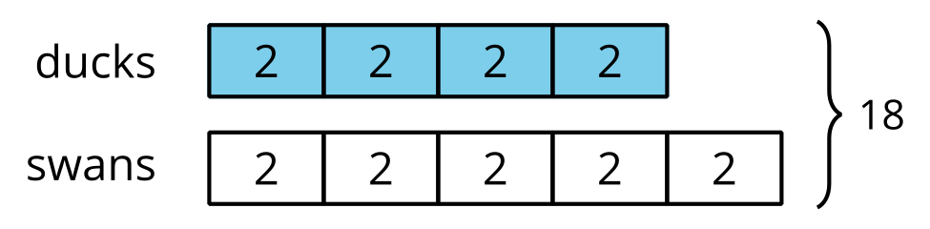
The 9 equal parts on the diagram need to represent 18 birds in all. This means that each part of the tape diagram represents 2 birds, because $18÷9=2$.
There are 4 parts of the tape representing ducks, and $4⋅2=8$, so there are 8 ducks in the pond.

