Unit 1 Lesson 3: Making the Moves

1 Notice and Wonder: The Isometric Grid (Warm up)

Student Task Statement
What do you notice? What do you wonder?


2 Transformation Information

Student Task Statement
Your teacher will give you tracing paper to carry out the moves specified. Use $A^{′}$, $B^{′}$, $C^{′}$, and $D^{′}$ to indicate vertices in the new figure that correspond to the points $A$, $B$, $C$, and $D$ in the original figure.
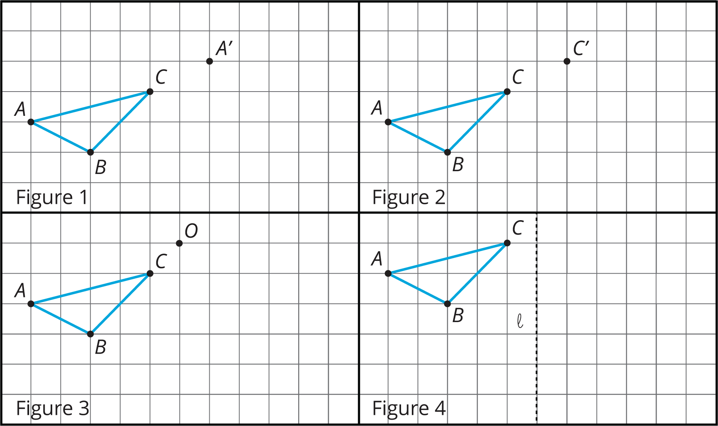
- In Figure 1, translate triangle $ABC$ so that $A$ goes to $A^{′}$.
- In Figure 2, translate triangle $ABC$ so that $C$ goes to $C^{′}$.
- In Figure 3, rotate triangle $ABC$ ${90}^{∘}$ counterclockwise using center $O$.
- In Figure 4, reflect triangle $ABC$ using line $ℓ$.
- 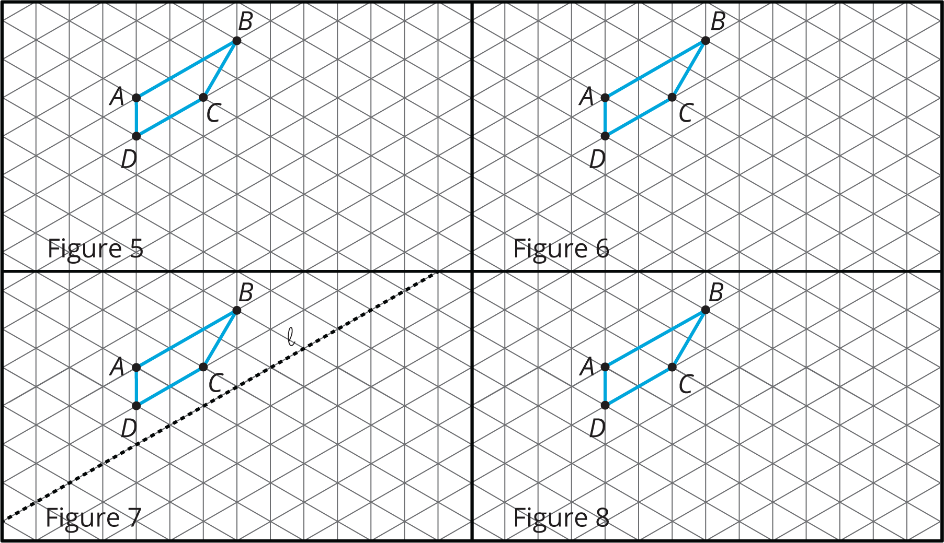
- In Figure 5, rotate quadrilateral $ABCD$ ${60}^{∘}$ counterclockwise using center $B$.
- In Figure 6, rotate quadrilateral $ABCD$ ${60}^{∘}$ clockwise using center $C$.
- In Figure 7, reflect quadrilateral $ABCD$ using line $ℓ$.
- In Figure 8, translate quadrilateral $ABCD$ so that $A$ goes to $C$.

3 A to B to C

Images for Launch
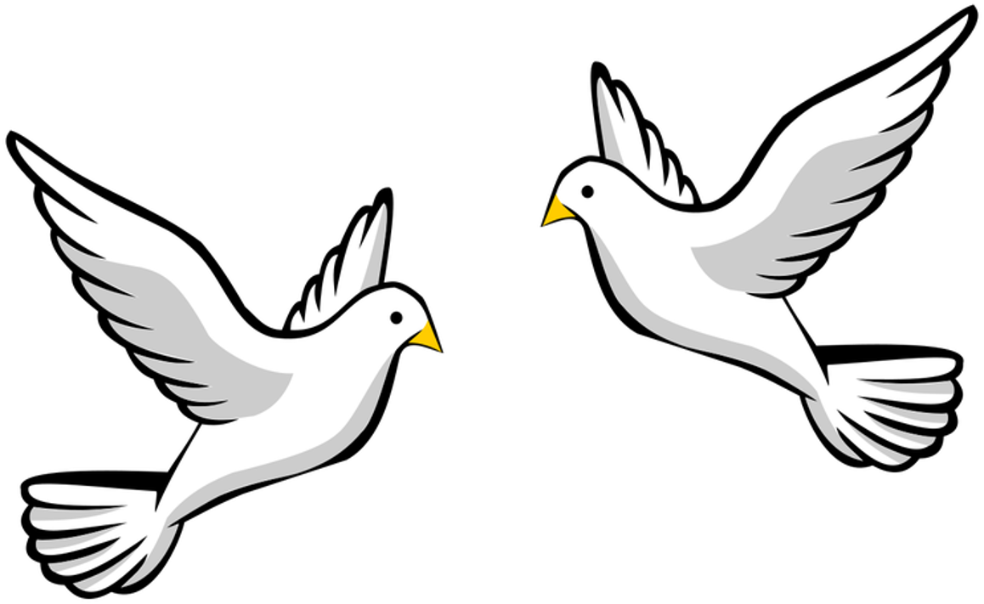

Student Task Statement
Here are some figures on an isometric grid.
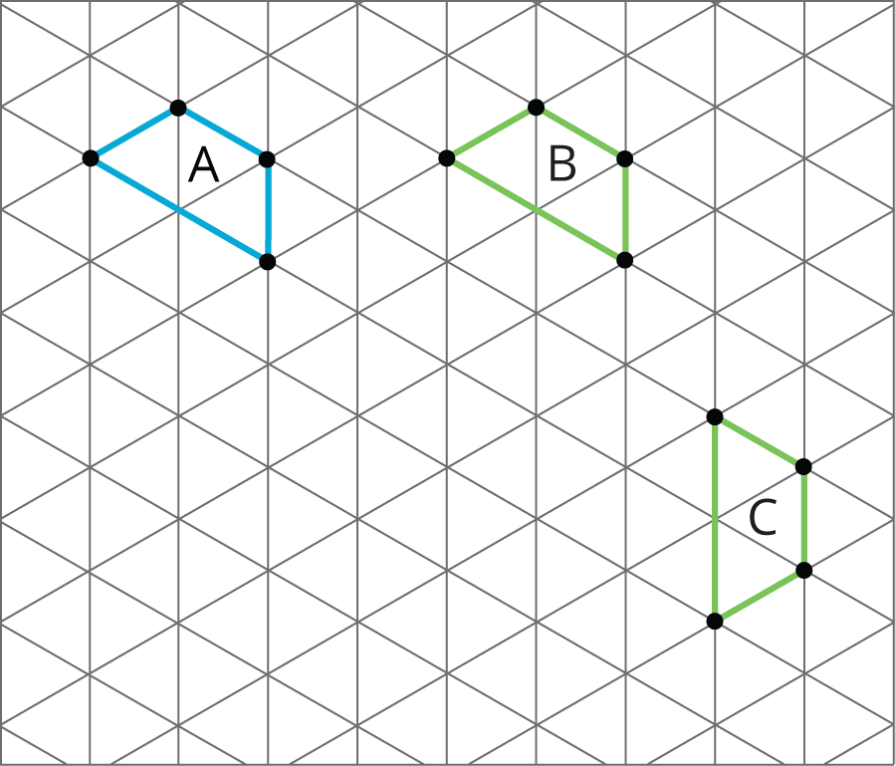
- Name a transformation that takes Figure $A$ to Figure $B$. Name a transformation that takes Figure $B$ to Figure $C$.
- What is one sequence of transformations that takes Figure $A$ to Figure $C$? Explain how you know.
© CC BY Open Up Resources. Adaptations CC BY IM.

