Lesson 11: Todo tipo de prismas

Standards Alignments
Addressing | 5.MD.C, 5.MD.C.5

Teacher-facing Learning Goals
- Solve real-world and mathematical problems involving volume.

Student-facing Learning Goals
- Encontremos el volumen de distintos tipos de prismas.

Lesson Purpose
The mathematical purpose of this lesson is for students to apply what they have learned about finding the volumes of right rectangular prisms and figures composed of right rectangular prisms to solve real-world problems.
In previous lessons, students learned to find the volume of a right rectangular prism by multiplying the number of cubes in a layer by the number of layers. They found the volumes of rectangular prisms with and without the unit cubes showing. They used the associative property of multiplication to represent threefold whole-number products as volumes and learned to find the volume of rectangular prisms with whole-number side lengths by multiplying the length by the width by the height and multiplying the area of the base times the height. They also understand volume as additive. They found volumes of solid figures composed of two non-overlapping right rectangular prisms by adding the volumes of the non-overlapping parts. In this lesson, students apply these understandings to solve real-world problems.
This lesson has a Student Section Summary.

Access for:

Students with Disabilities
- Action and Expression (Activity 2)

English Learners
- MLR6 (Activity 1)

Instructional Routines
Which One Doesn’t Belong? (Warm-up)

Lesson Timeline
Warm-up | 10 min
Activity 1 | 20 min
Activity 2 | 15 min
Lesson Synthesis | 10 min
Cool-down | 5 min

Teacher Reflection Question
As you finish up this unit, reflect on the norms and activities that have supported each student in learning math. How have you seen each student grow as a young mathematician throughout this work? How have you seen yourself grow as a teacher? What will you continue to do and what will you improve on in Unit 2?

Cool-down
(to be completed at the end of the lesson) 5min
El volumen de un arenero

Student-facing Task Statement
Una escuela preescolar está construyendo un arenero. El diagrama muestra las longitudes de los lados del arenero.
¿Cuál es el volumen del arenero? Explica o muestra tu razonamiento.
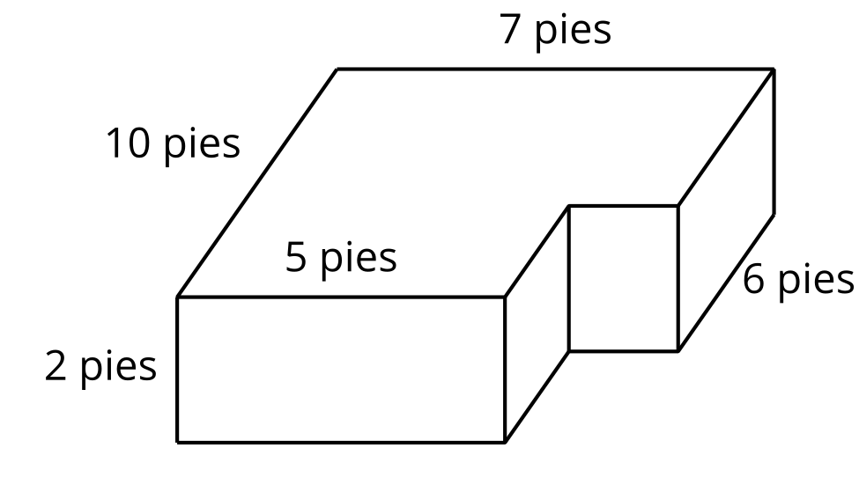

Student Responses
The volume of the sandbox is 124 cubic feet. Sample response: It is a 10 foot by 5 foot by 2 foot prism and a 6 foot by 2 foot by 2 foot prism, so that’s $\left(10×5×2\right)+\left(6×2×2\right)$ cubic feet.

