Lesson 11: Graphing from the Factored Form
- Let’s graph some quadratic functions in factored form.

11.1: Finding Coordinates
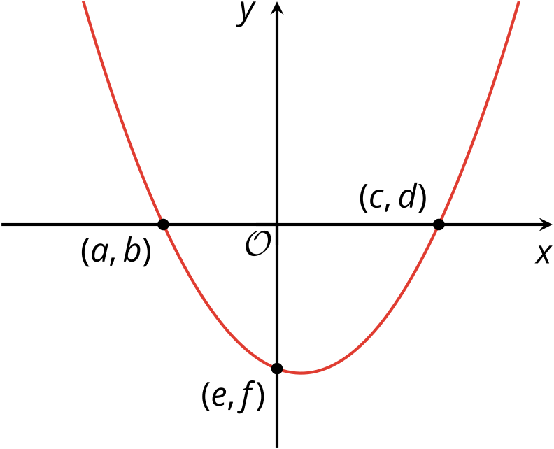
Here is a graph of a function $w$ defined by $w\left(x\right)=\left(x+1.6\right)\left(x−2\right)$. Three points on the graph are labeled.
Find the values of $a,b,c,d,e$, and $f$. Be prepared to explain your reasoning.

11.2: Comparing Two Graphs
Consider two functions defined by $f\left(x\right)=x\left(x+4\right)$ and $g\left(x\right)=x\left(x−4\right)$.
- Complete the table of values for each function. Then, determine the $x$-intercepts and vertex of each graph. Be prepared to explain how you know.
- $x$ | - $f\left(x\right)$
- -5 | - 5
- -4
- -3
- -2 | - -4
- -1 | - -3
- 0
- 1
- 2
- 3
- 4 | - 32
- 5
- $x$-intercepts:
- Vertex:
- $x$ | - $g\left(x\right)$
- -5 | - 45
- -4
- -3
- -2 | - 12
- -1 | - 5
- 0
- 1
- 2
- 3 | - -3
- 4
- 5
- $x$-intercepts:
- Vertex:
- Plot the points from the tables on the same coordinate plane. (Consider using different colors or markings for each set of points so you can tell them apart.)
- Then, make a couple of observations about how the two graphs compare.
- 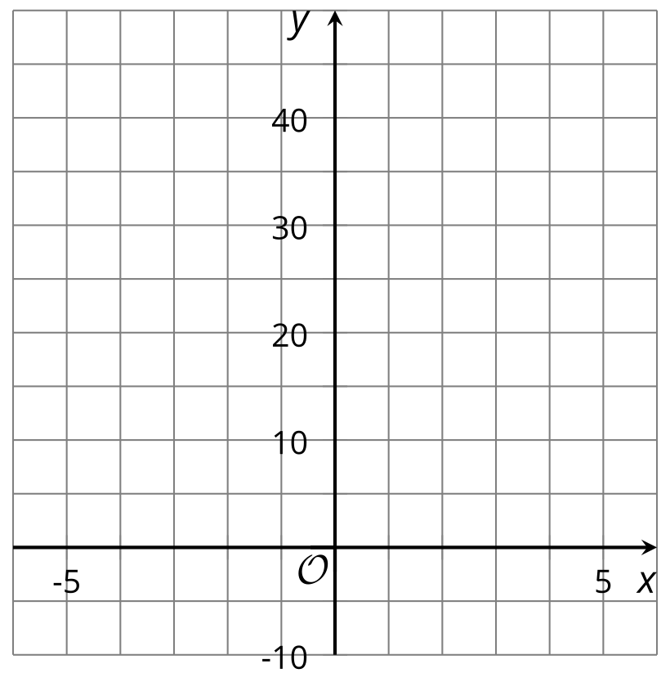
- ​​​​​​

11.3: What Do We Need to Sketch a Graph?
- The functions $f$, $g$, and $h$ are given. Predict the $x$-intercepts and the $x$-coordinate of the vertex of each function.
- equation | - $x$-intercepts | - $x$-coordinate of the vertex
- $f\left(x\right)=\left(x+3\right)\left(x−5\right)$
- $g\left(x\right)=2x\left(x−3\right)$
- $h\left(x\right)=\left(x+4\right)\left(4−x\right)$
- Use graphing technology to graph the functions $f$, $g$, and $h$. Use the graphs to check your predictions.
- Without using technology, sketch a graph that represents the equation $y=\left(x−7\right)\left(x+11\right)$ and that shows the $x$-intercepts and the vertex. Think about how to find the $y$-coordinate of the vertex. Be prepared to explain your reasoning.
- 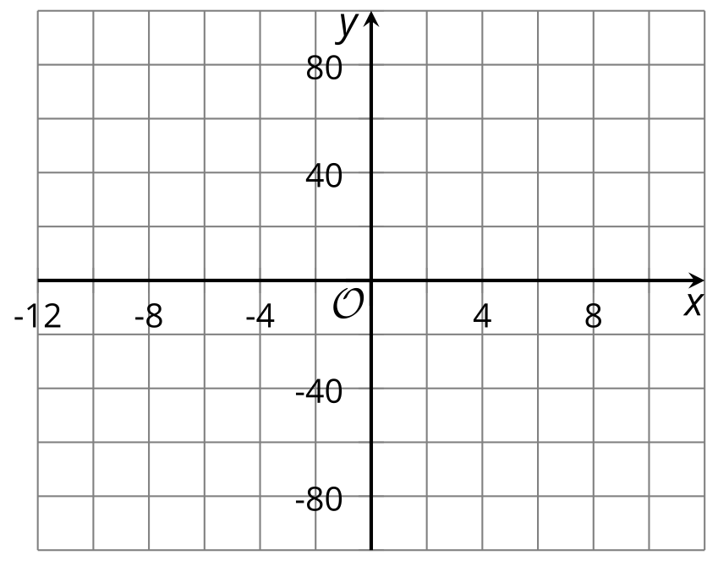

Are you ready for more?
The quadratic function $f$ is given by $f\left(x\right)=x^{2}+2x+6$.
- Find $f\left(\text{-}2\right)$ and $f\left(0\right)$.
- What is the $x$-coordinate of the vertex of the graph of this quadratic function?
- Does the graph have any $x$-intercepts? Explain or show how you know.

Lesson 11 Summary
The function $f$ given by $f\left(x\right)=\left(x+1\right)\left(x−3\right)$ is written in factored form. Recall that this form is helpful for finding the zeros of the function (where the function has the value 0) and telling us the $x$-intercepts on the graph representing the function.
Here is a graph representing $f$. It shows 2 $x$-intercepts at $x=\text{-}1$ and $x=3$.
If we use -1 and 3 as inputs to $f$, what are the outputs?
- $f\left(\text{-}1\right)=\left(\text{-}1+1\right)\left(\text{-}1−3\right)=\left(0\right)\left(\text{-}4\right)=0$
- $f\left(3\right)=\left(3+1\right)\left(3−3\right)=\left(4\right)\left(0\right)=0$
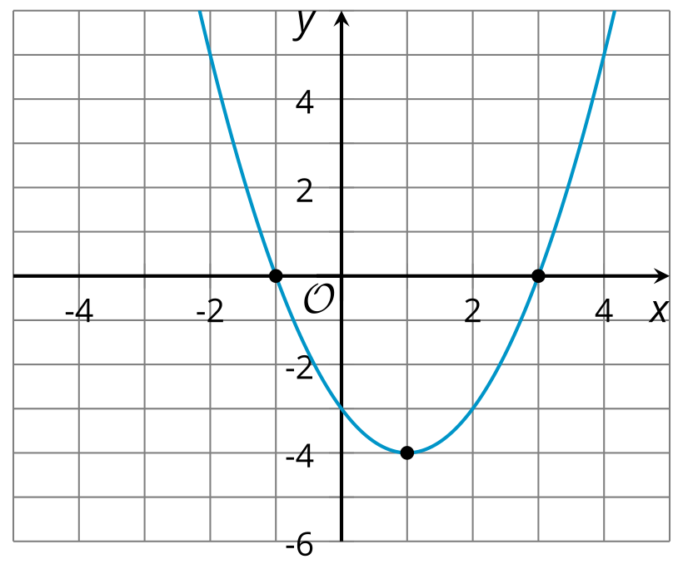
Because the inputs -1 and 3 produce an output of 0, they are the zeros of the function $f$. And because both $x$ values have 0 for their $y$ value, they also give us the $x$-intercepts of the graph (the points where the graph crosses the $x$-axis, which always have a $y$-coordinate of 0). So, the zeros of a function have the same values as the $x$-coordinates of the $x$-intercepts of the graph of the function.
The factored form can also help us identify the vertex of the graph, which is the point where the function reaches its minimum value. Notice that the $x$-coordinate of the vertex is 1, and that 1 is halfway between -1 and 3. Once we know the $x$-coordinate of the vertex, we can find the $y$-coordinate by evaluating the function: $f\left(1\right)=\left(1+1\right)\left(1−3\right)=2\left(\text{-}2\right)=\text{-}4$. So the vertex is at $\left(1,\text{-}4\right)$.
When a quadratic function is in standard form, the $y$-intercept is clear: its $y$-coordinate is the constant term $c$ in $ax^{2}+bx+c$. To find the $y$-intercept from factored form, we can evaluate the function at $x=0$, because the $y$-intercept is the point where the graph has an input value of 0. $f\left(0\right)=\left(0+1\right)\left(0−3\right)=\left(1\right)\left(\text{-}3\right)=\text{-}3$.
© CC BY 2019 by Illustrative Mathematics®

