Grade 2
Unit 1CC BY NC 2024 Illustrative Mathematics®

Unit 1 Family Support Materials

Adding, Subtracting, and Working with Data
In this unit, students build on what they learned about addition and subtraction in grade 1 to develop fluency with addition and subtraction facts within 20. They learn how to represent and interpret data in picture graphs and in bar graphs, and they use these graphs to solve story problems involving addition and subtraction within 100. Students also learn a new representation, tape diagrams, to apply their understanding of the relationship between addition and subtraction and to solve problems.

Section A: Add and Subtract within 20
In this section, students use what they know about the relationship between addition and subtraction to find the unknown values in equations. They use strategies learned in grade 1, such as making a ten, counting on, and counting back to add within 50 and to subtract within 20. For example, when adding $8+7$, students break apart the 7 into $2+5$ and make a ten by adding $8+2$, and then add 5, so $8+2+5=15$. Students later use these strategies to add and subtract within 100.

Section B: Ways to Represent Data
In this section, students are asked to make sense of two new data representations: a picture graph and a bar graph. Students learn to represent and interpret data in these graphs, and they ask and answer questions based on the data.
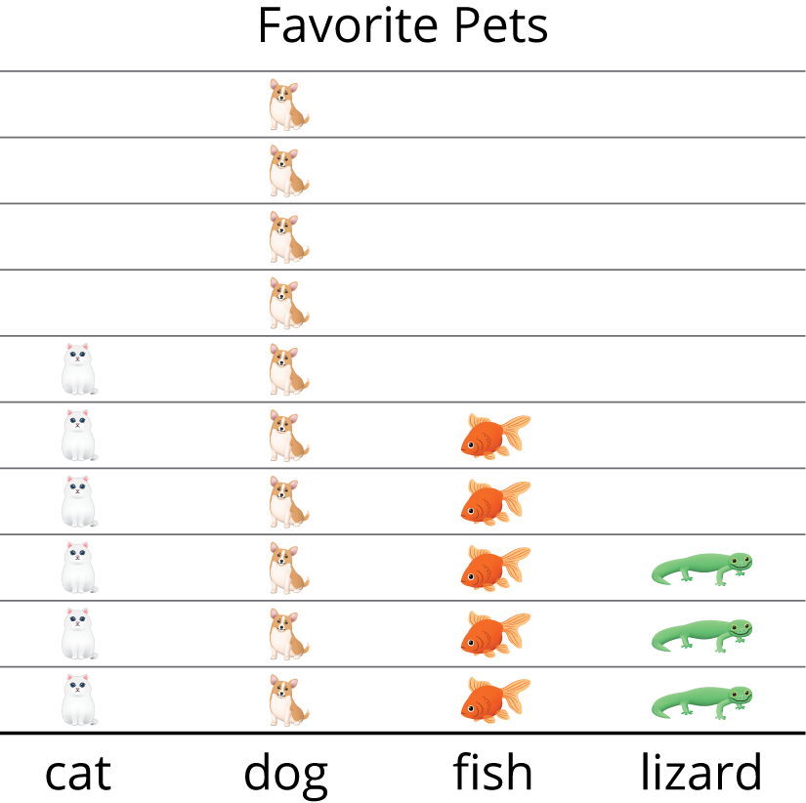
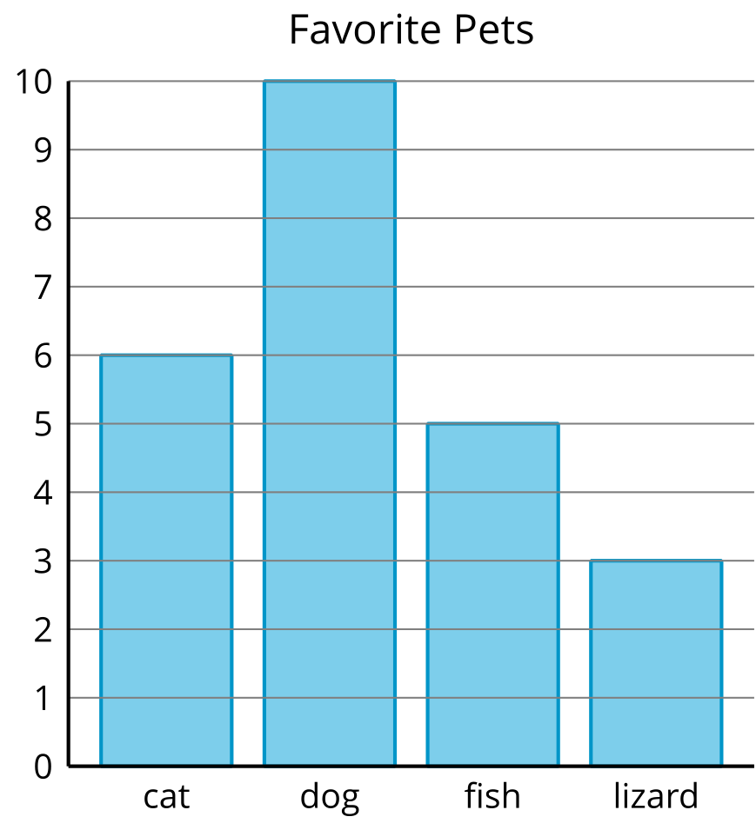

Section C: Diagrams to Compare
In this section, students solve story problems involving addition and subtraction within 100. The tape diagram is introduced to support students with making sense of story problems and understanding the relationship between addition and subtraction. Before using a tape diagram, students have an opportunity to make sense of its structure and connect it to story problems. As an example, the following problem is represented by a tape diagram:
Noah swam for 25 minutes.
Jada swam for 30 minutes more
than Noah. How many minutes did
Jada swim?
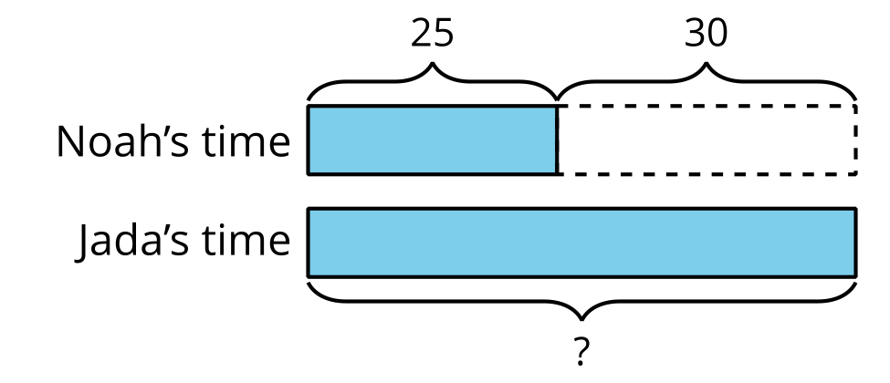

Try it at home!
Near the end of the unit:
- Ask your second grader to write as many statements as they can about the bar graph.
- Ask your second grader to represent and solve the problem:
- Andre read 45 pages of his book last night. Priya read 20 fewer pages of her book than Andre. How many pages did Priya read? Explain or show your reasoning.
Questions that may be helpful as they work:
- How does the graph show that piece of information?
- Can you explain to me how you solved the problem?
- What pieces of information were helpful?
Solution:
- Answers may vary. Sample response: 10 students picked dogs as their favorite pet. 2 more students chose fish as their favorite pet than lizards. 11 students chose either cats or fish as their favorite pet.
- Priya read 25 pages. I drew a diagram to represent the problem, and then I subtracted to solve: $45−20=25$.
Sample Response:
- Each bar is labeled with a pet. The height of the bar shows me how many students picked that pet as their favorite. I know 10 students picked dogs as their favorite because the bar labeled “dog” reaches the number 10.
- I drew a tape diagram to represent the problem. I represented my diagram with the equation: $45−20=?$. Then I subtracted to solve: $45−20=25$.
- It was helpful to know how many pages Andre read and how many fewer pages Priya read.

