Unit 6 Lesson 2: Patterns that Repeat

WU How Many Do You See: Colorful Tiles (Warm up)

Student Task Statement
How many tiles do you see? How do you see them?

1 Patterns that Repeat

Student Task Statement
- Here is a pattern made by arranging shapes.
  - Look for as many features of patterns as you can and describe them to your partner.
  - What rule might this pattern follow?
  - Use the rule to extend the pattern so that it repeats one more time.
- Create a new pattern that uses only a circle and one other shape, and that follows a new rule.
- 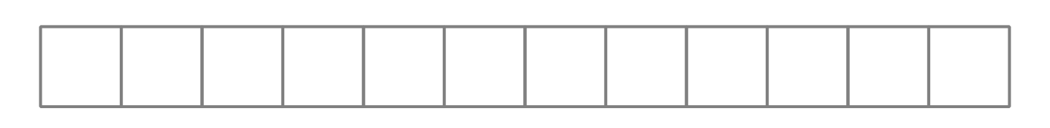
  - Trade your pattern with your partner. Look for as many features of patterns as you can and describe them.
  - What rule might your partner have followed to create their pattern?
  - Use the rule to extend their pattern so that it repeats one more time.

2 Numbered Patterns

Student Task Statement
Here is the pattern of shapes you saw earlier.
- Number the shapes 1 to 12.
- Your teacher will assign you a shape. Write it in every blank space and answer the questions.
  - What numbers were written for the ____________________s?
  - If you extend the pattern, what numbers will be written for the next two
  - _____________________s?
  - What number will the tenth ____________________ have? Explain or show your reasoning.
  - Will the 30th shape be a ____________________? Explain or show your reasoning.

3 Clare’s Pattern

Student Task Statement
Clare created a pattern using 3 shapes—a triangle, a circle, and a square—that repeat in that order.
- Draw the first 10 shapes in Clare’s pattern.
- Clare numbered her shapes. What numbers are the first 5 squares?
- What rule is the numerical pattern following?
- What is the 31st shape in Clare’s pattern? Explain or show your reasoning.
- Clare wants to use 40 shapes in her pattern and the last shape to be a square. Is this possible? Explain or show your reasoning.
© CC BY 2021 Illustrative Mathematics®

