Unit 3 Lesson 6: Rectangles and Squares

WU What Do You Know About Triangles? (Warm up)

Student Task Statement
What do you know about triangles?

Activity Synthesis
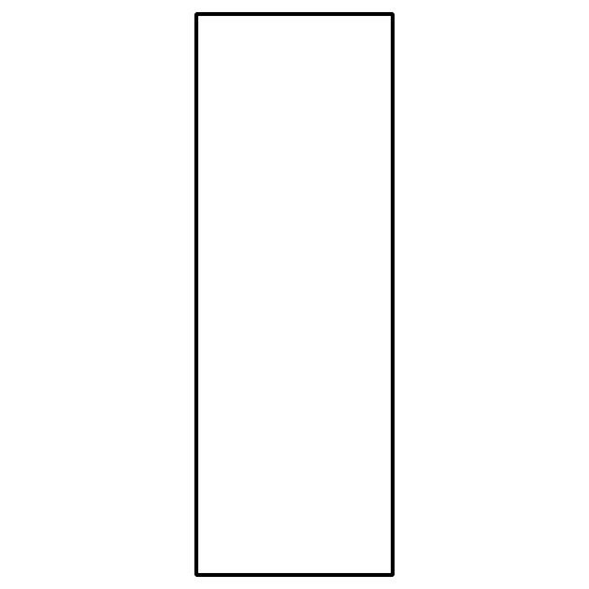
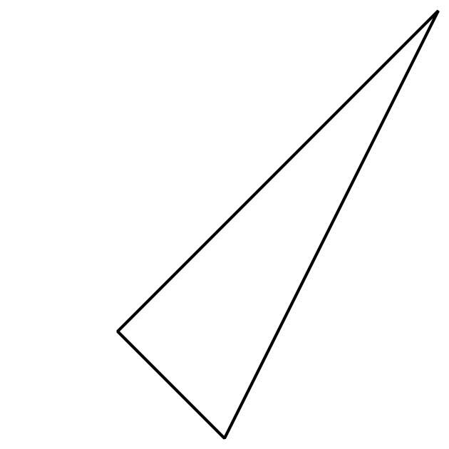

1 Sort Rectangles

Images for Launch
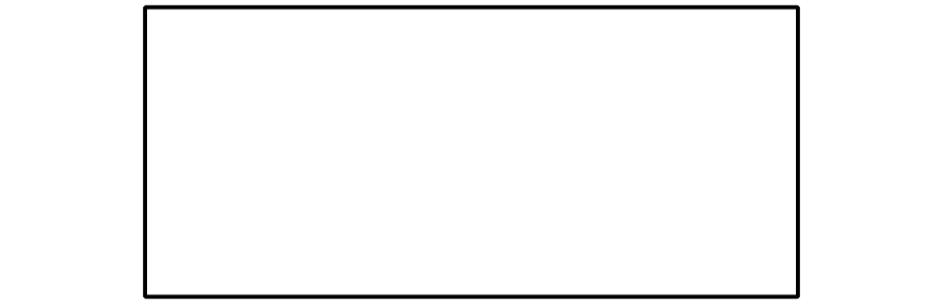

Student Task Statement
Let’s put the shapes into 2 groups.
Rectangle
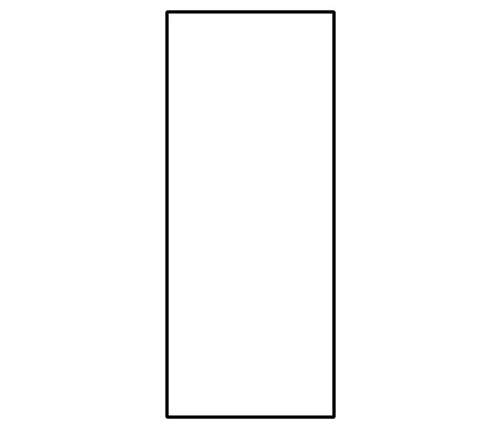
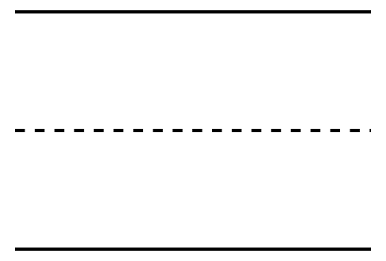
Not a Rectangle
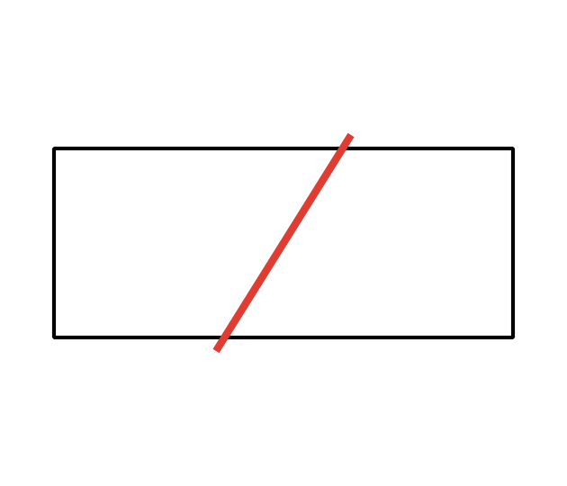

Activity Synthesis
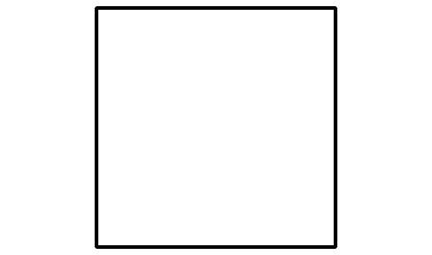

2 Compare Length of Rectangles

Images for Launch
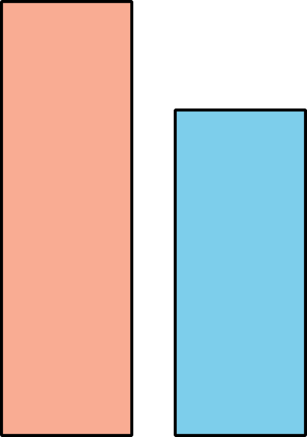

Student Task Statement

- 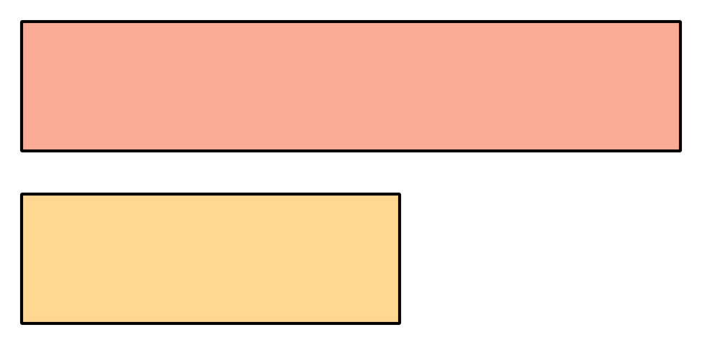

- 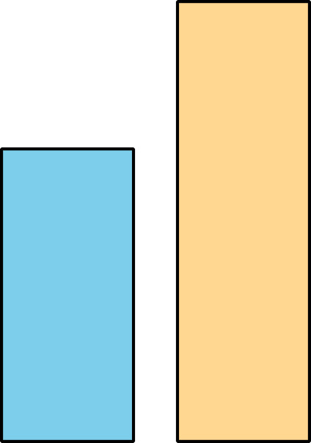

- 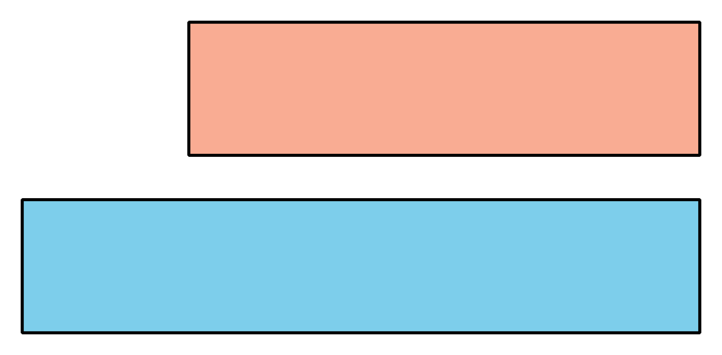

- 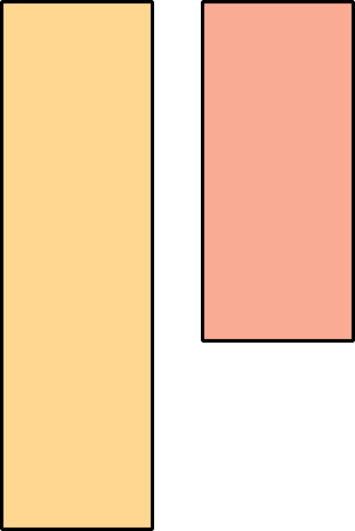

Activity Synthesis
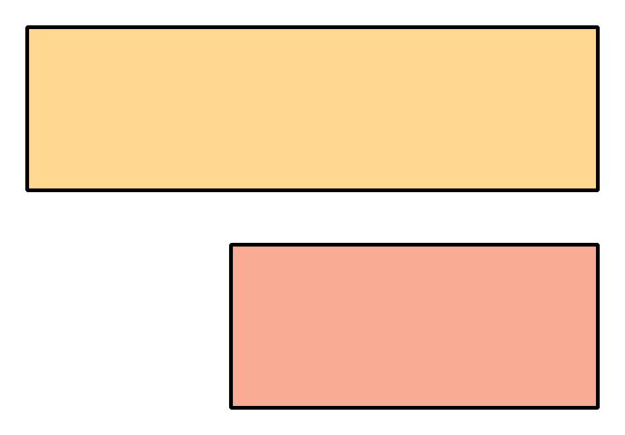

3 Centers: Choice Time

Student Task Statement
Choose a center.
Counting Collections
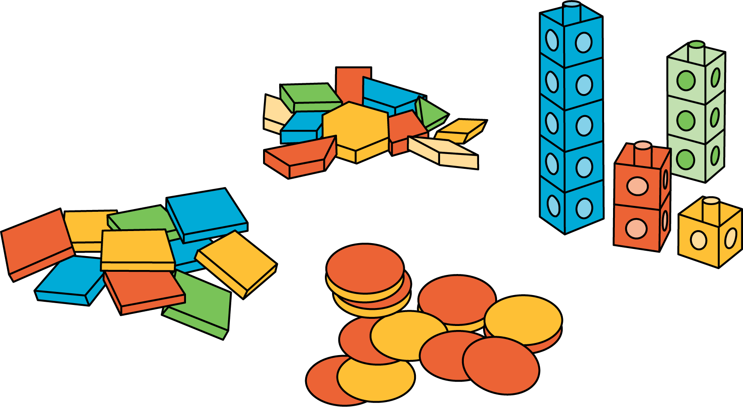
Which One
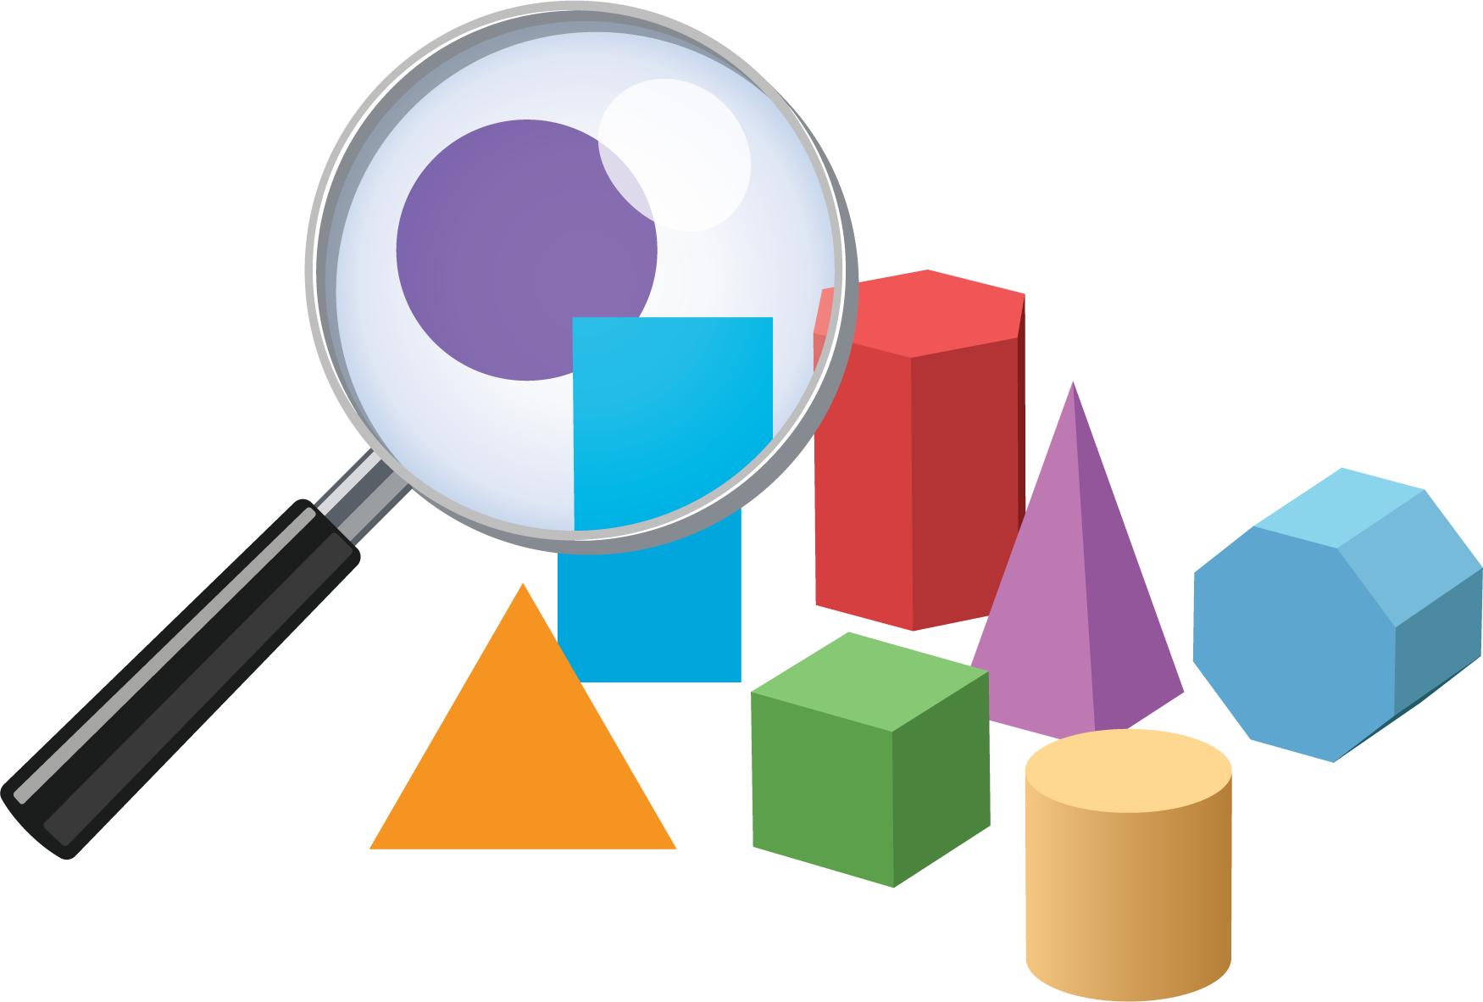
Picture Books
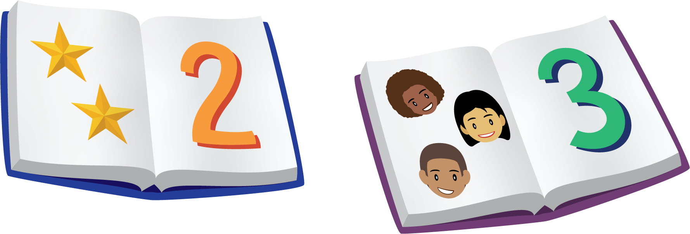
Bingo
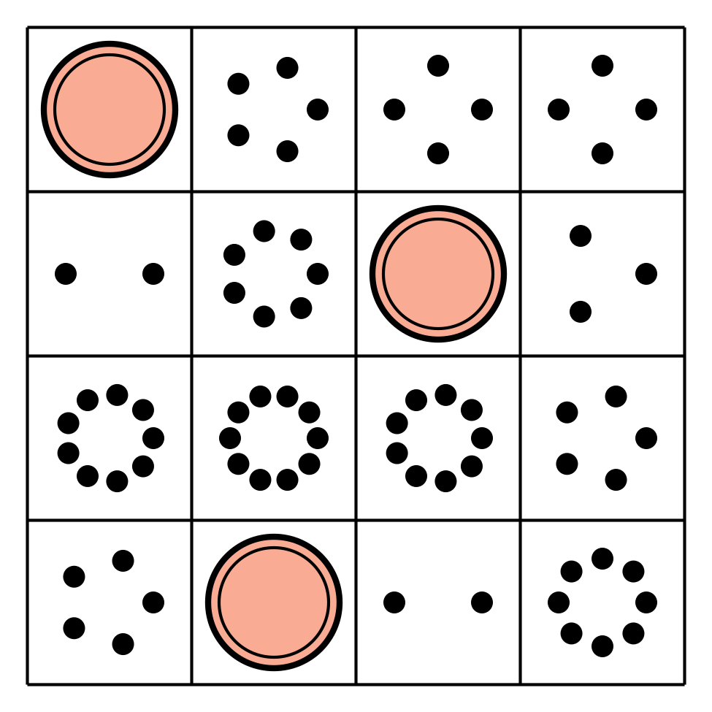
Shake and Spill


Images for Activity Synthesis
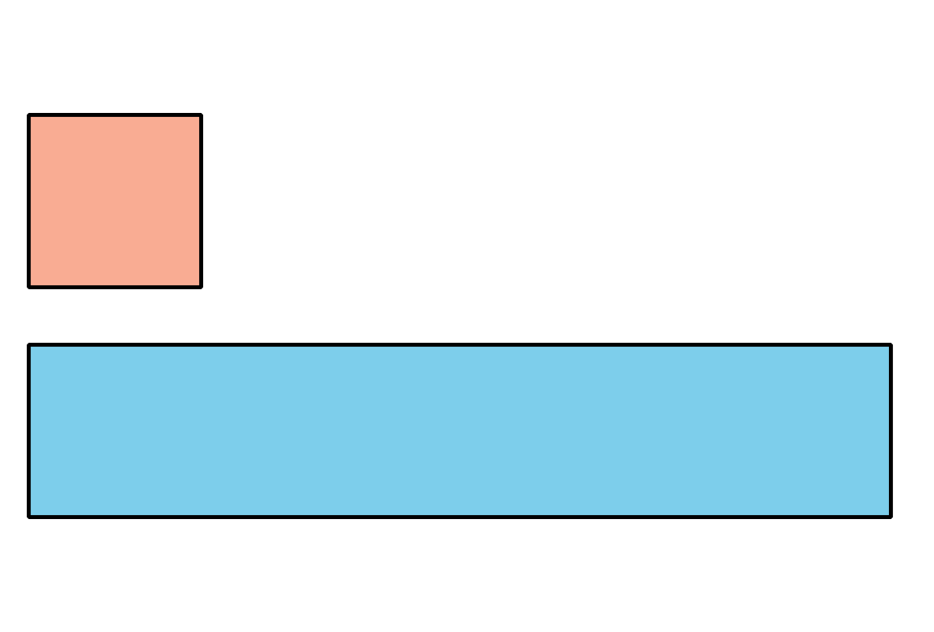
© CC BY 2021 Illustrative Mathematics®

