Unit 6 Lesson 1: Inputs and Outputs

1 Dividing by 0 (Warm up)

Student Task Statement
Study the statements carefully.
- $12÷3=4$ because $12=4⋅3$
- $6÷0=x$ because $6=x⋅0$
What value can be used in place of $x$ to create true statements? Explain your reasoning.

2 Guess My Rule

Student Task Statement
Keep the rule cards face down. Decide who will go first.
- Player 1 picks up a card and silently reads the rule without showing it to Player 2.
- Player 2 chooses an integer and asks Player 1 for the result of applying the rule to that number.
- Player 1 gives the result, without saying how they got it.
- Keep going until Player 2 correctly guesses the rule.
After each round, the players switch roles.

3 Making Tables

Images for Launch
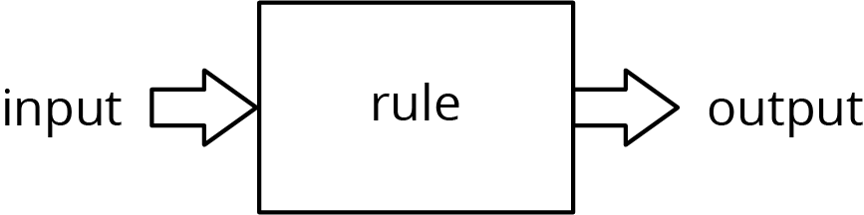

Student Task Statement
For each input-output rule, fill in the table with the outputs that go with a given input. Add two more input-output pairs to the table.
- 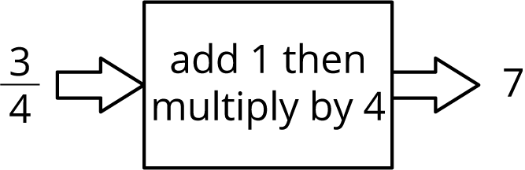
- input | - output
- $\frac{3}{4}$ | - 7
- 2.35
- 42
- 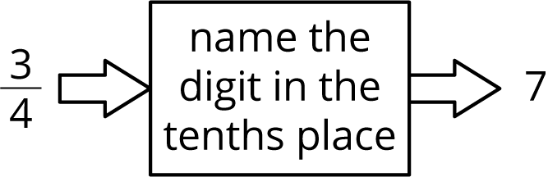
- input | - output
- $\frac{3}{4}$ | - 7
- 2.35
- 42
- 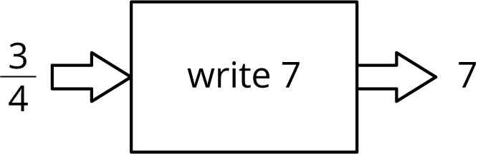
- input | - output
- $\frac{3}{4}$ | - 7
- 2.35
- 42
- Pause here until your teacher directs you to the last rule.
- 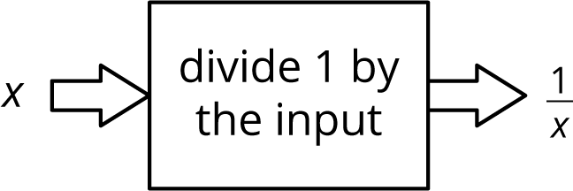
- input | - output
- $\frac{3}{7}$ | - $\frac{7}{3}$
- 1
- 0

Activity Synthesis
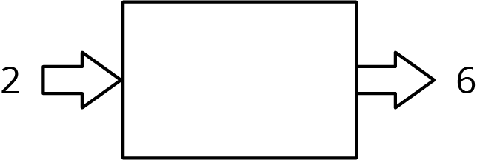
© CC BY Open Up Resources. Adaptations CC BY IM.

