Algebra 1
Unit 7Lesson 16CC BY NC 2024 Illustrative Mathematics®
Unit 7, Lesson 16

Graphing from the Vertex Form
- Let’s graph equations in vertex form.
Algebra 1
Unit 7Lesson 16CC BY NC 2024 Illustrative Mathematics®

16.1Which Form to Use?
Expressions in different forms can be used to define the same function. Here are three ways to define a function, $f$.
$f\left(x\right)=x^{2}−4x+3$
standard form
$f\left(x\right)=\left(x−3\right)\left(x−1\right)$
factored form
$f\left(x\right)={\left(x−2\right)}^{2}−1$
vertex form
Which form would you use if you want to find the following features of the graph of $f$? Be prepared to explain your reasoning.
- the $x$-intercepts
- the vertex
- the $y$-intercept
Algebra 1
Unit 7Lesson 16CC BY NC 2024 Illustrative Mathematics®

16.2Sharing a Vertex
Here are two equations that define quadratic functions.
$p\left(x\right)=\text{-}{\left(x−4\right)}^{2}+10q\left(x\right)=\frac{1}{2}{\left(x−4\right)}^{2}+10$
- The graph of $p$ passes through $\left(0,\text{-}6\right)$ and $\left(4,10\right)$, as shown on the coordinate plane.
- Find the coordinates of another point on the graph of $p$. Explain or show your reasoning. Then use the points to sketch and label the graph.
- 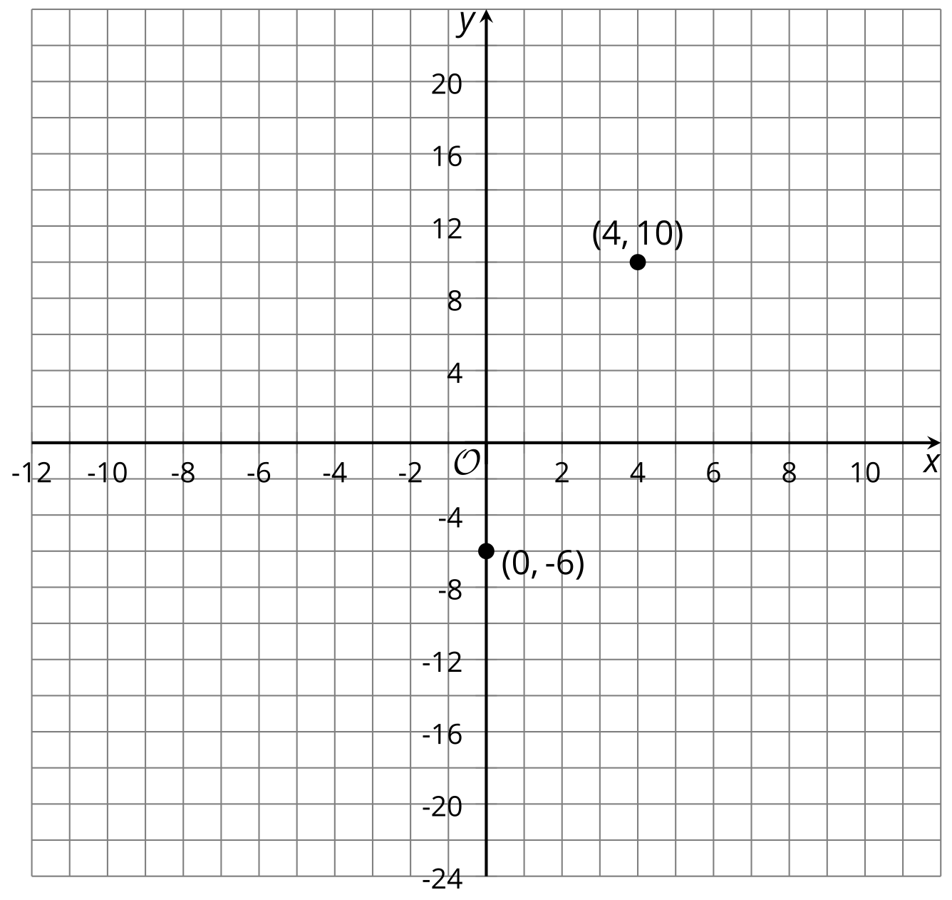
- On the same coordinate plane, identify the vertex and two other points that are on the graph of $q$. Explain or show your reasoning. Sketch and label the graph of $q$.
- Priya says, "Once I know that the vertex is $\left(4,10\right)$, I can find out, without graphing, whether the vertex is the maximum or the minimum of function $p$. I can just compare the coordinates of the vertex with the coordinates of a point on either side of it."
- Complete the table, and then explain how Priya might have reasoned about whether the vertex is the minimum or maximum.
- $x$ | - 3 | - 4 | - 5
- $p\left(x\right)$ |  | - 10

Are you ready for more?
- Write a the equation for a quadratic function whose graph has the vertex at $\left(2,3\right)$ and contains the point $\left(0,\text{-}5\right)$.
- Sketch a graph of your function.
Algebra 1
Unit 7Lesson 16CC BY NC 2024 Illustrative Mathematics®

16.3Card Sort: Matching Equations with Graphs
Your teacher will give you a set of cards containing an equation or a graph that represents a quadratic function. Take turns matching each equation to a graph that represents the same function. Record your matches, and be prepared to explain your reasoning.

Lesson 16 Summary
Not surprisingly, vertex form is especially helpful for finding the vertex of a graph of a quadratic function. For example, we can tell that the function, $p$, given by $p\left(x\right)={\left(x−3\right)}^{2}+1$ has a vertex at $\left(3,1\right)$.
We also noticed that, when the squared expression ${\left(x−3\right)}^{2}$ has a positive coefficient, the graph opens upward. This means that the vertex, $\left(3,1\right)$, represents the minimum function value, $p\left(x\right)$.
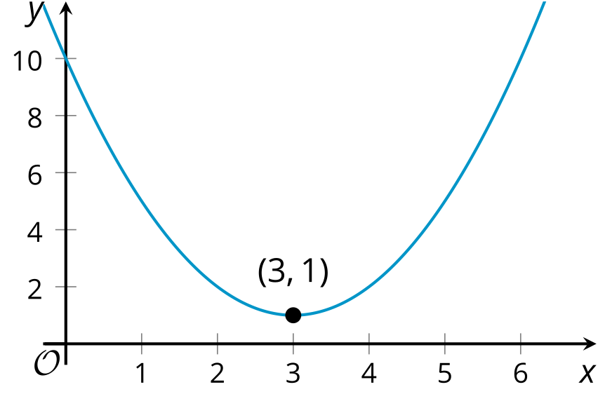
But why does function $p$ take on its minimum value when $x$ is 3?
Here is one way to explain it: When $x=3$, the squared term ${\left(x−3\right)}^{2}$ equals 0, because ${\left(3−3\right)}^{2}=0^{2}=0$. When $x$ is any other value besides 3, the squared term ${\left(x−3\right)}^{2}$ is a positive number greater than 0. (Squaring any number results in a positive number.) This means that the output when $x≠3$ will always be greater than the output when $x=3$, so function $p$ has a minimum value at $x=3$.
This table shows some values of the function for some values of $x$. Notice that the output is the least when $x=3$, and it increases both as $x$ increases and as it decreases.
$x$ | 0 | 1 | 2 | 3 | 4 | 5 | 6
${\left(x−3\right)}^{2}+1$ | 10 | 5 | 2 | 1 | 2 | 5 | 10
The squared term sometimes has a negative coefficient, for instance in $h\left(x\right)=\text{-}2{\left(x+4\right)}^{2}$. The $x$ value that makes ${\left(x+4\right)}^{2}$ equal 0 is -4, because ${\left(\text{-}4+4\right)}^{2}=0^{2}=0$. Any other $x$ value makes ${\left(x+4\right)}^{2}$ greater than 0. But when ${\left(x+4\right)}^{2}$ is multiplied by a negative number like -2, the resulting expression, $\text{-}2{\left(x+4\right)}^{2}$, ends up being negative. This means that the output when $x≠\text{-}4$ will always be less than the output when $x=\text{-}4$, so function $h$ has its maximum value when $x=\text{-}4$.
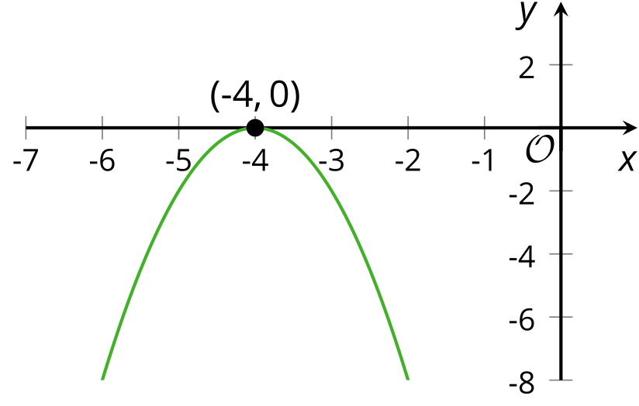
Remember that we can find the $y$-intercept of the graph representing any function that we have seen. The $y$-coordinate of the $y$-intercept is the value of the function when $x=0$. If $g$ is defined by $g\left(x\right)={\left(x+1\right)}^{2}−5$, then the $y$-intercept is $\left(0,\text{-}4\right)$ because $g\left(0\right)={\left(0+1\right)}^{2}−5=\text{-}4$. Its vertex is at $\left(\text{-}1,\text{-}5\right)$. Another point on the graph with the same $y$-coordinate is located the same horizontal distance from the vertex but on the other side.
