Grade 2
Unit 4Lesson 14CC BY NC 2024 Illustrative Mathematics®
Unit 4, Lesson 14

Center Day 2
- Let’s practice adding and subtracting using the number line.
Grade 2
Unit 4Lesson 14CC BY NC 2024 Illustrative Mathematics®

Warm-up True or False: Is This 50?
Decide if each statement is true or false. Be prepared to explain your reasoning.
- $28+2+20=50$
- $16+3+30=50$
- $36+4+20=50$
Grade 2
Unit 4Lesson 14CC BY NC 2024 Illustrative Mathematics®

Activity 2 Centers: Choice Time
Choose a center.
Jump the Line
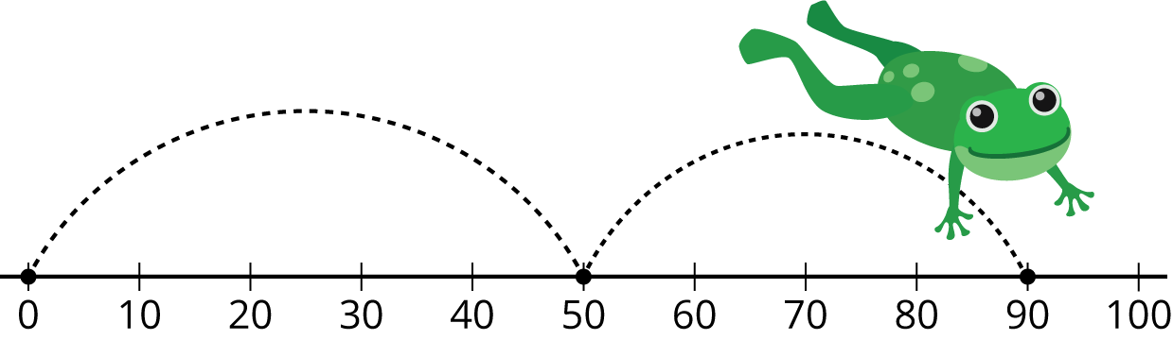
Number Line Scoot
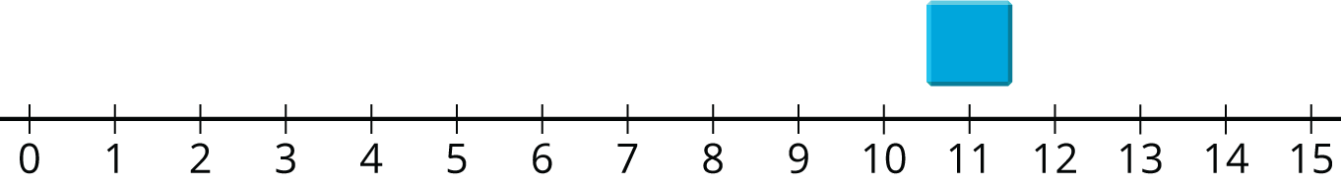
How Close?
