Unit 2 Lesson 6: Different Square Units (Part 1)

WU Notice and Wonder: Squares, Squares (Warm up)

Student Task Statement
What do you notice? What do you wonder?
A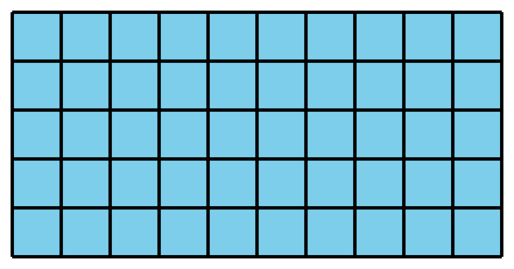
B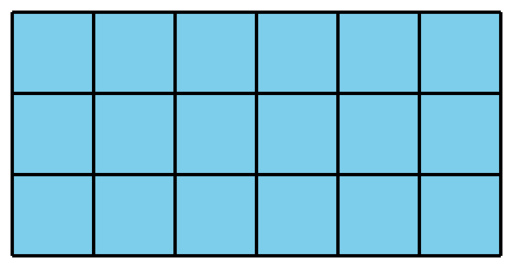
C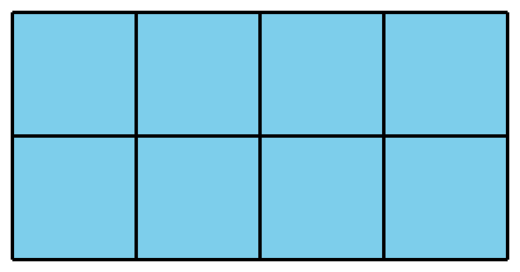
D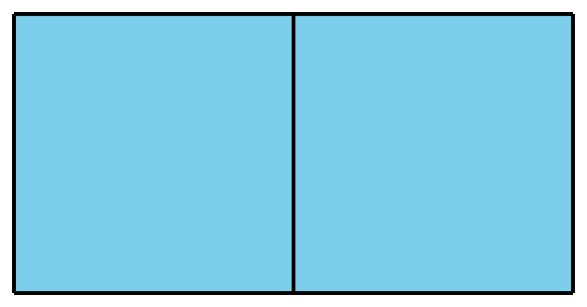

1 Same Rectangle, Different Units

Student Task Statement
Your teacher will give you two kinds of grid paper. Use them to create a rectangle for each expression.
Partner 1: Use grid 1.
Partner 2: Use grid 2.
- $2×5$
- $7×3$
- $6×8$

2 What’s the Area?

Student Task Statement
Estimate how many square centimeters and inches it will take to tile this square.
- square inches (estimate) _________
- square centimeters (estimate) _________
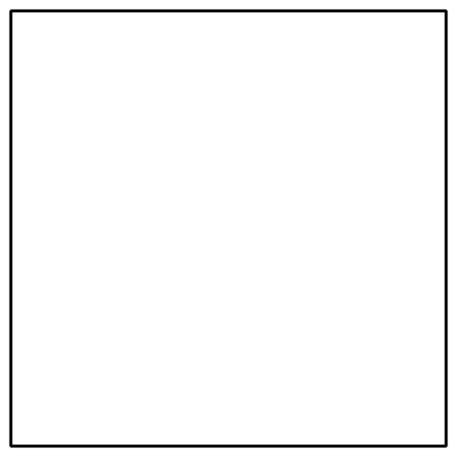
- Use the inch grid and centimeter grid to find the area of the square
  - square inches ____________________
  - square centimeters ____________________
- Write a multiplication expression that describes the rows and columns in the square and can tell us the area in each unit.
  - square inches ____________________
  - square centimeters ____________________
© CC BY 2021 Illustrative Mathematics®

