Grade 6
Unit 9Lesson 10CC BY NC Illustrative Mathematics, based on IM 6–8 Math, CC BY Open Up Resources.
Unit 9, Lesson 10

Rectangle Madness
Let’s cut up rectangles.
Grade 6
Unit 9Lesson 10CC BY NC Illustrative Mathematics, based on IM 6–8 Math, CC BY Open Up Resources.

10.1Squares in Rectangles
- Rectangle $ABCD$ is not a square. Rectangle $ABEF$ is a square. Use the possible segment lengths to find the missing segment length.
- 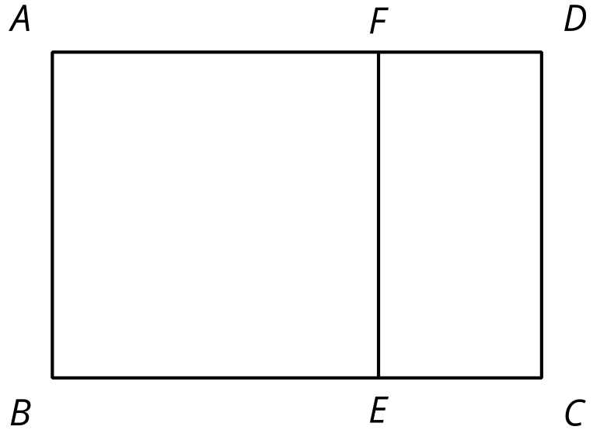
  - If segment $AF$ is 5 units long and segment $FD$ is 2 units long, how long would segment $AD$ be?
  - If segment $BC$ is 10 units long and segment $BE$ is 6 units long, how long would segment $EC$ be?
  - If segment $AF$ is 12 units long and segment $FD$ is 5 units long, how long would segment $FE$ be?
  - If segment $AD$ is 9 units long and segment $AB$ is 5 units long, how long would segment $FD$ be?
- Rectangle $JKXW$ has been decomposed into squares.
- 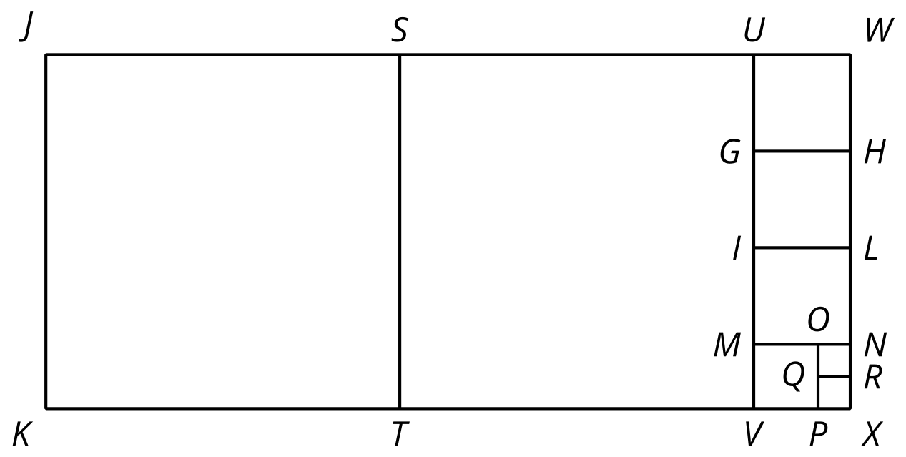
- Segment $JK$ is 33 units long and segment $JW$ is 75 units long. Find the areas of all of the squares in the diagram.
- Rectangle $ABCD$ is 16 units by 5 units.
- 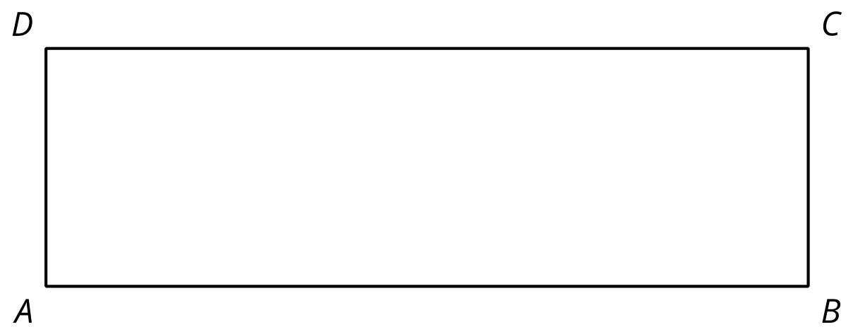
  - In the diagram, draw a line segment that decomposes $ABCD$ into two regions: a square that is the largest possible and a new rectangle.
  - Draw another line segment that decomposes the new rectangle into two regions: a square that is the largest possible and another new rectangle.
  - Keep going until rectangle $ABCD$ is entirely decomposed into squares.
  - List the side lengths of all the squares in your diagram.

Are you ready for more?
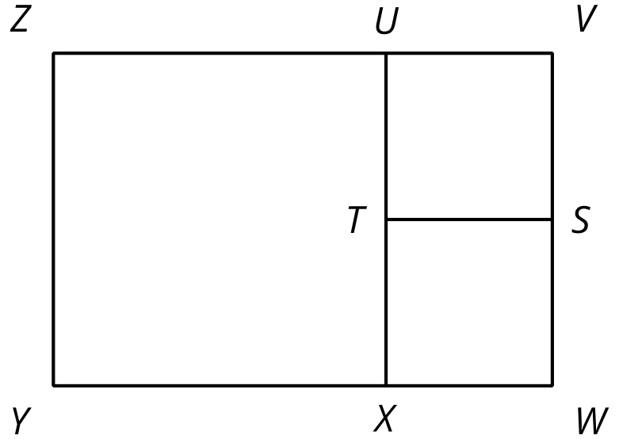
- The diagram shows rectangle $VWYZ$ which has been decomposed into 3 squares. What could the side lengths of this rectangle be?
- How many different side lengths can you find for rectangle $VWYZ$?
- What are some rules for possible side lengths of rectangle $VWYZ$?
Grade 6
Unit 9Lesson 10CC BY NC Illustrative Mathematics, based on IM 6–8 Math, CC BY Open Up Resources.

10.2More Rectangles, More Squares
- Draw a rectangle that is 21 units by 6 units.
  - In your rectangle, draw a line segment that decomposes the rectangle into a new rectangle and a square that is as large as possible. Continue until the diagram shows that your original rectangle has been entirely decomposed into squares.
  - How many squares of each size are in your diagram?
  - What is the side length of the smallest square?
- Draw a rectangle that is 28 units by 12 units.
  - In your rectangle, draw a line segment that decomposes the rectangle into a new rectangle and a square that is as large as possible. Continue until the diagram shows that your original rectangle has been decomposed into squares.
  - How many squares of each size are in your diagram?
  - What is the side length of the smallest square?
- Write each of these fractions as a mixed number with the smallest possible numerator and denominator:
  - $\frac{16}{5}$
  - $\frac{21}{6}$
  - $\frac{28}{12}$
- What do the fraction problems have to do with the earlier rectangle decomposition problems?

