Lesson 16: Parts to Make 5
- Let’s find the missing part.

Warm-up: How Many Do You See: Add and Subtract
How many do you see?
How do you see them?
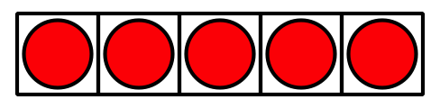
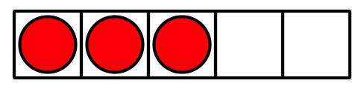
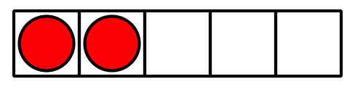
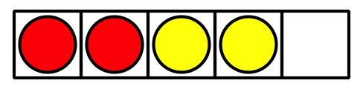

16.1: Revisit Shake and Spill, Cover
Put 3, 4, or 5 counters in the cup.
Shake and spill the counters.
Hide some of the counters under the cup.
Figure out how many of the counters are hidden.
Write an expression.

16.2: Missing Value
Fill in the missing part of each equation.
$3−\underset{_}{}=2$
$2+\underset{_}{}=2$
$5−\underset{_}{}=2$
$1+\underset{_}{}=2$
$5−\underset{_}{}=3$
$2+\underset{_}{}=3$
$4−\underset{_}{}=3$
$0+\underset{_}{}=3$
$5−\underset{_}{}=4$
$3+\underset{_}{}=4$
$4−\underset{_}{}=4$
$2+\underset{_}{}=4$
$1+\underset{_}{}=5$
$4+\underset{_}{}=5$
$5−\underset{_}{}=5$
$3+\underset{_}{}=5$

16.3: Centers: Choice Time
Choose a center.
5-frames
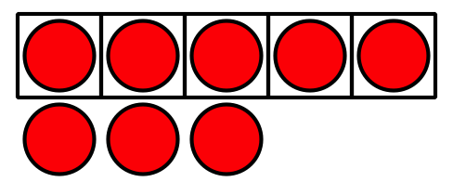
Roll and Add
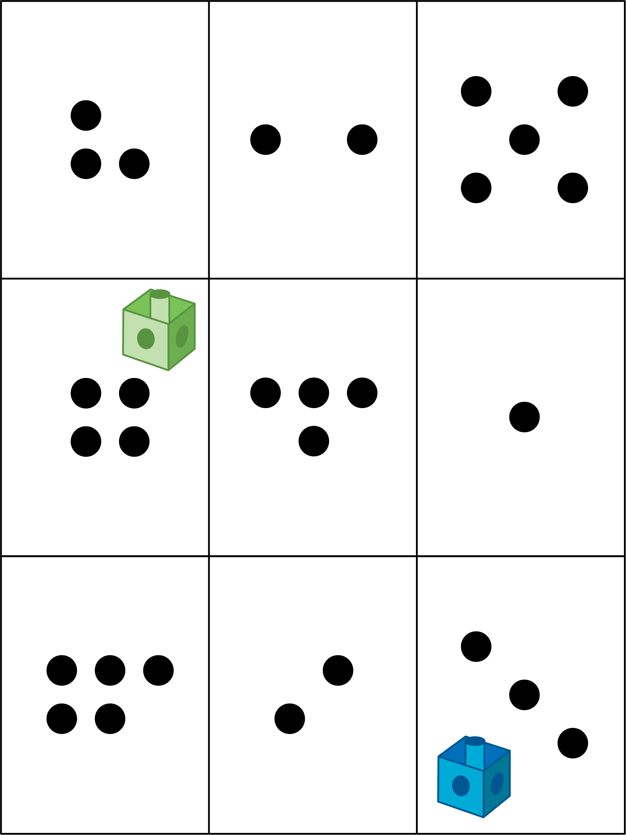
Bingo
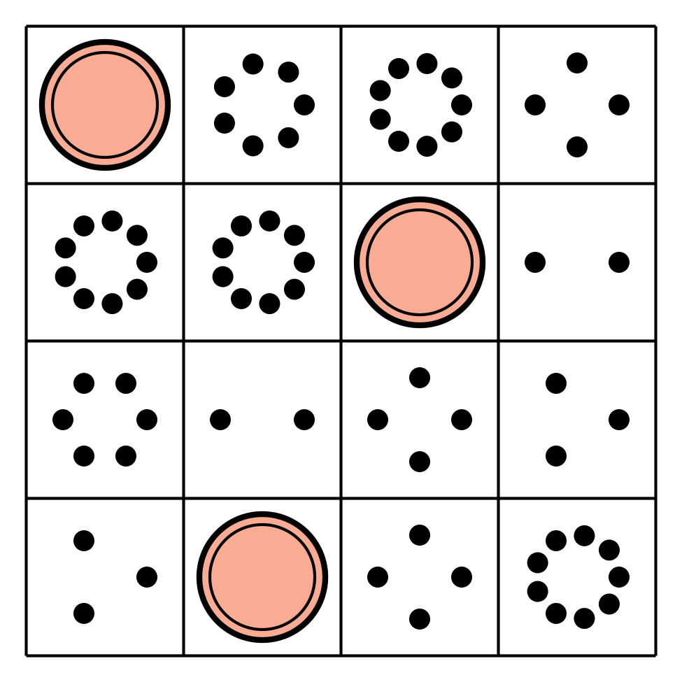
Geoblocks
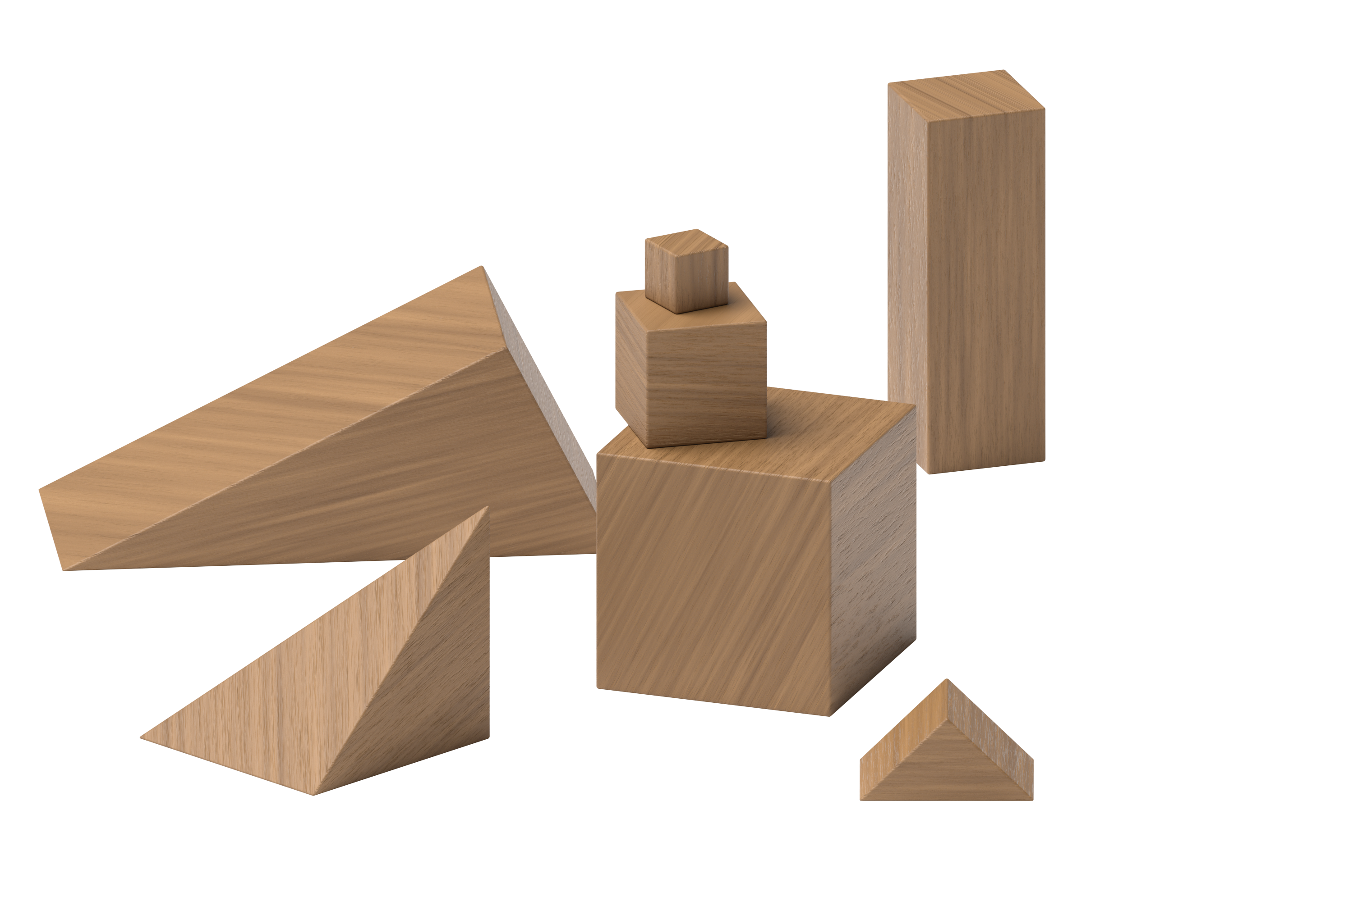
Find the Value of Expressions
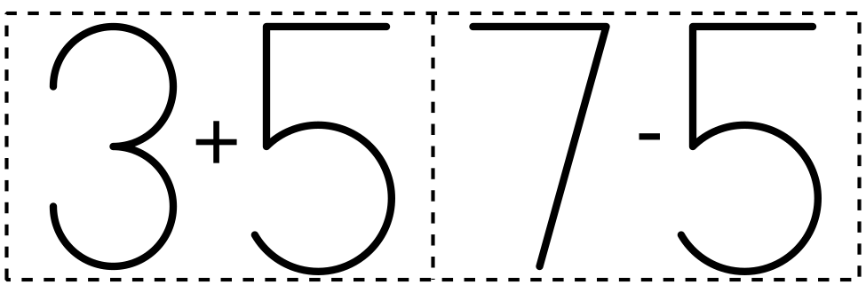

Section Summary
Section Summary
In this section, we showed different ways to make numbers to 5.
$5=3+2$
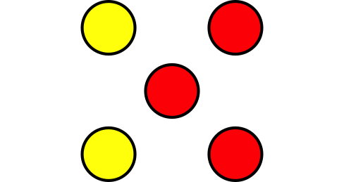
$1+4=5$
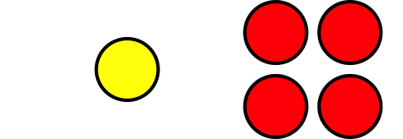
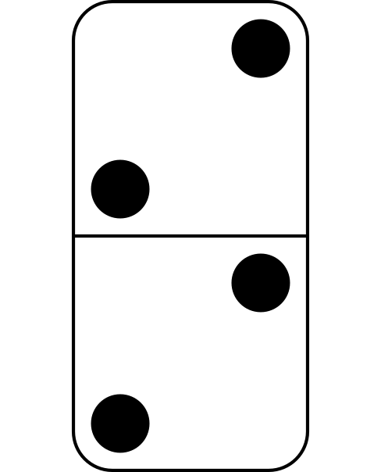
$2+2=4$
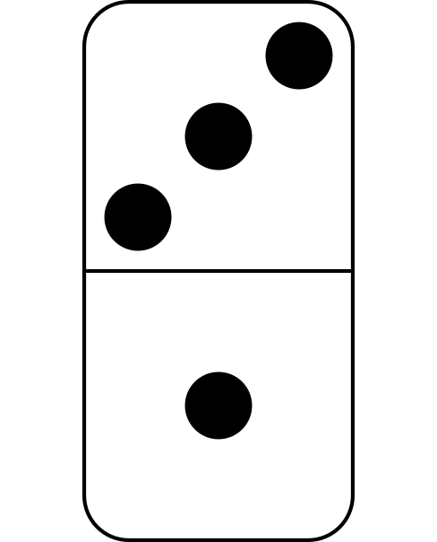
$4=3+1$
We added and subtracted within 5.
$2+1=3$

$5−2=3$

We filled in the missing part in equations.
$2+\underset{_}{}=3$
$2+\underset{_}{1}=3$
$5−\underset{_}{}=2$
$5−\underset{_}{3}=2$
© CC BY 2021 Illustrative Mathematics®

