Grade 6
Unit 2Lesson 2CC BY NC Illustrative Mathematics, based on IM 6–8 Math, CC BY Open Up Resources.
Unit 2, Lesson 2

Representing Ratios with Diagrams
Let’s use diagrams to represent ratios.
Grade 6
Unit 2Lesson 2CC BY NC Illustrative Mathematics, based on IM 6–8 Math, CC BY Open Up Resources.

2.1Which Three Go Together: Representations
Which three go together? Why do they go together?
A
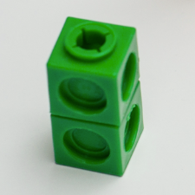
B

C
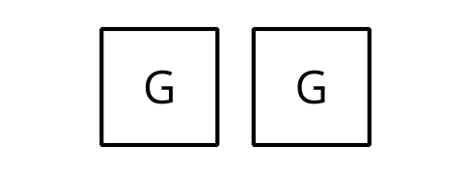
D
2 green objects
Grade 6
Unit 2Lesson 2CC BY NC Illustrative Mathematics, based on IM 6–8 Math, CC BY Open Up Resources.

2.2Blue Paint and Play Clay
Elena mixed 2 cups of white paint with 6 tablespoons of blue paint.
Here is a diagram that represents this situation.
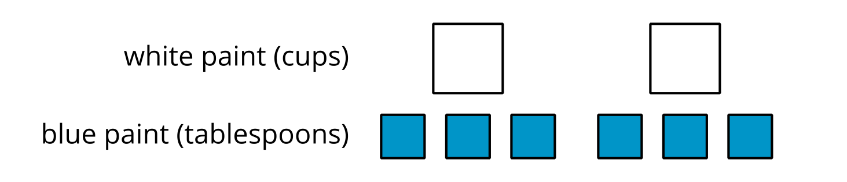
- Discuss each statement, and circle all those that correctly describe this situation. Make sure that both you and your partner agree with each circled answer.
  - The ratio of cups of white paint to tablespoons of blue paint is $2:6$.
  - For every cup of white paint, there are 2 tablespoons of blue paint.
  - There is 1 cup of white paint for every 3 tablespoons of blue paint.
  - There are 3 tablespoons of blue paint for every cup of white paint.
  - For each tablespoon of blue paint, there are 3 cups of white paint.
  - For every 6 tablespoons of blue paint, there are 2 cups of white paint.
  - The ratio of tablespoons of blue paint to cups of white paint is 6 to 2.
- Jada mixed 8 cups of corn flour with 2 pints of liquid glue to make play clay.
  - Draw a diagram that represents the situation.
  - Write at least two sentences describing the ratio of corn flour and glue.
Grade 6
Unit 2Lesson 2CC BY NC Illustrative Mathematics, based on IM 6–8 Math, CC BY Open Up Resources.

2.3Card Sort: Pencil Cases
Your teacher will give you cards showing diagrams or sentences that describe the items in different pencil cases. In the diagrams:
- A circle represents a pencil.
- A square represents an eraser.
- A triangle represents a paper clip.
- Take turns with your partner to match a sentence with a diagram.
  - For each match that you find, explain to your partner how you know it’s a match.
  - For each match that your partner finds, listen carefully to their explanation. If you disagree, discuss your thinking and work to reach an agreement.
- After you and your partner have agreed on all of the matches, check your answers with the answer key. If there are any errors, discuss why and revise your matches.
- There were two diagrams that each matched with two different sentences. Which were they?
  - Diagram $\underset{_}{}$ matched with both sentences $\underset{_}{}$ and $\underset{_}{}$.
  - Diagram $\underset{_}{}$ matched with both sentences $\underset{_}{}$ and $\underset{_}{}$.
- Select one of the other diagrams and invent another sentence that could describe the ratio shown in the diagram.

Are you ready for more?
Andre has markers, pens, and rulers in his drawer. There are 2 markers for every ruler. There are 3 pens for every marker.
- What is the ratio of pens to markers to rulers? Draw a diagram to show your reasoning.
- Keeping that ratio, could there be 9 pens in Andre’s drawer? Explain your reasoning.

Lesson 2 Summary
Ratios can be represented using diagrams. The diagrams do not need to include realistic details. For example, there are 2 pairs of scissors and 6 glue sticks in a bin. Instead of this:
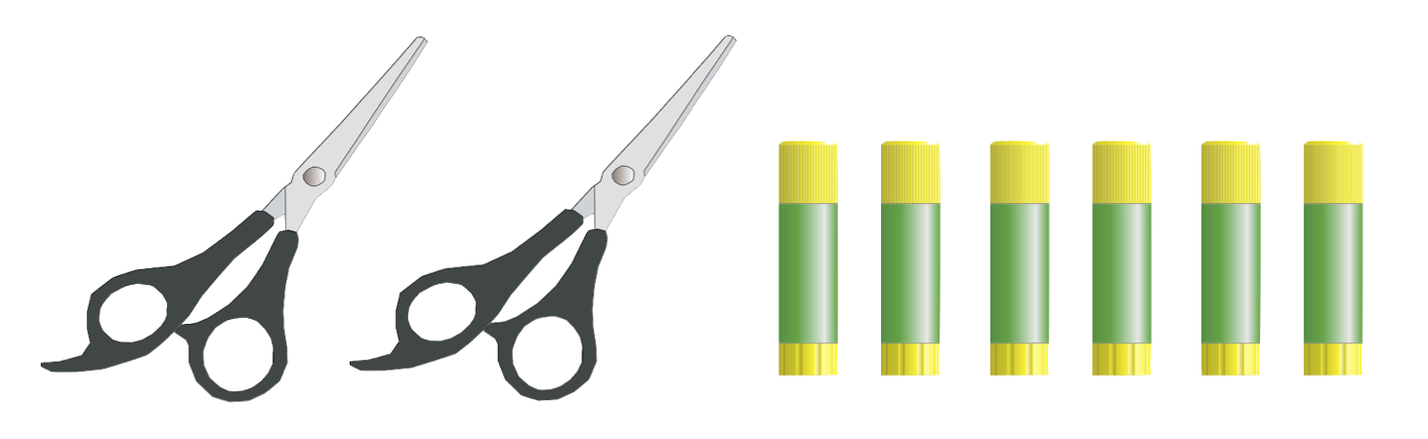
We can draw something like this:
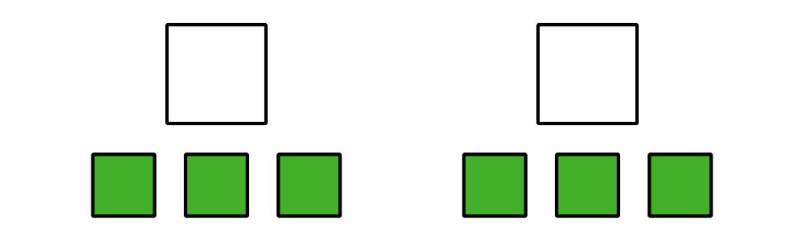
This diagram shows that the ratio of glue sticks to pairs of scissors is 6 to 2. We can also see that for every pair of scissors, there are 3 glue sticks.

