Unit 6 Lesson 17: Parameters and Graphs

1 Which One Doesn’t Belong: Triangles (Warm up)

Student Task Statement
Each figure shows triangle $PQR$, and its image after a transformation, $P^{′}Q^{′}R^{′}$. Which one doesn’t belong?

A
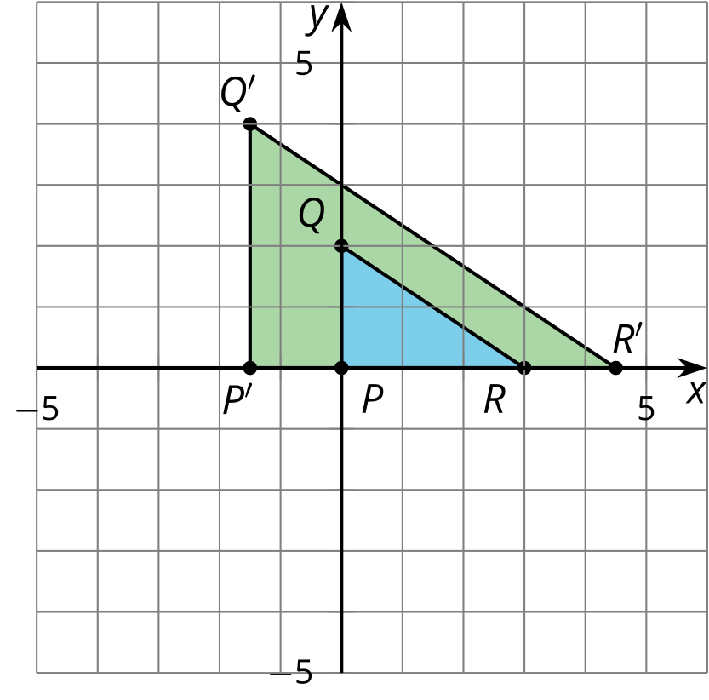

B
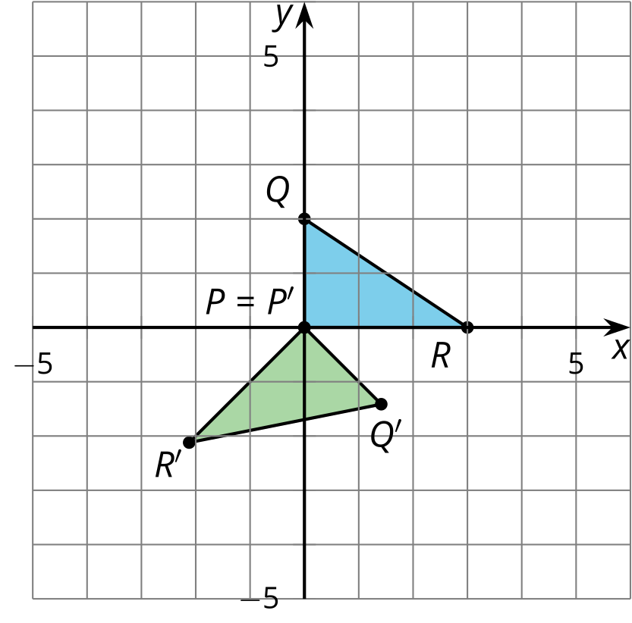

C
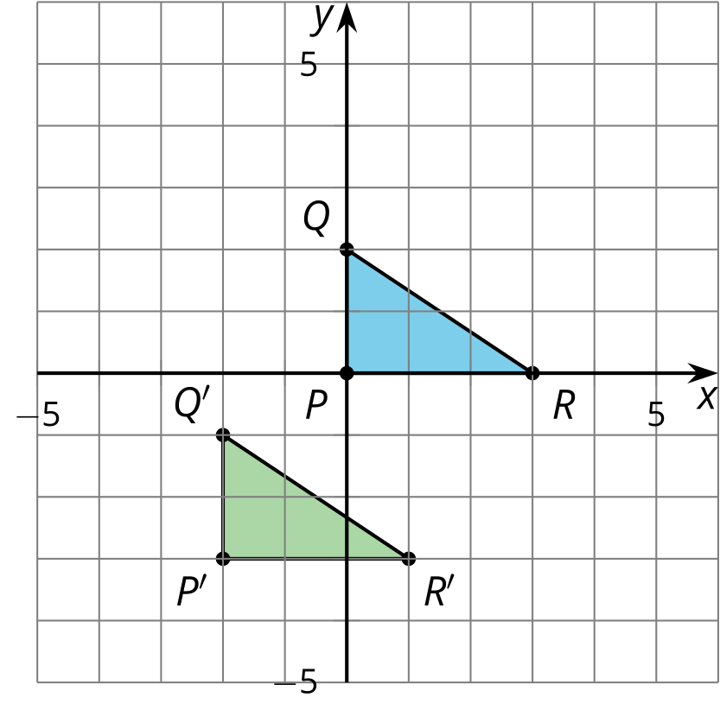

D
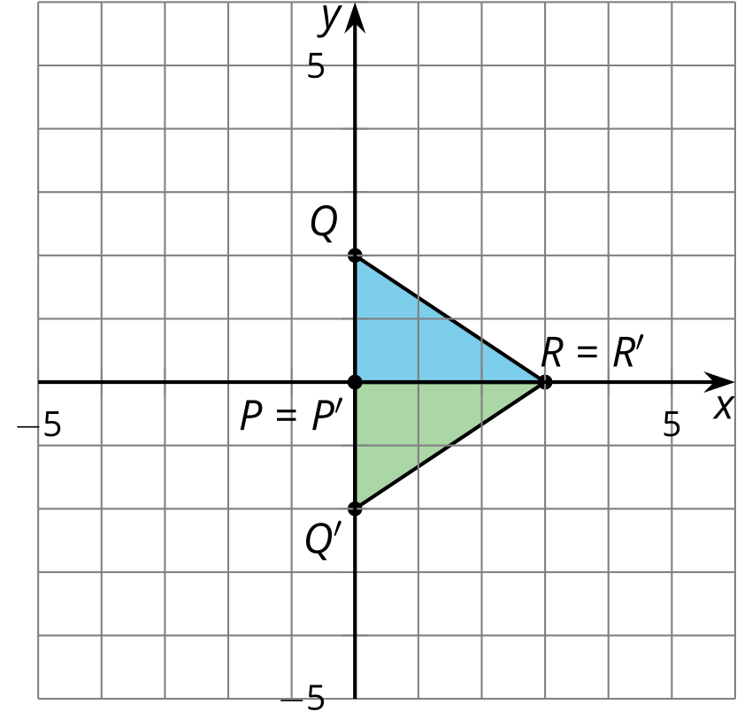

2 Describe the Change

Student Task Statement
- Use graphing technology to graph each equation. Describe how each graph changes from the previous graph and draw a sketch of the change.
- equation | - description of change | - sketch of graph
- $y=x^{2}$ | - original graph | - 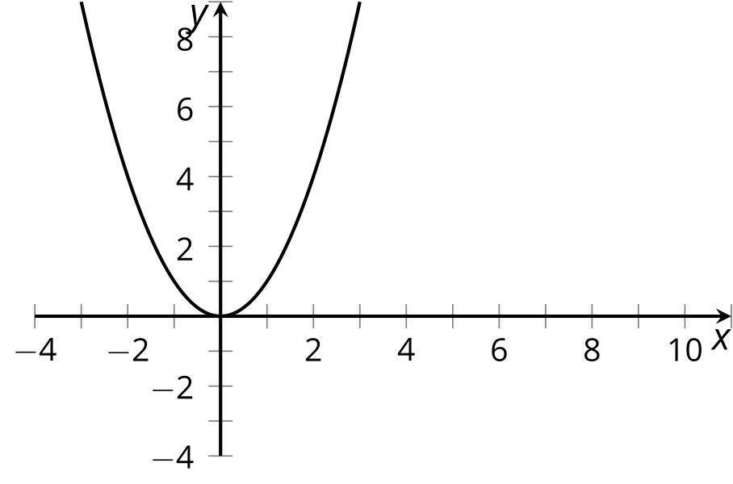
- $y={\left(x−5\right)}^{2}$
- $y={\left(x−5\right)}^{2}+4$
- Describe the change in the given sketch and write an equation that you think would generate that change.
- equation | - description of change | - sketch of graph
- $y=x^{2}$ | - original graph | - 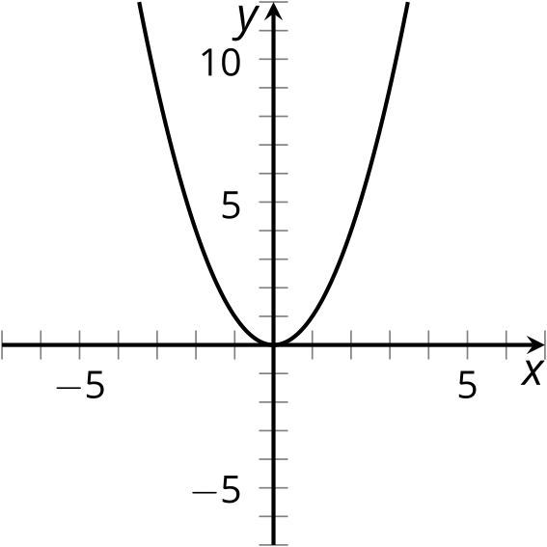
 |  | - 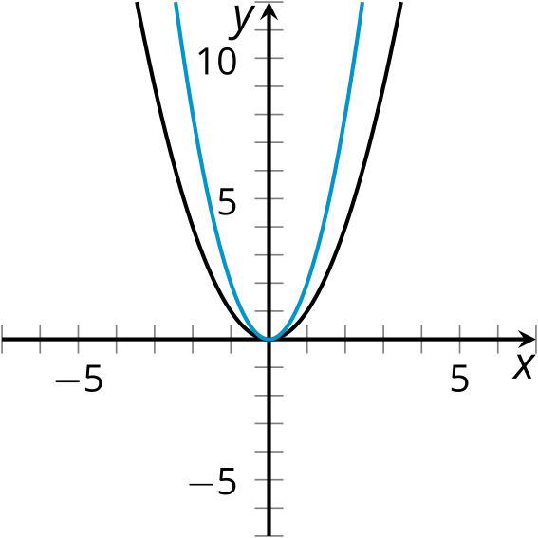
 |  | - 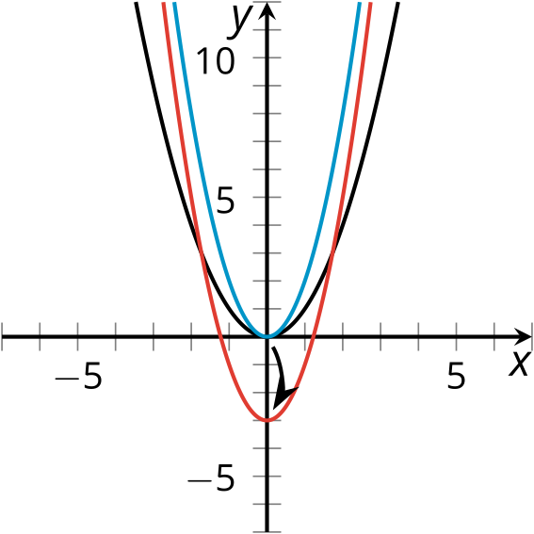
- How would the graph of $y=\text{-}2x^{2}−3$ compare to the graph of $y=2x^{2}−3$?

3 Select a Function

Student Task Statement
Let’s call the graph of $y=x^{2}$ “the original graph.”
Select the function that will affect the original graph in the way described.
- Shift the vertex of the graph left 1 unit.
- Shift the vertex of the graph up 1 unit.
- Shift the vertex of the graph right 1 unit and up 1 unit.
- Make the original graph narrower.
- Make the original graph narrower, and shift the vertex 1 unit to the right.
- $y=x^{2}+1$
- $y={\left(x+1\right)}^{2}$
- $y=3x^{2}$
- $y={\left(x−1\right)}^{2}+1$
- $y=3{\left(x−1\right)}^{2}$
© CC BY 2019 by Illustrative Mathematics®

