Grade 2
Unit 4Lesson 3CC BY NC 2024 Illustrative Mathematics®
Unit 4, Lesson 3

Unlabeled Tick Marks
- Let’s locate numbers on the number line.
Grade 2
Unit 4Lesson 3CC BY NC 2024 Illustrative Mathematics®

Warm-up Notice and Wonder: From 0 to 30
What do you notice? What do you wonder?
A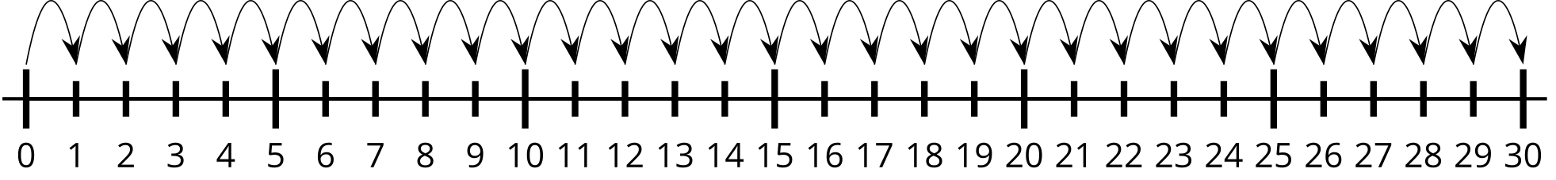
B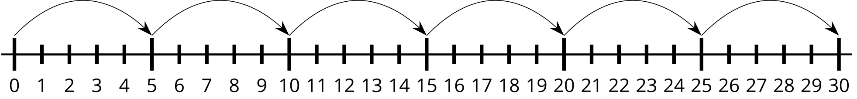
C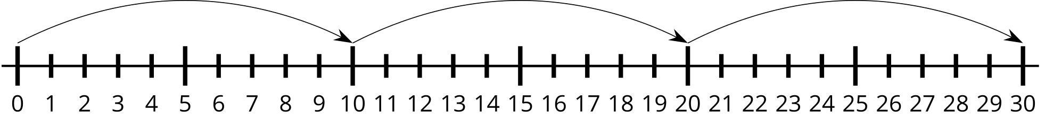
Grade 2
Unit 4Lesson 3CC BY NC 2024 Illustrative Mathematics®

Activity 1 Locate the Numbers
- Locate 24. Mark it with a point.
- Locate 37. Mark it with a point.
- Locate 48. Mark it with a point.
- Locate 83. Mark it with a point.
- Are the numbers you marked on the number lines in the correct locations? How do you know?
Grade 2
Unit 4Lesson 3CC BY NC 2024 Illustrative Mathematics®

Activity 2 Are You Missing Something?
Complete each number line. Fill in the labels with the number the tick mark represents. Locate each number. Mark it with a point. Label it with the number it represents.
- Locate and label 17.
- 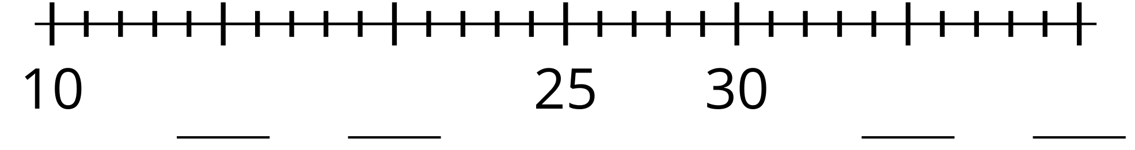
- Locate and label 59.
- 
- Locate and label 43.
- 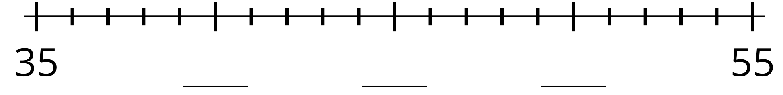
- Locate and label 35.
- 
- Share your number lines with your partner.
