Algebra 1
Unit 5Lesson 6CC BY NC 2024 Illustrative Mathematics®
Unit 5, Lesson 6

Features of Graphs
- Let’s use graphs of functions to learn about situations.
Algebra 1
Unit 5Lesson 6CC BY NC 2024 Illustrative Mathematics®

6.1Walking Home
Diego is walking home from school at a constant rate. This graph represents function $d$, which gives his distance from home, in kilometers, $m$ minutes since leaving the school.
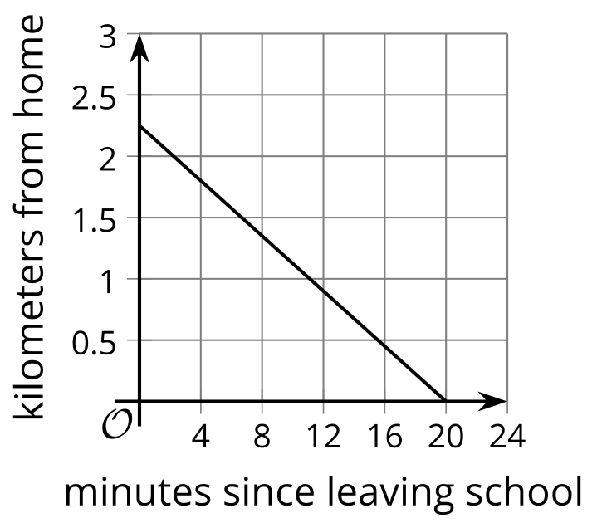
Use the graph to find or estimate:
- $d\left(0\right)$
- $d\left(12\right)$
- the solution to $d\left(m\right)=1$
- the solution to $d\left(m\right)=0$
Algebra 1
Unit 5Lesson 6CC BY NC 2024 Illustrative Mathematics®

6.2A Toy Rocket and a Drone
A toy rocket and a drone were launched at the same time.
Here are the graphs that represent the heights of the two objects as a function of time since they were launched.
Height is measured in meters above the ground, and time is measured in seconds since launch.
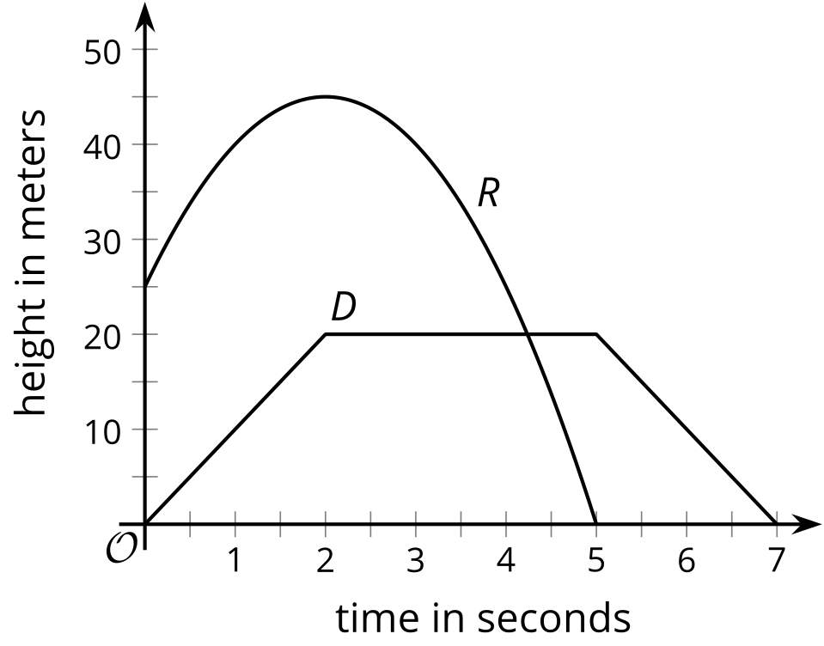
- Analyze the graphs and describe—as precisely as you can—what was happening with each object. ​​Your descriptions should be complete and precise enough that someone who is not looking at the graph could visualize how the objects were behaving.
- Which parts or features of the graphs show important information about each object’s movement? List the features, or mark them on the graphs.
Algebra 1
Unit 5Lesson 6CC BY NC 2024 Illustrative Mathematics®

6.3The Jump
In a bungee jump, the height of the jumper is a function of time since the jump begins.
Function $h$ defines the height, in meters, of a jumper above a river, $t$ seconds since leaving the platform.
Here is a graph of function $h$, followed by five expressions or equations and five graphical features.

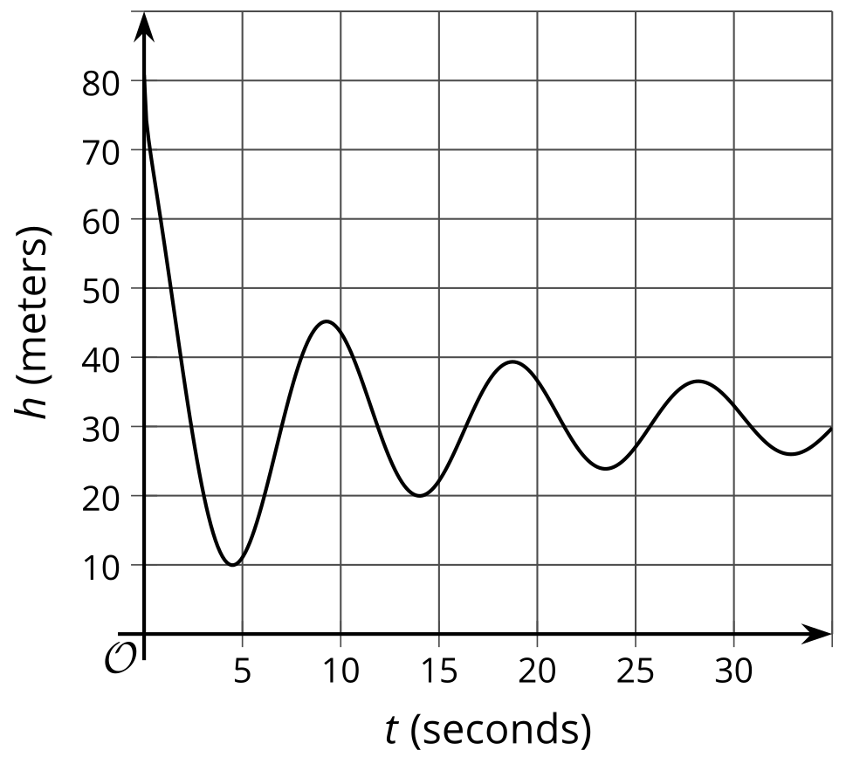
$h\left(0\right)$
$h\left(t\right)=0$
$h\left(4\right)$
$h\left(t\right)=80$
$h\left(t\right)=45$
- first dip in the graph
- vertical intercept
- first peak in the graph
- horizontal intercept
- maximum
- Match each description about the jump to a corresponding expression or equation and to a feature on the graph.
- One expression or equation does not have a matching verbal description. Its corresponding graphical feature is also not shown on the graph. Interpret that expression or equation in terms of the jump, and describe the feature of the graph it represents. Record your answers in the last row of the table.
- description of jump | - expression  or equation | - feature of graph
- a. the greatest height that the jumper is from the river
- b. the height from which the jumper was jumping
- c. the time at which the jumper reached the highest point after the first bounce
- d. the lowest point that the jumper reached in the entire jump
- e.
- Use the graph to:
  - estimate $h\left(0\right)$ and $h\left(4\right)$
  - estimate the solutions to $h\left(t\right)=45$ and $h\left(t\right)=0$

Are you ready for more?
Based on the information available, how long do you think the bungee cord is? Make an estimate, and explain your reasoning.

Lesson 6 Summary
The graph of the function can give us useful information about the quantities in a situation. Some points and features of a graph are particularly informative, so we pay closer attention to them.
Let’s look at the graph of function $h$, which gives the height, in meters, of a ball $t$ seconds after it is tossed up in the air. From the graph, we can see that:
- The point $\left(0,20\right)$ is the vertical intercept of the graph, or the point where the graph intersects the vertical axis.
- This point tells us that the initial height of the ball is 20 meters, because when $t$ is 0, the value of $h\left(t\right)$ is 20​​​​​.
- The statement $h\left(0\right)=20$ captures this information.
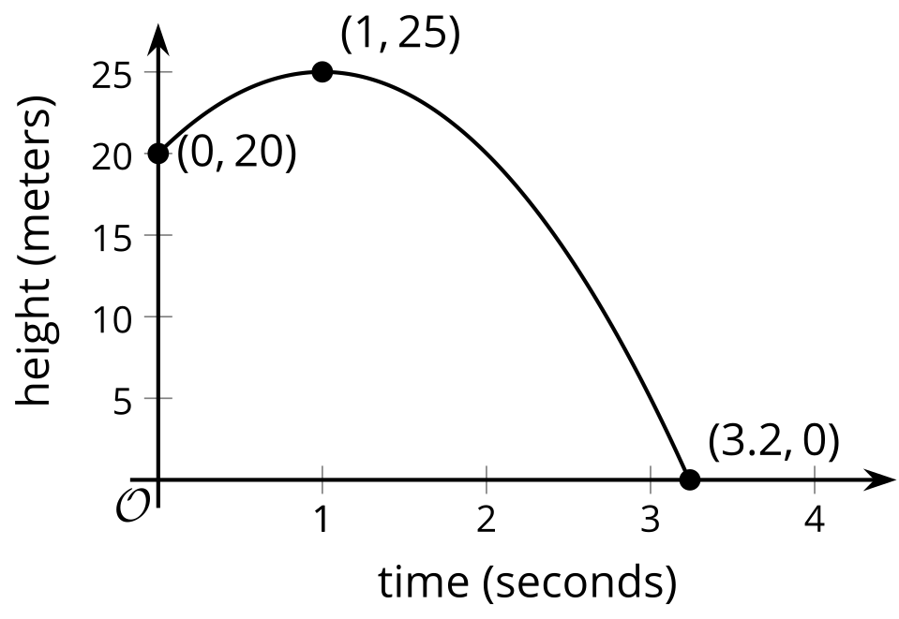
- The point $\left(1,25\right)$ is the highest point on the graph, so it is a maximum of the graph.
- The value 25 is also the maximum value of the function $h$. It tells us that the highest point the ball reaches is 25 meters, and that this happens 1 second after the ball is tossed.
- The point $\left(3.2,0\right)$ is a horizontal intercept of the graph, a point where the graph intersects the horizontal axis. This point is also the lowest point on the graph, so it represents a minimum of the graph.
- This point tells us that the ball hits the ground 3.2 seconds after being tossed up, so the height of the ball is 0 when $t$ is 3.2, which we can write as $h\left(3.2\right)=0$. Because $h$ cannot have any lower value, 0 is also the minimum value of the function.
- The height of the graph increases when $t$ is between 0 and 1. (A graph is increasing where the function’s values get greater as the graph is read left to right.) Then, the graph changes direction, and the height decreases when $t$ is between 1 and 3.2. (A graph is decreasing where the function’s values get lesser as the graph is read left to right.) Neither the increasing part nor the decreasing part is a straight line.
- This suggests that the ball increases in height in the first second after being tossed and then starts falling between 1 second and 3.2 seconds. It also tells us that the height does not increase or decrease at a constant rate.
Because the intercepts of a graph are points on an axis, at least one of their coordinates is 0. The 0 corresponds to the input or the output of a function, or both.
- A vertical intercept is on the vertical axis, so its coordinates have the form $\left(0,b\right)$, where the first coordinate is 0 and $b$ can be any number. The 0 is the input.
- A horizontal intercept is on the horizontal axis, so its coordinates have the form $\left(a,0\right)$, where $a$ can be any number and the second coordinate is 0. The 0 is an output.
- A graph that passes through $\left(0,0\right)$ intersects both axes so that point is both a horizontal intercept and a vertical intercept. Both the input and output are 0.

