Unit 5 Lesson 19: Adjusting Windows

1 Enough with the Zooming Already (Warm up)

Student Task Statement
Use graphing technology to create a graph of $y={10}^{x}$. Here are some different graphing windows to try:
- A: $\text{-}10≤x≤10$ and $\text{-}10≤y≤10$
- B: $\text{-}1≤x≤1$ and $\text{-}10≤y≤10$
- C: $\text{-}50≤x≤50$ and $\text{-}10≤y≤10$
- D: $\text{-}1≤x≤1$ and $\text{-}50≤y≤50$
- Which graphing window makes the graph look . . .
  - the steepest?
  - the flattest?
- Come up with a new graphing window that makes the graph look even steeper than the steepest one you identified.
- Come up with a new graphing window that makes the graph look even flatter than the flattest one you identified.

2 How to Lie with Graphing Windows

Student Task Statement
These graphs represent a function modeling the amount of a harmful chemical in drinking water in parts per billion over time in years.

A
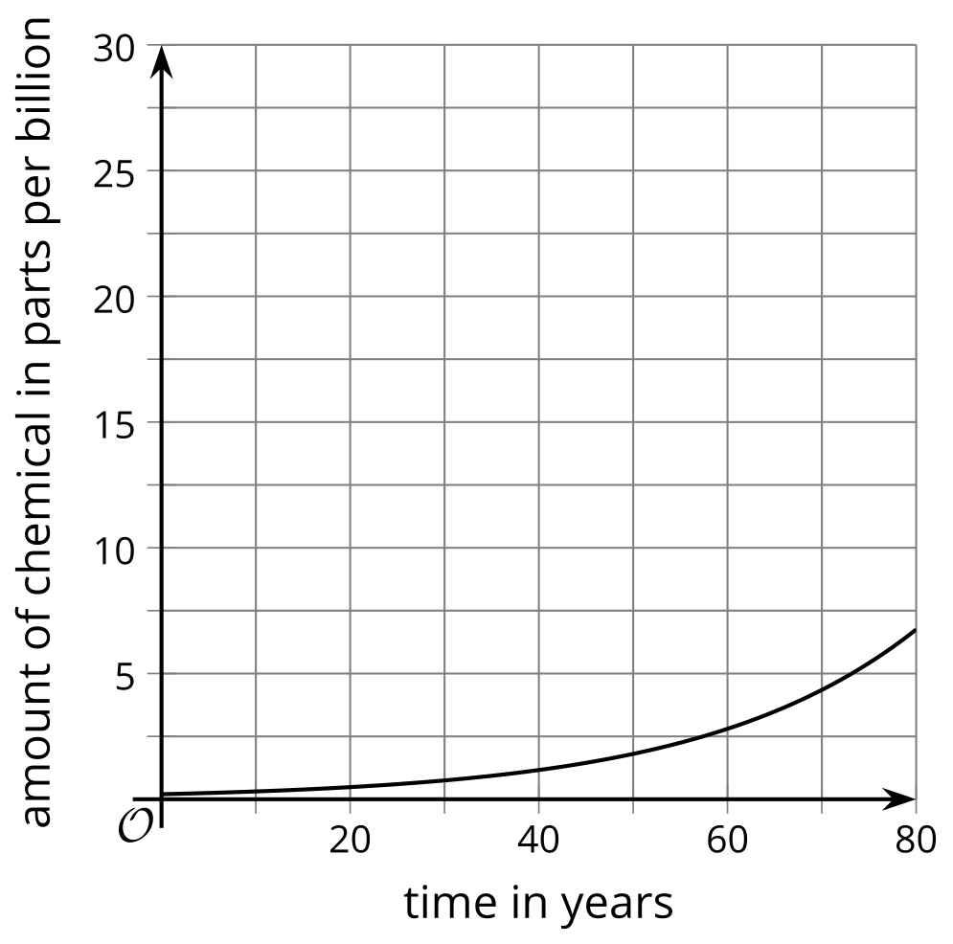

B
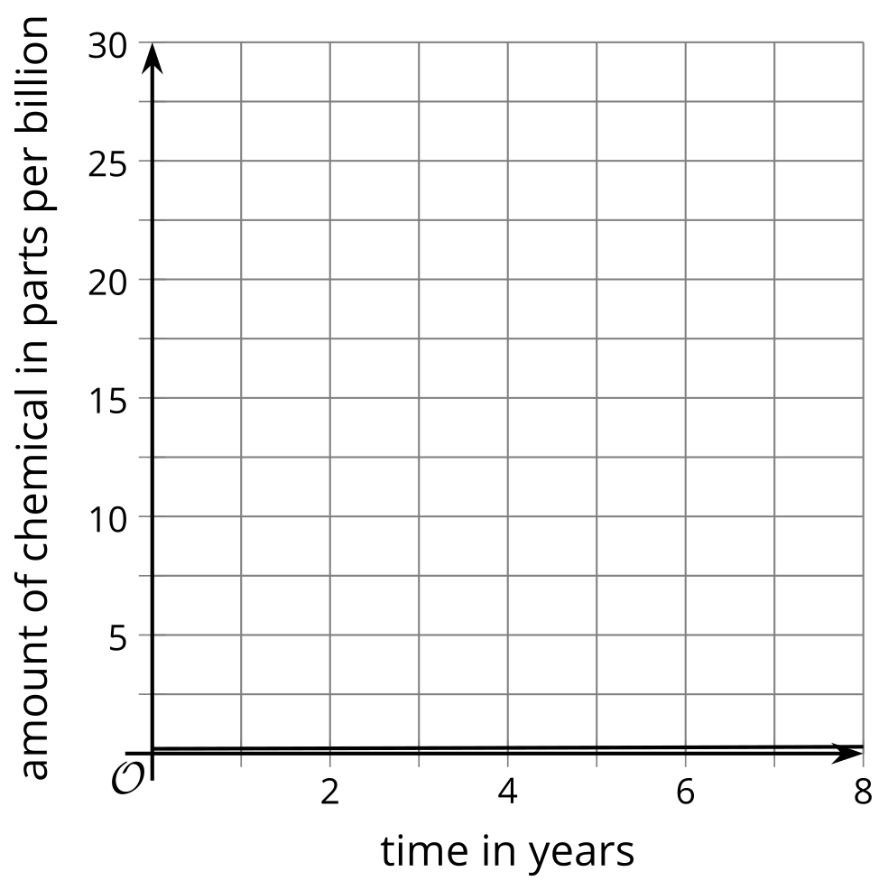

C
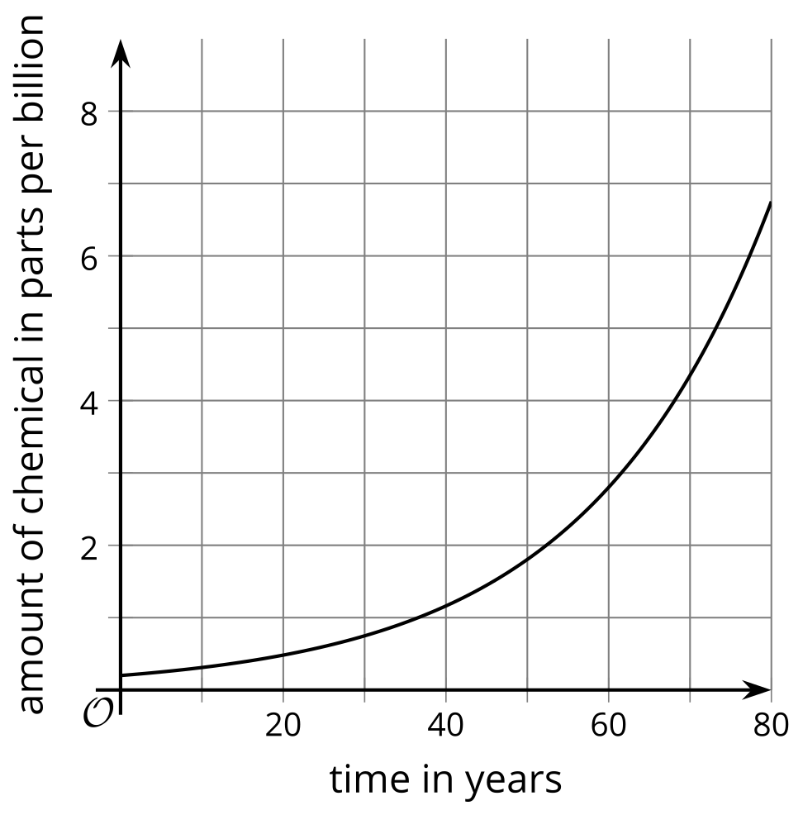

D
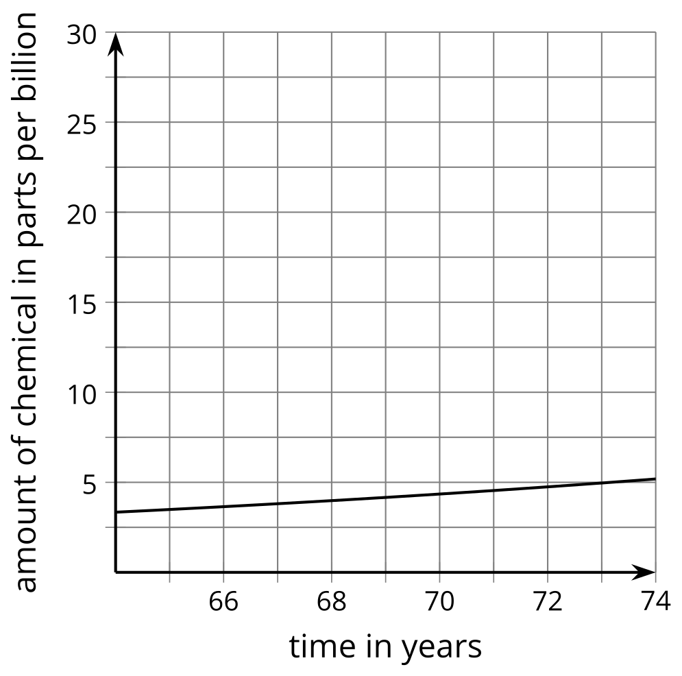
- Here is Graph A, with rectangles approximating the graphing windows of B, C, and D superimposed. Which rectangle matches which graph?
- 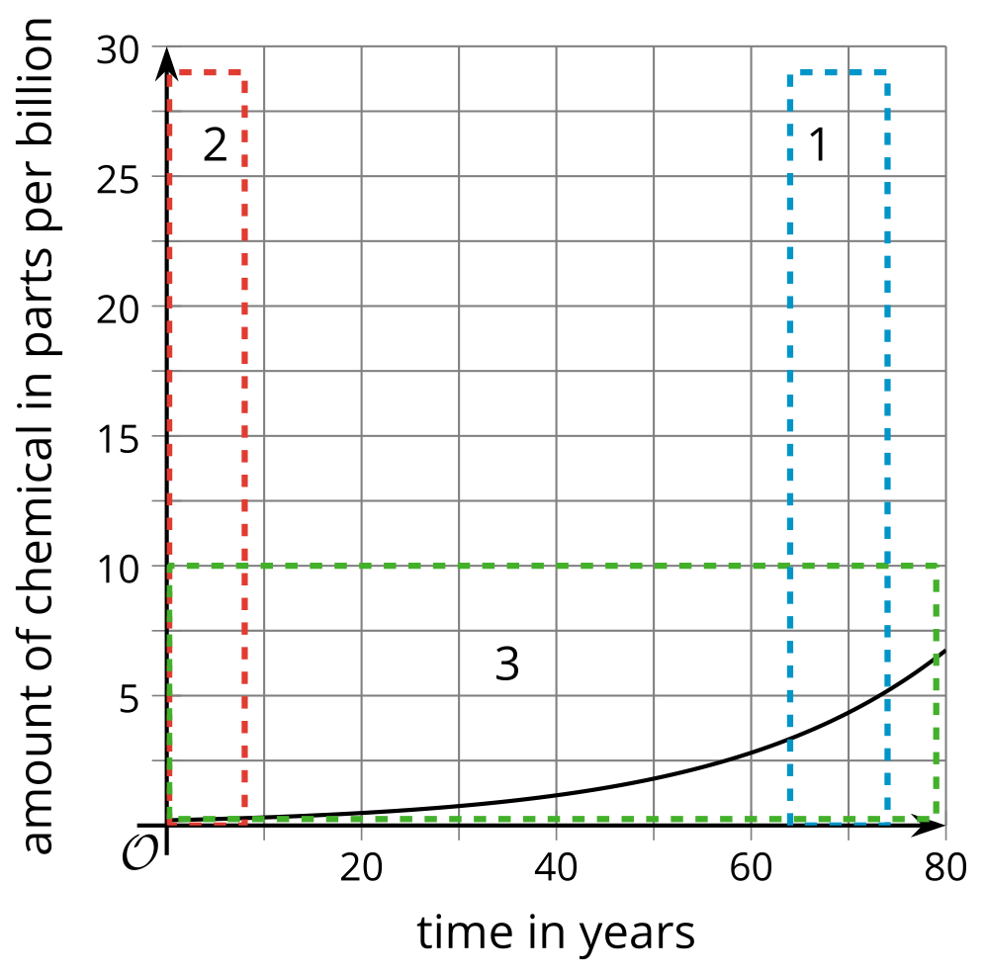
- Use graphing technology to create a graph of $f\left(x\right)=0.2⋅{\left(1.045\right)}^{x}$. Practice adjusting the graphing window so your graph looks like A, B, C, and D.
- Imagine you are a public health official worried about this model, and you want to convince others that they should be worried, too. Which graphing window would you use, and why?
- Imagine you are a public relations official for the company responsible for the chemical in the drinking water, and you want to convince others not to worry. Which graphing window would you use, and why?
- What questions should a journalist writing about the issue ask each person about their graphs, and which graph should she publish with the article?

3 Renting a Car

Student Task Statement
Suppose $y=0.50d+4$ represents the cost of renting a car, $y$, as a function of miles driven, $d$. Here’s a graph representing the function.
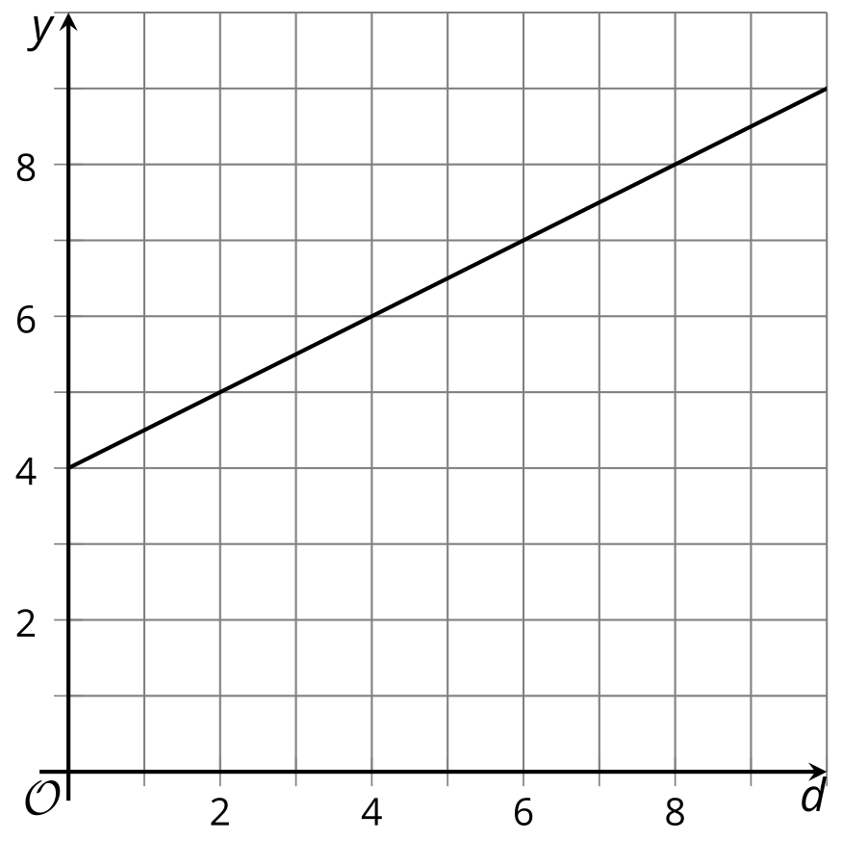
- What is the graphing window used for the given graph?
- Find a graphing window so that:
  - It gives the impression that the charge per mile driven is very high and the total rental cost gets really expensive really fast.
  - It gives the impression that the charge for every mile driven is close to nothing and the total rental cost will be pretty low even if the car is driven many miles.
© CC BY 2019 by Illustrative Mathematics®

