Lesson 3: Representing Proportional Relationships
Let's graph proportional relationships.

3.1: Number Talk: Multiplication
Find the value of each product mentally.
$15⋅2$
$15⋅0.5$
$15⋅0.25$
$15⋅\left(2.25\right)$

3.2: Representations of Proportional Relationships
- Here are two ways to represent a situation.
- Description:
- Jada and Noah counted the number of steps they took to walk a set distance. To walk the same distance, Jada took 8 steps while Noah took 10 steps. Then they found that when Noah took 15 steps, Jada took 12 steps.
- Equation:
- Let $x$ represent the number of steps Jada takes and let $y$ represent the number of steps Noah takes. $y=\frac{5}{4}x$
  - Create a table that represents this situation with at least 3 pairs of values.
  - Graph this relationship and label the axes.
  - 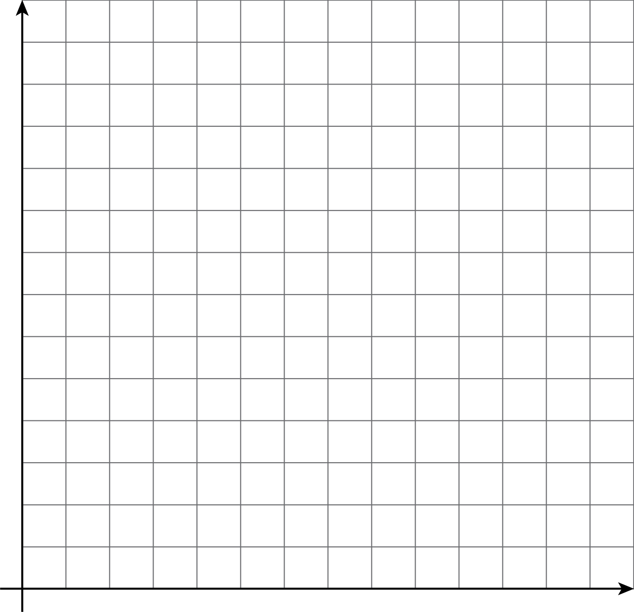
  - How can you see or calculate the constant of proportionality in each representation? What does it mean?
  - Explain how you can tell that the equation, description, graph, and table all represent the same situation.
- Here are two ways to represent a situation.
- Description:
- The Origami Club is doing a car wash fundraiser to raise money for a trip. They charge the same price for every car. After 11 cars, they raised a total of $93.50. After 23 cars, they raised a total of $195.50.
- Table:
- number of  cars | - amount raised  in dollars
- 11 | - 93.50
- 23 | - 195.50
  - Write an equation that represents this situation. (Use $c$ to represent number of cars and use $m$ to represent amount raised in dollars.)
  - Create a graph that represents this situation.
  - 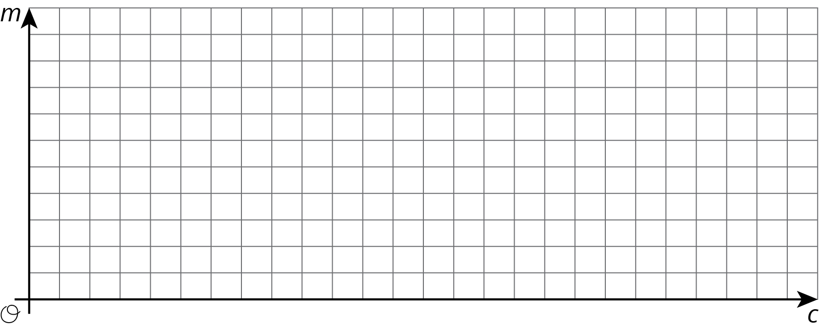
  - How can you see or calculate the constant of proportionality in each representation? What does it mean?
  - Explain how you can tell that the equation, description, graph, and table all represent the same situation.

3.3: Info Gap: Proportional Relationships
Your teacher will give you either a problem card or a data card. Do not show or read your card to your partner.
If your teacher gives you the problem card:
- Silently read your card and think about what information you need to be able to answer the question.
- Ask your partner for the specific information that you need.
- Explain how you are using the information to solve the problem.
- Continue to ask questions until you have enough information to solve the problem.
- Share the problem card and solve the problem independently.
- Read the data card and discuss your reasoning.
If your teacher gives you the data card:
- Silently read your card.
- Ask your partner “What specific information do you need?” and wait for them to ask for information.
- If your partner asks for information that is not on the card, do not do the calculations for them. Tell them you don’t have that information.
- Before sharing the information, ask “Why do you need that information?” Listen to your partner’s reasoning and ask clarifying questions.
- Read the problem card and solve the problem independently.
- Share the data card and discuss your reasoning.
Pause here so your teacher can review your work. Ask your teacher for a new set of cards and repeat the activity, trading roles with your partner.

Are you ready for more?
Ten people can dig five holes in three hours. If $n$ people digging at the same rate dig $m$ holes in $d$ hours:
- Is $n$ proportional to $m$ when $d=3$?
- Is $n$ proportional to $d$ when $m=5$?
- Is $m$ proportional to $d$ when $n=10$?

Lesson 3 Summary
Proportional relationships can be represented in multiple ways. Which representation we choose depends on the purpose. And when we create representations we can choose helpful values by paying attention to the context. For example, a stew recipe calls for 3 carrots for every 2 potatoes. One way to represent this is using an equation. If there are $p$ potatoes and $c$ carrots, then $c=\frac{3}{2}p$.
Suppose we want to make a large batch of this recipe for a family gathering, using 150 potatoes. To find the number of carrots we could just use the equation: $\frac{3}{2}⋅150=225$ carrots.
Now suppose the recipe is used in a restaurant that makes the stew in large batches of different sizes depending on how busy a day it is, using up to 300 potatoes at at time.
Then we might make a graph to show how many carrots are needed for different amounts of potatoes. We set up a pair of coordinate axes with a scale from 0 to 300 along the horizontal axis and 0 to 450 on the vertical axis, because $450=\frac{3}{2}⋅300$. Then we can read how many carrots are needed for any number of potatoes up to 300.
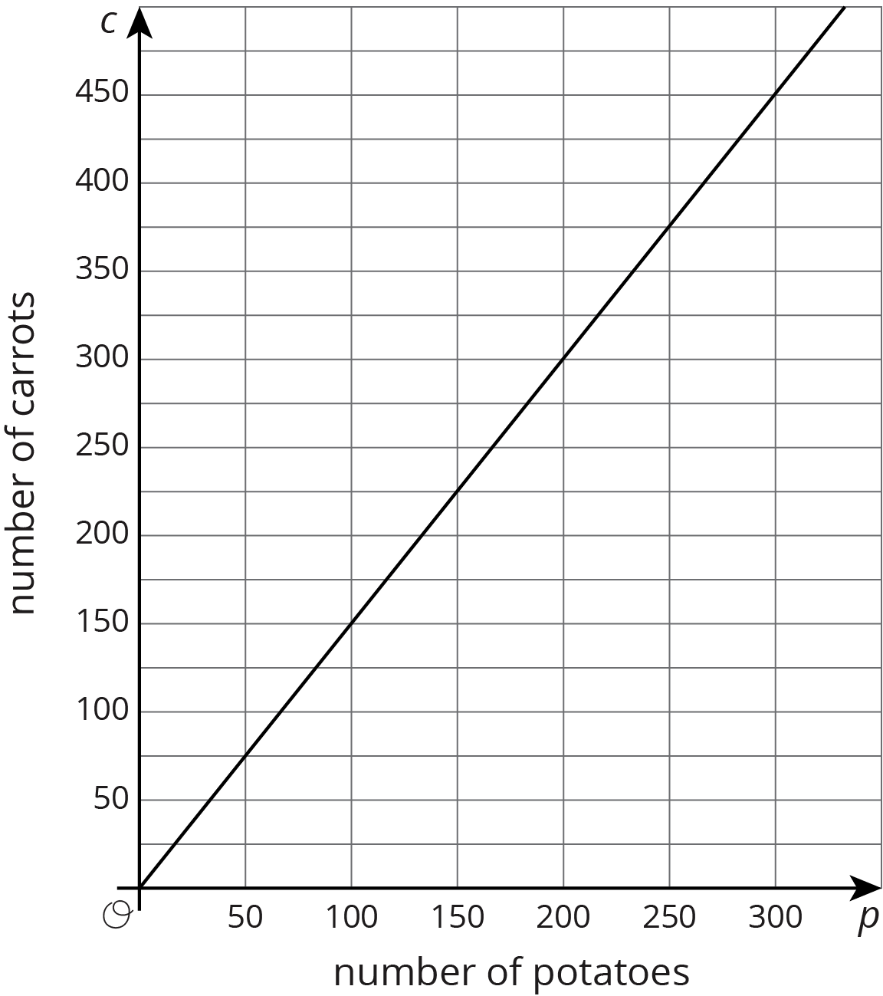
Or if the recipe is used in a food factory that produces very large quantities and the potatoes come in bags of 150, we might just make a table of values showing the number of carrots needed for different multiplies of 150.
number of potatoes | number of carrots
150 | 225
300 | 450
450 | 675
600 | 900
No matter the representation or the scale used, the constant of proportionality, $\frac{3}{2}$, is evident in each. In the equation it is the number we multiply $p$ by; in the graph, it is the slope; and in the table, it is the number we multiply values in the left column to get numbers in the right column. We can think of the constant of proportionality as a rate of change of $c$ with respect to $p$. In this case the rate of change is $\frac{3}{2}$ carrots per potato.
© CC BY Open Up Resources. Adaptations CC BY IM.

