Grade 6
Unit 9Lesson 3CC BY NC Illustrative Mathematics, based on IM 6–8 Math, CC BY Open Up Resources.
Unit 9, Lesson 3

Making Paper
Let's decide what material to make paper from.
Grade 6
Unit 9Lesson 3CC BY NC Illustrative Mathematics, based on IM 6–8 Math, CC BY Open Up Resources.

3.1Notice and Wonder: Paper Sources
What do you notice? What do you wonder?
 | tree fiber | recycled material
energy consumption (kWh) | 4 | 2
carbon dioxide (CO₂) emission (lb) | 9 | 4
Grade 6
Unit 9Lesson 3CC BY NC Illustrative Mathematics, based on IM 6–8 Math, CC BY Open Up Resources.

3.2Sources of Paper Products
The table shows the environmental effect of making one pound of plain paper using only tree fiber compared to using only recycled material.
 | tree fiber | recycled material
energy consumption (kWh) | 4 | 2
carbon dioxide (CO₂) emission (lb) | 9 | 4
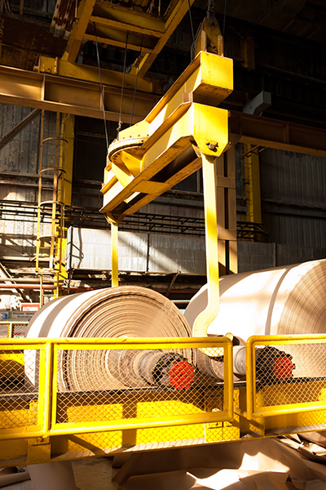
A paper company has two mills that produce the same amount of paper. Mill A uses only tree fiber. Mill B uses only recycled material. Each day, the two mills used a total of 9,000 kWh of energy for their paper production.
- How many pounds of paper did each mill produce? How many pounds did they produce in total?
- How much carbon dioxide did the two mills emit in total?
- Suppose Mill A is converted to use only recycled material.
  - If the mills still produce the same amount of paper as before, how would their total energy use change?
  - How would their carbon dioxide emission change?
  - Should Mill A change to only recycled materials? Explain your reasoning.

