Grade 2
Unit 4Lesson 9CC BY NC 2024 Illustrative Mathematics®
Unit 4, Lesson 9

The Difference between Numbers
- Let’s represent ways to subtract on the number line.
Grade 2
Unit 4Lesson 9CC BY NC 2024 Illustrative Mathematics®

Warm-up Number Talk: Add To
Find the value of each expression mentally.
- $20−2$
- $20−17$
- $49−3$
- $67−64$
Grade 2
Unit 4Lesson 9CC BY NC 2024 Illustrative Mathematics®

Activity 1 Add or Subtract
- What number makes this equation true? _____
- $38−4=?$
- Show your thinking using the number line.
- What number makes this equation true? _____
- $75−68=?$
- Show your thinking using the number line.
- What number makes this equation true? _____
- $57−24=?$
- Show your thinking using the number line.
Grade 2
Unit 4Lesson 9CC BY NC 2024 Illustrative Mathematics®

Activity 2 Different Ways to Find the Difference
- Elena’s string is much too long. The string is 65 inches long. Elena cuts 33 inches off the length. How long is the string now?
- Choose 2 number lines that show a way to find the length of Elena’s string.
  - 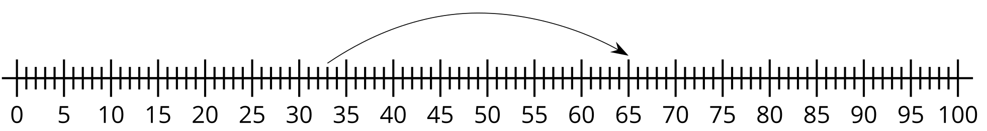
  - 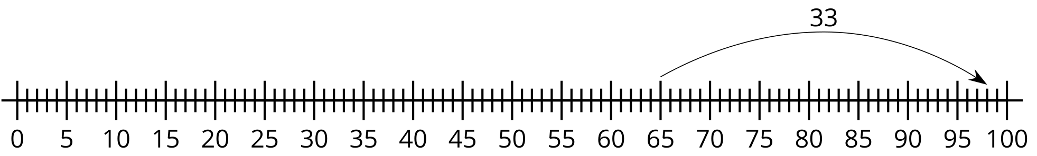
  - 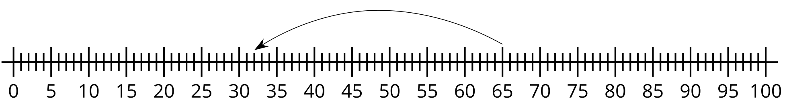
- Han has 87 inches of string. He cuts off 85 inches of it. How much string does he have left?
  - Write an equation to represent the problem. Use a ? for the unknown.
  - Find the number that makes the equation true.
  - Show your thinking using the number line.
- Find someone who used a different method.
- Show their method on the number line.

