Grade 6
Unit 3Lesson 10CC BY NC Illustrative Mathematics, based on IM 6–8 Math, CC BY Open Up Resources.
Unit 3, Lesson 10

What Are Percentages?
Let’s learn about percentages.
Grade 6
Unit 3Lesson 10CC BY NC Illustrative Mathematics, based on IM 6–8 Math, CC BY Open Up Resources.

10.1A Large Square of 100 Square Units
- A large square represents an area of 100 square units. How many square units are shaded in each diagram?
- A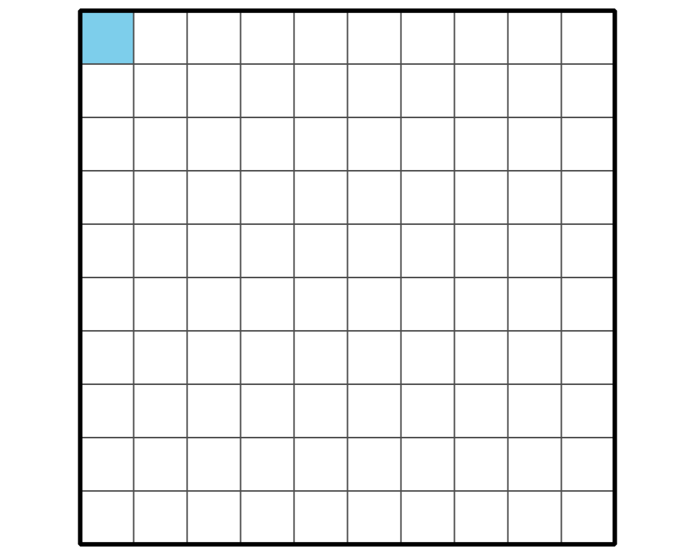
- B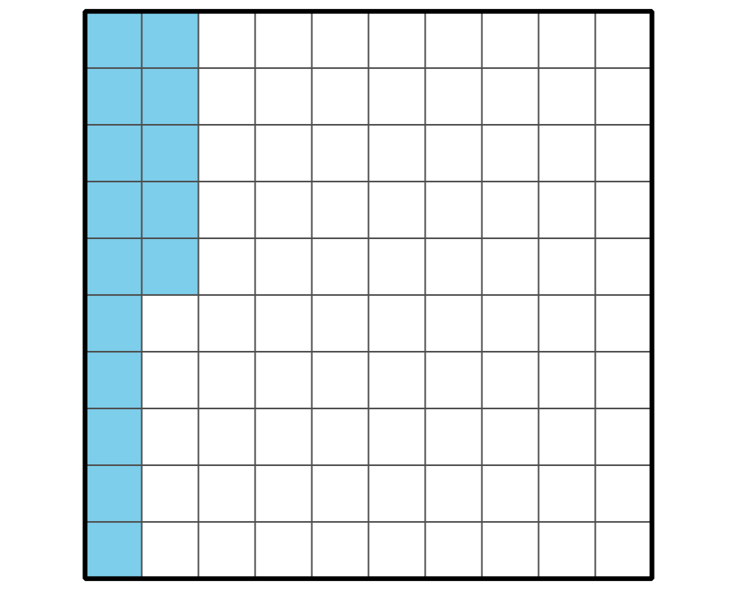
- C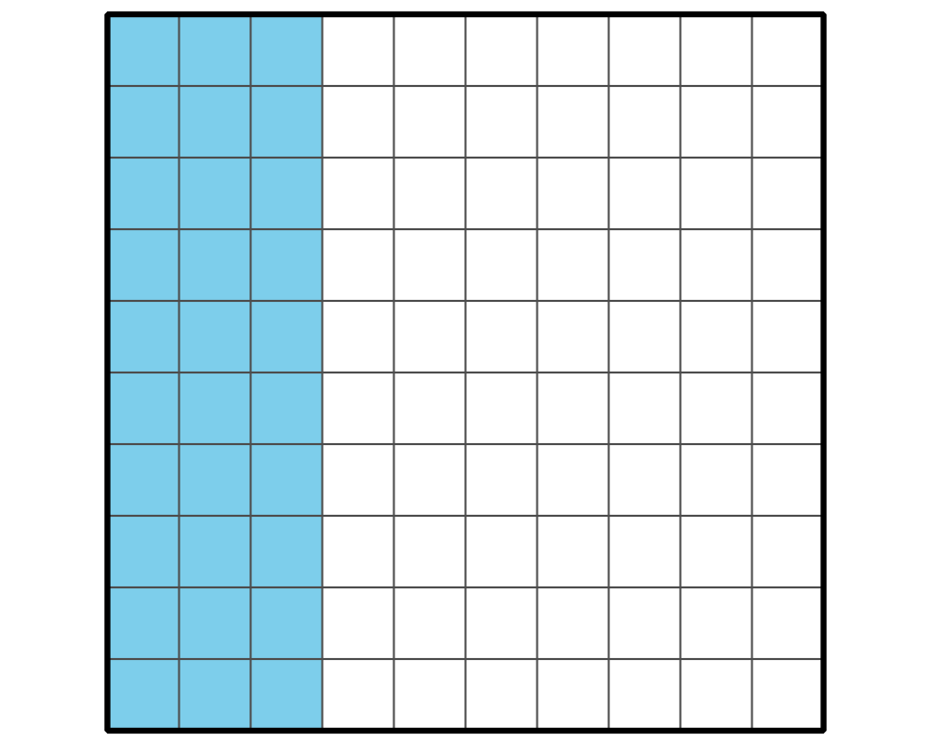
- D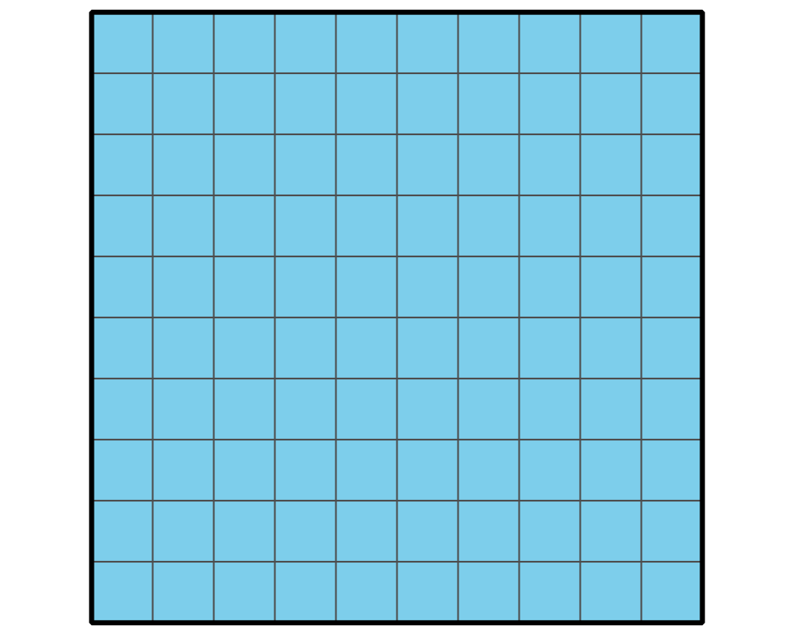
- E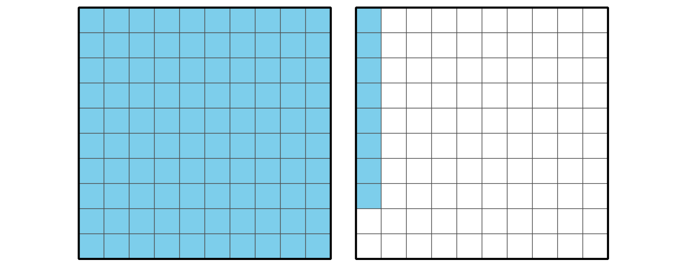
- Pause here so your teacher can review your work.
- We can say that “1 percent of the large square” is shaded in Diagram A and “15 percent of the large square” is shaded in Diagram B.
- Shade 50 percent of the area of the large square.
- 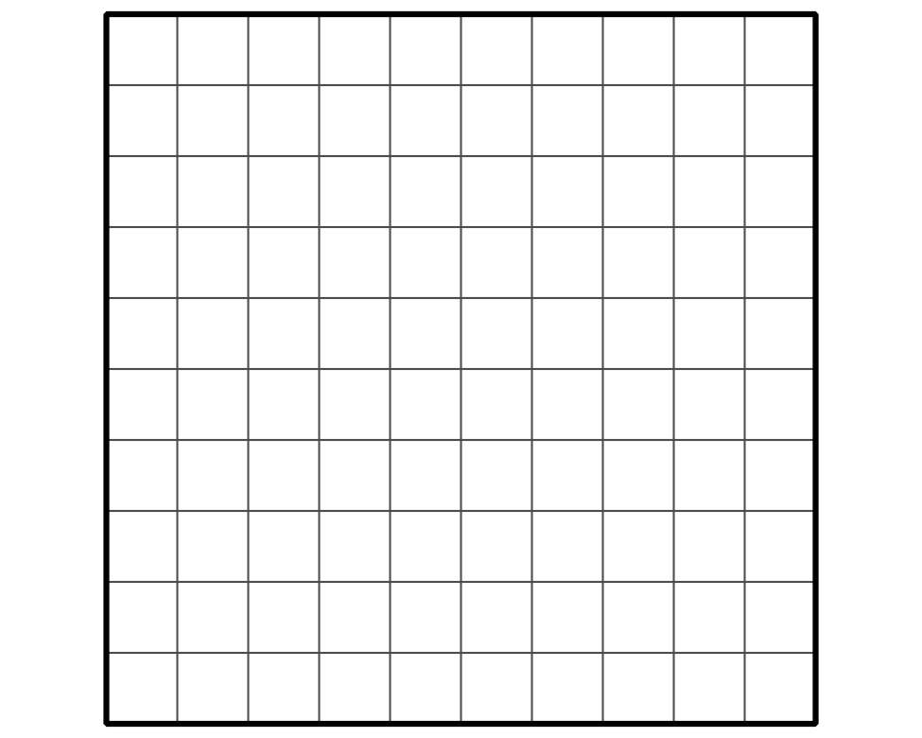
Grade 6
Unit 3Lesson 10CC BY NC Illustrative Mathematics, based on IM 6–8 Math, CC BY Open Up Resources.

10.2Coins
Here are the names and values of some U.S. coins.
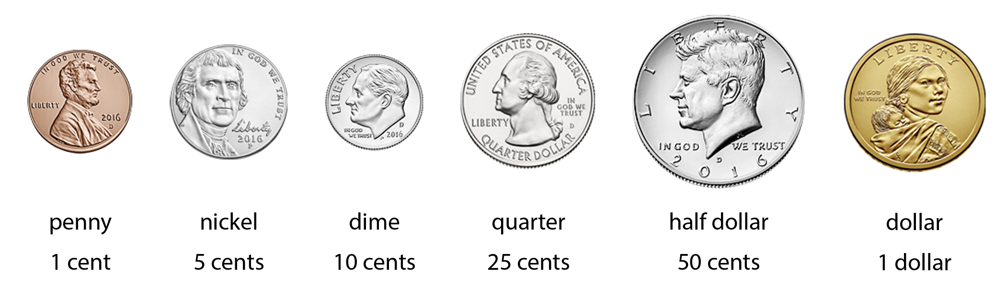
Here are some ways to describe the coins’ values using percent (%):
- The value of a dime is 10 percent of a dollar.
- The value of a quarter is 25 percent of a dollar.
- The value of 5 dimes is 50 percent of a dollar.
- Describe the value of each coin using “percent of a dollar.”
  - A penny
  - A nickel
  - A half dollar
  - A dollar
- Jada has two coin collections. Each collection has the same type of coins.
  - Her first collection of coins is worth 105 percent of a dollar. What is the value of this collection?
  - Her second collection of coins is worth $2.00. What percent of a dollar is that?
- Write a definition for “percent” based on your understanding now.

Are you ready for more?
Find two different sets of coins that each make 120% of a dollar, where no type of coin is in both sets.
Grade 6
Unit 3Lesson 10CC BY NC Illustrative Mathematics, based on IM 6–8 Math, CC BY Open Up Resources.

10.3Coins on a Double Number Line Diagram
Double number line diagrams can help us think about percentages.
- Here is a diagram that can represent the value of money as a percentage of a dollar.
- 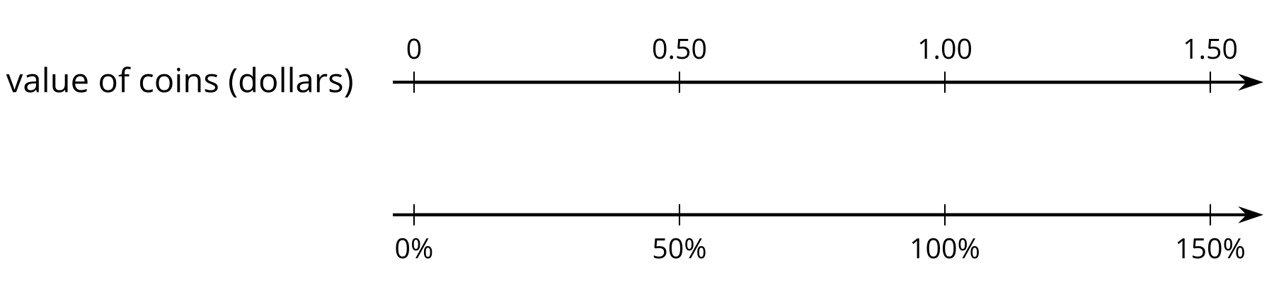
  - The value of 2 quarters is 50 percent of a dollar. How can you see that in the diagram?
  - Label the diagram to show the values of 1 quarter and 3 quarters. What percent are they of a dollar?
- For each question, use the double number line diagram to show your reasoning.
  - Clare has 6 dimes in her pocket. What percentage of a dollar does she have?
  - 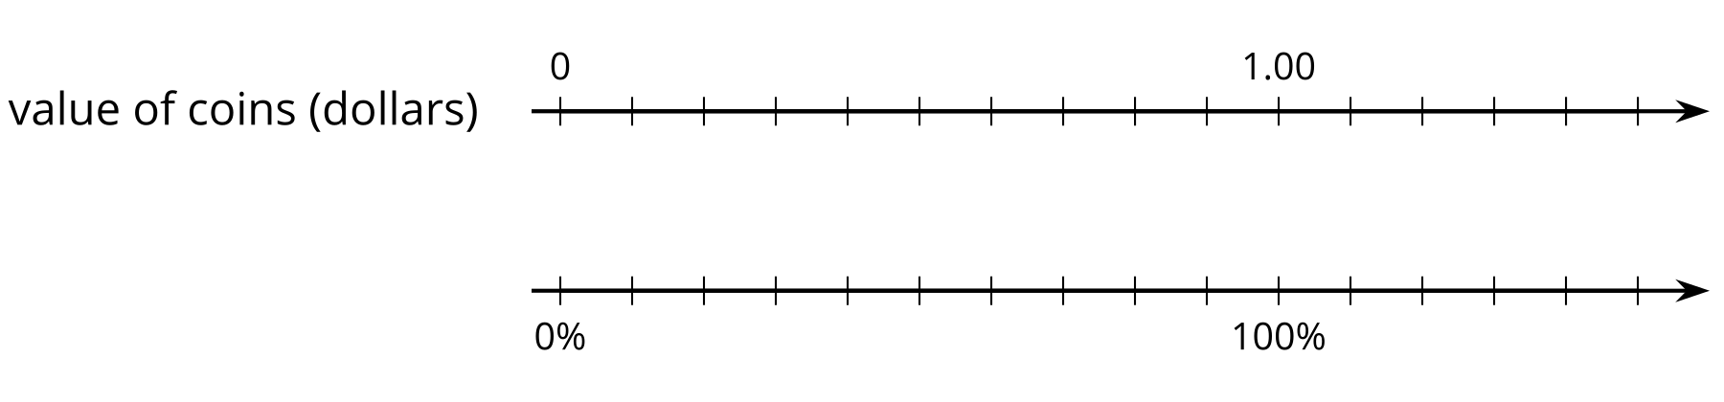
  - Han has 6 quarters in his pocket. What percentage of a dollar does he have?
  - 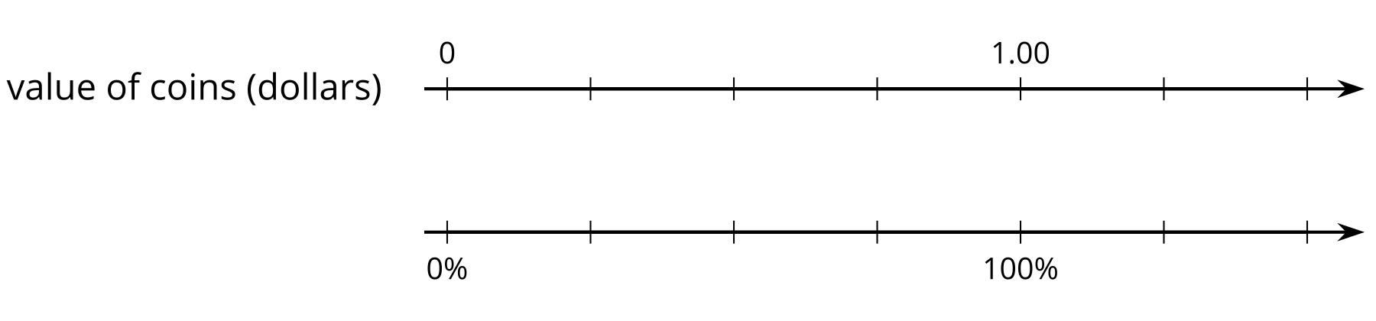
  - Which has a greater value: 8 nickels or 40% of a dollar?

Lesson 10 Summary
Percent means “per 100.” A percentage is a rate per 100.
We can use percentages to describe the relationship between two quantities. For instance:
- The value of a quarter is 25 percent of a dollar because there are 25 cents in a quarter per 100 cents in a dollar. The ratio of their values is 25 to 100.
- The value of a half-dollar coin is 50 percent of a dollar because there are 50 cents in a half-dollar coin per 100 cents in a dollar. The ratio of their values is 50 to 100.
- The value of five quarters is 125 percent of a dollar because there are 125 cents in five quarters per 100 cents in a dollar. The ratio of their values is 125 to 100.
Here is a double number line diagram that can represent these coin values. Because we’re representing percentages of a dollar, 100% is aligned to $1 on the number line.
