Grade 2
Unit 6Lesson 11CC BY NC 2024 Illustrative Mathematics®
Unit 6, Lesson 11

Tell Time with Halves and Quarters
- Let’s tell time with halves and quarters.
Grade 2
Unit 6Lesson 11CC BY NC 2024 Illustrative Mathematics®

Warm-up What Do You Know about Ways to Tell Time?
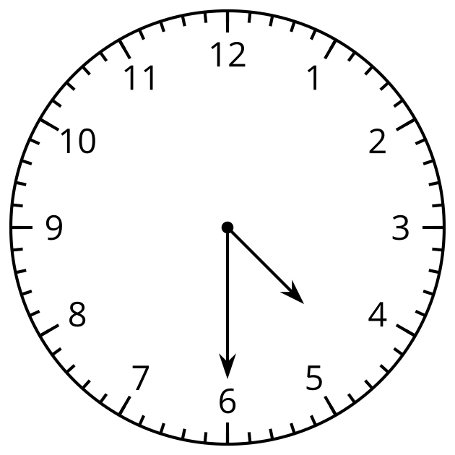
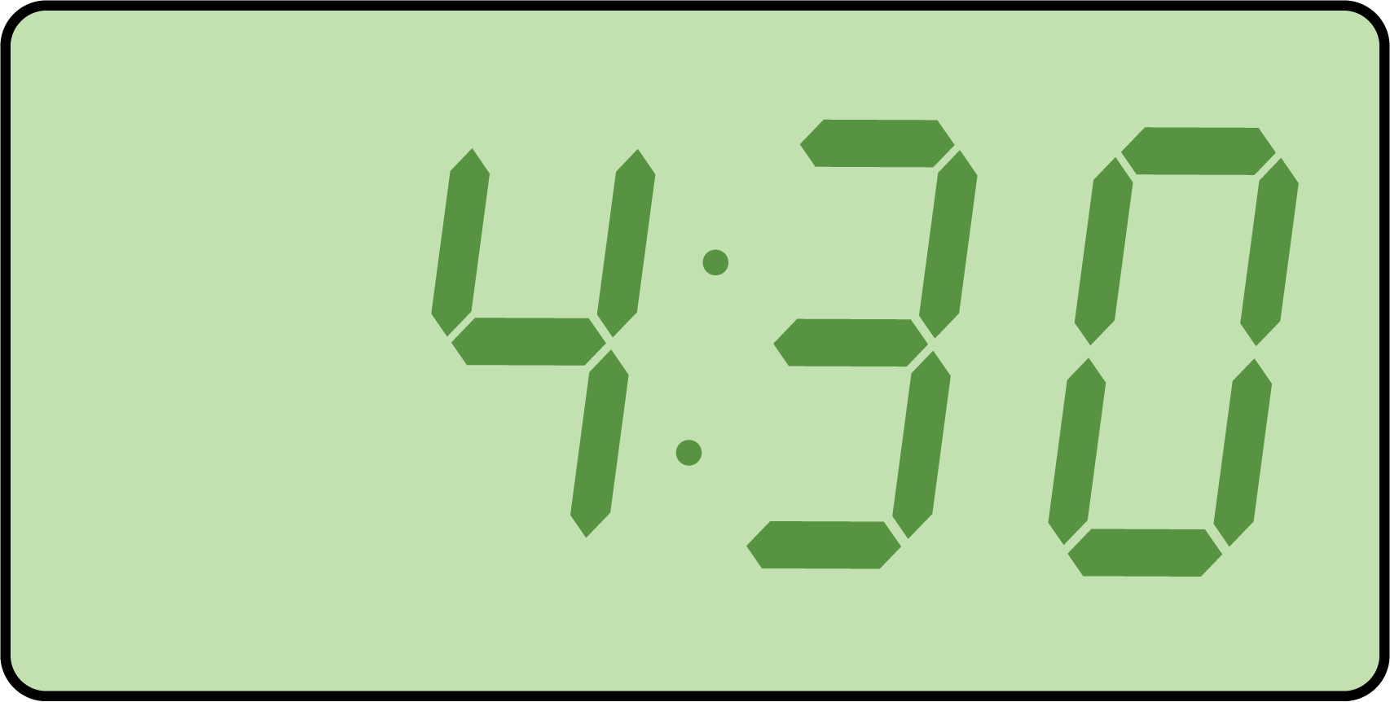
What do you know about telling time? What words do you use to talk about time?
Grade 2
Unit 6Lesson 11CC BY NC 2024 Illustrative Mathematics®

Activity 1Tell Time to the Hour and Half Hour
- Circle the clock that shows 4 o’clock.
- 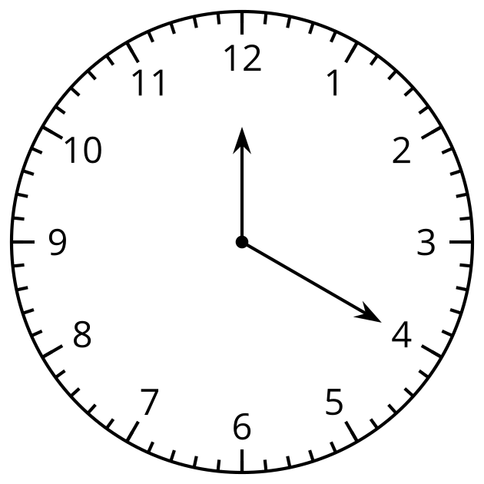
- 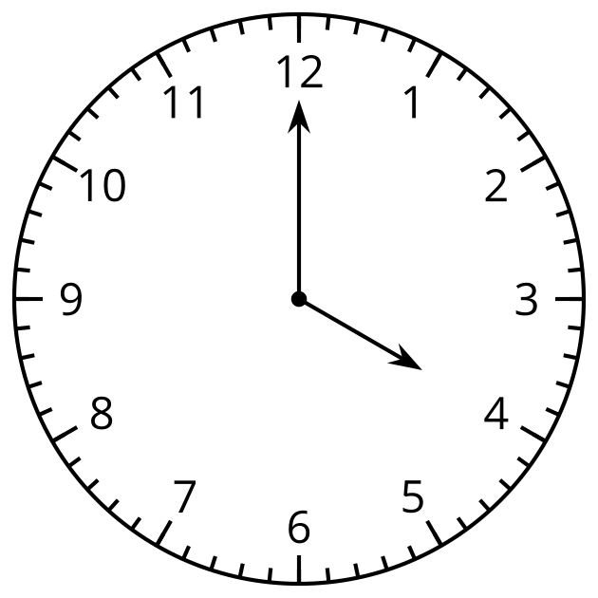
- Why doesn’t the other clock show 4 o’clock? Explain your reasoning.
- Circle the clock that shows half past 7.
- 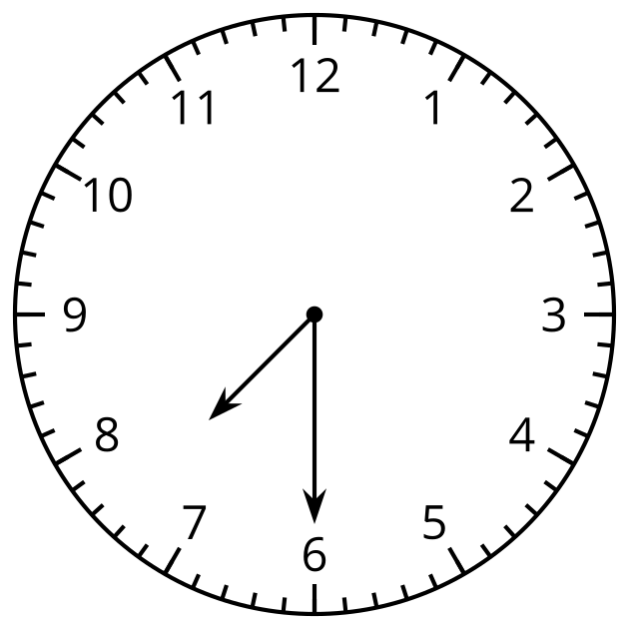
- 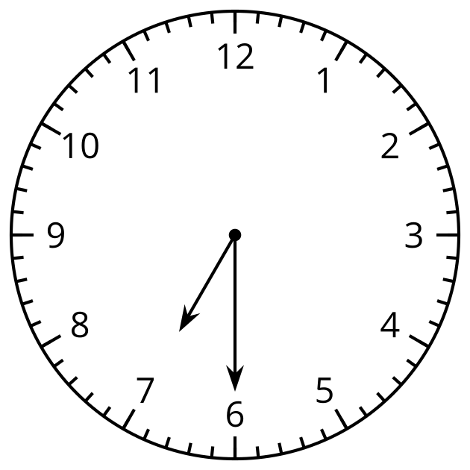
- Why doesn’t the other clock show half past 7? Explain your reasoning.
- Draw hands on the clock to show 10:00.
- 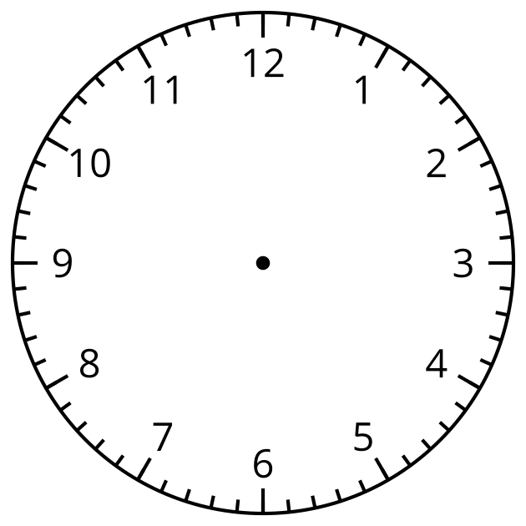
- Draw hands on the clock to show 1:30.
Grade 2
Unit 6Lesson 11CC BY NC 2024 Illustrative Mathematics®

Activity 2Card Sort: Halves and Quarters
- Your teacher will give you a set of cards. Match each clock face with a circle and a phrase. Be ready to explain your reasoning.
- Write the time shown on each clock. Use the words “half past,” “quarter past,” or “quarter till.”

  - 

   