Lesson 1: What Attributes Do You See?

Standards Alignments
Addressing | 3.G.A.1
Building Towards | 3.G.A.1

Teacher-facing Learning Goals
- Describe attributes of shapes.
- Sort shapes based on attributes in a way that makes sense to them.

Student-facing Learning Goals
- Let’s sort shapes into groups.

Lesson Purpose
The purpose of this lesson is for students to sort shapes into categories based on their attributes.
In previous grades, students sorted shapes into categories based on the attributes of the shape. In this lesson, students revisit this work and learn the terms angle in a shape and right angle in a shape to describe the corners of shapes. This will be helpful in later lessons as students further sort triangles and rectangles by additional attributes. Throughout the lesson, if students have trouble determining if sides have the same length, offer rulers to measure the side lengths.

Access for:

Students with Disabilities
- Representation (Activity 1)

English Learners
- MLR2 (Activity 1)

Instructional Routines
Card Sort (Activity 1), Which One Doesn’t Belong? (Warm-up)

Materials to Copy
- Shape Cards Grade 3 (groups of 2): Activity 1

Lesson Timeline
Warm-up | 10 min
Activity 1 | 35 min
Lesson Synthesis | 10 min
Cool-down | 5 min

Teacher Reflection Question
What part of the lesson went really well today in terms of students’ learning? What did you do that made that part go well?

Cool-down
(to be completed at the end of the lesson) 5min
Tell Me About It

Standards Alignments
Addressing | 3.G.A.1

Student-facing Task Statement
Select all the statements that are true about the shape.
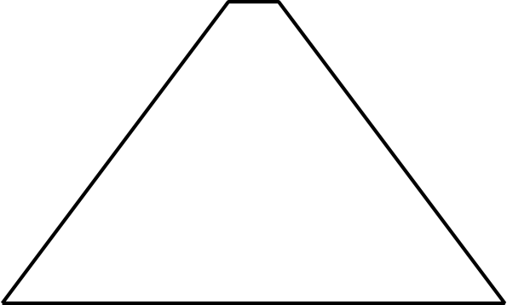
- The shape has 3 sides.
- The shape has 4 sides.
- The shape has 5 sides.
- The shape has a right angle.
- None of the sides are the same length.
- Two of the sides are the same length.
- All of the sides are the same length.

Student Responses
B, F

