Lesson 15: Más factores, más problemas

Standards Alignments
Addressing | 3.OA.A.3, 3.OA.A.4, 3.OA.D.9
Building Towards | 3.OA.C.7

Teacher-facing Learning Goals
- Solve multiplication problems.

Student-facing Learning Goals
- Resolvamos más problemas de multiplicación.

Lesson Purpose
The purpose of this lesson is for students to solve multiplication problems.
Students write equations with a symbol for the unknown to represent multiplication problems and then solve the problems. As in the previous lesson, some problems are unknown factor problems which students do not relate to division until a future unit. Students put together what they have learned about drawings, diagrams, expressions, and equations to solve multiplication problems.
This lesson has a Student Section Summary.

Access for:

Students with Disabilities
- Engagement (Activity 1)

English Learners
- MLR8 (Activity 2)

Instructional Routines
Number Talk (Warm-up)

Lesson Timeline
Warm-up | 10 min
Activity 1 | 15 min
Activity 2 | 20 min
Lesson Synthesis | 10 min
Cool-down | 5 min

Teacher Reflection Question
As students worked in their small-groups today, whose ideas were heard, valued, and accepted? How can you adjust the group structure tomorrow to ensure each student’s ideas are a part of the collective learning?

Cool-down
(to be completed at the end of the lesson) 5min
Resuelve el problema

Standards Alignments
Addressing | 3.OA.A.3

Student-facing Task Statement
Resuelve cada problema. Explica o muestra tu razonamiento.
- Hay 4 cajas. En cada caja hay 10 juguetes. ¿Cuántos juguetes hay en total?
- Elena tiene 10 calcetines. Los pone en grupos de 2. ¿Cuántos grupos arma?

Student Responses
- 40 toys. Sample response:
- 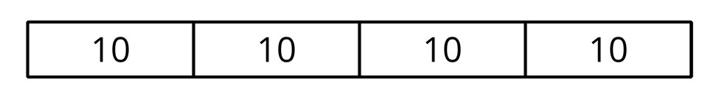
- 5 piles. Sample response: $10=?×2$ I know that $5×2$ is 10.

