Grade 6
Unit 4Lesson 5CC BY NC Illustrative Mathematics, based on IM 6–8 Math, CC BY Open Up Resources.
Unit 4, Lesson 5

How Many Groups? (Part 2)
Let’s use blocks and diagrams to understand more about division with fractions.
Grade 6
Unit 4Lesson 5CC BY NC Illustrative Mathematics, based on IM 6–8 Math, CC BY Open Up Resources.

5.1Reasoning with Fraction Strips
Write a fraction or whole number as an answer for each question. If you get stuck, use the fraction strips. Be prepared to share your reasoning.
- How many $\frac{1}{2}$s are in 2?
- How many $\frac{1}{5}$s are in 3?
- How many $\frac{1}{8}$s are in $1\frac{1}{4}$?
- $1÷\frac{2}{6}=?$
- $2÷\frac{2}{9}=?$
- $4÷\frac{2}{10}=?$
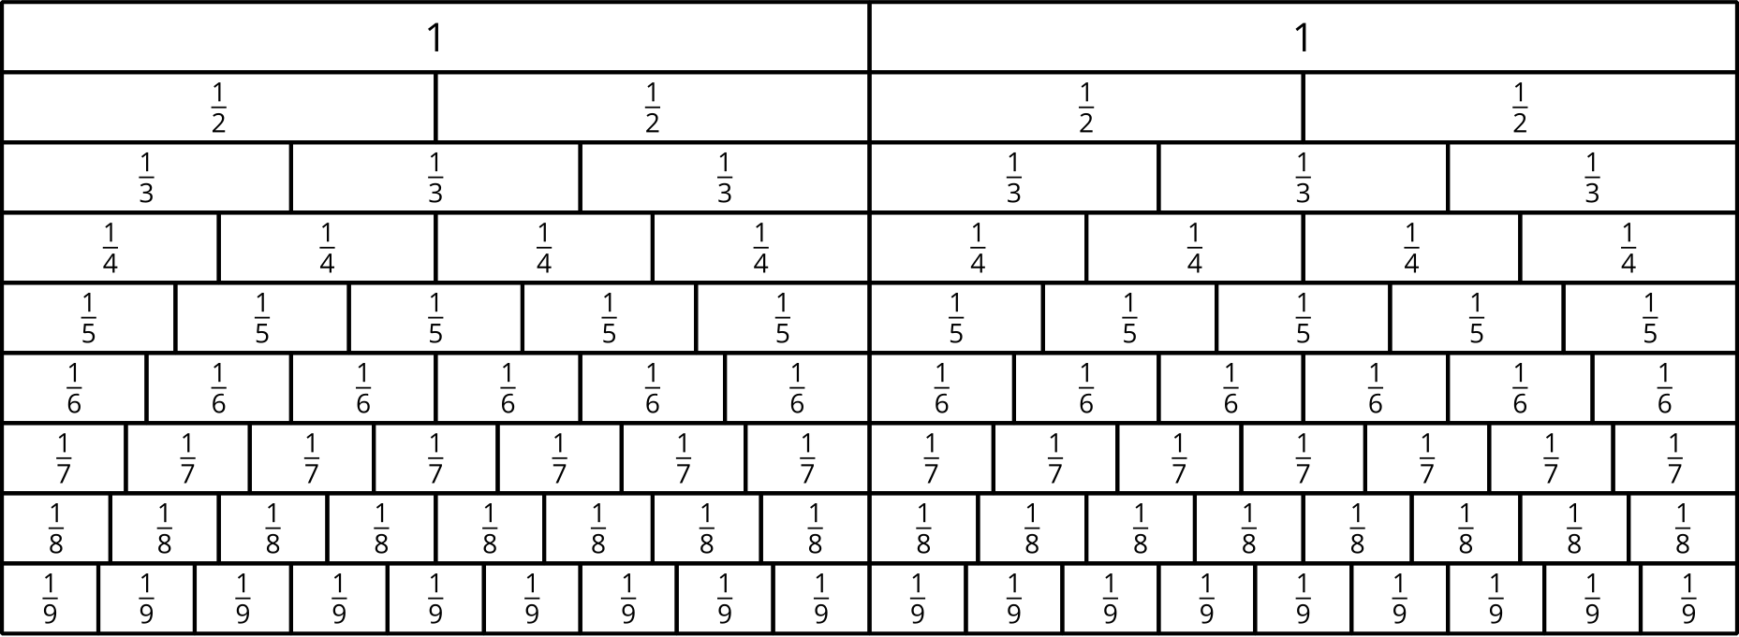

Grade 6
Unit 4Lesson 5CC BY NC Illustrative Mathematics, based on IM 6–8 Math, CC BY Open Up Resources.

5.2More Reasoning with Pattern Blocks
Your teacher will give you pattern blocks. Use them to answer the questions.
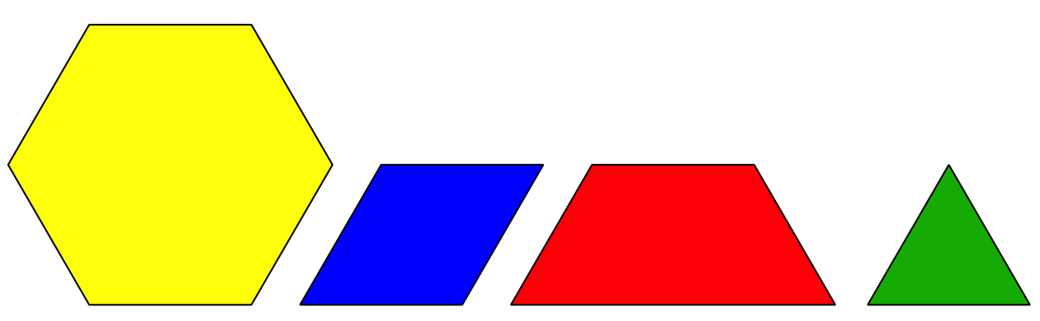
- If the trapezoid represents 1 whole, what does each of the other shapes represent? Be prepared to show or explain your reasoning.
  - 1 triangle
  - 1 rhombus
  - 1 hexagon
- Use pattern blocks to represent each multiplication equation. Use the trapezoid to represent 1 whole. Sketch or trace the blocks to record your representation.
  - $3⋅\frac{1}{3}=1$
  - $3⋅\frac{2}{3}=2$
- Diego and Jada were asked “How many rhombuses are in a trapezoid?”
  - Diego says, “$1\frac{1}{3}$. If I put 1 rhombus on a trapezoid, the leftover shape is a triangle, which is $\frac{1}{3}$ of the trapezoid.”
  - Jada says, “I think it’s $1\frac{1}{2}$. Since we want to find out ‘How many rhombuses . . . ?’ we should compare the leftover triangle to a rhombus. A triangle is $\frac{1}{2}$ of a rhombus.”
- Do you agree with either of them? Explain or show your reasoning.
- Select all the equations that can be used to answer the question: “How many rhombuses are in a trapezoid?”
  - $\frac{2}{3}÷?=1$
  - $?⋅\frac{2}{3}=1$
  - $1÷\frac{2}{3}=?$
  - $1⋅\frac{2}{3}=?$
  - $?÷\frac{2}{3}=1$
Grade 6
Unit 4Lesson 5CC BY NC Illustrative Mathematics, based on IM 6–8 Math, CC BY Open Up Resources.

5.3Drawing Diagrams to Show Equal-size Groups
For each situation:
- Draw a diagram to represent the situation.
- Answer the question.
- Write a multiplication equation or a division equation for the relationship between the quantities.
- The water hose fills a bucket at $\frac{1}{3}$ gallon per minute. How many minutes does it take to fill a 2-gallon bucket?
- The distance around a park is $\frac{3}{2}$ miles. Noah rode his bicycle around the park for a total of 3 miles. How many times around the park did he ride?
- You need $\frac{3}{4}$ yard of ribbon for one gift box. You have 3 yards of ribbon. How many gift boxes do you have ribbon for?

Are you ready for more?
There are 48 level teaspoons in 1 cup. Estimate:
- How many rounded teaspoons are in 1 cup?
- How many scant teaspoons are in 1 cup?
- How many extra-heaped teaspoons are in 1 cup?
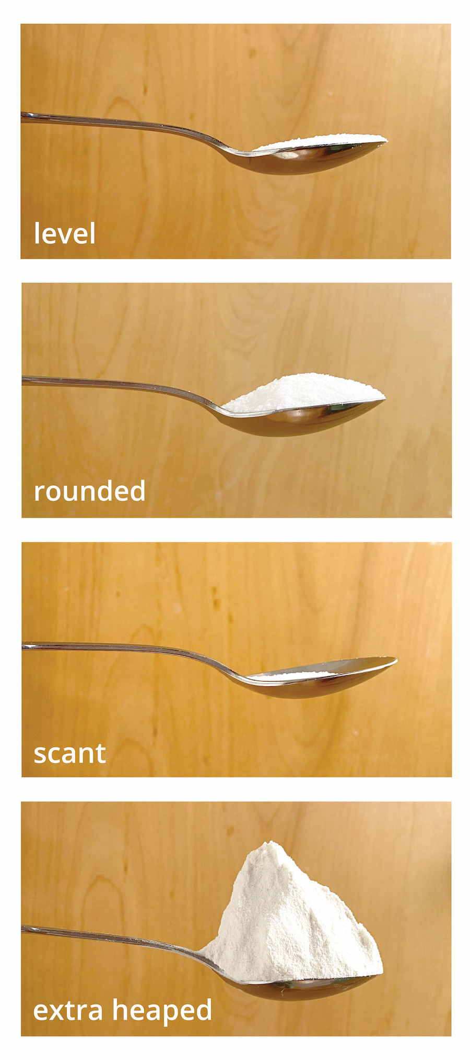

Lesson 5 Summary
Suppose one batch of cookies requires $\frac{2}{3}$ cup of flour. How many batches can be made with 4 cups of flour?
We can think of the question as being: “How many $\frac{2}{3}$s are in 4?” and represent it using multiplication and division equations.
$?⋅\frac{2}{3}=4$
$4÷\frac{2}{3}=?$
Let’s use pattern blocks to visualize the situation and say that a hexagon is 1 whole.
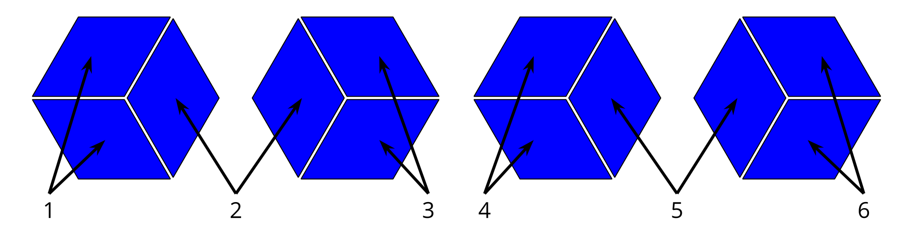
Since 3 rhombuses make a hexagon, 1 rhombus represents $\frac{1}{3}$, and 2 rhombuses represent $\frac{2}{3}$.
We can see that 6 pairs of rhombuses make 4 hexagons, so there are 6 groups of $\frac{2}{3}$ in 4.
Other kinds of diagrams can also help us reason about equal-size groups involving fractions. This example shows how we might reason about the same question asked earlier: “How many $\frac{2}{3}$-cup are in 4 cups?”
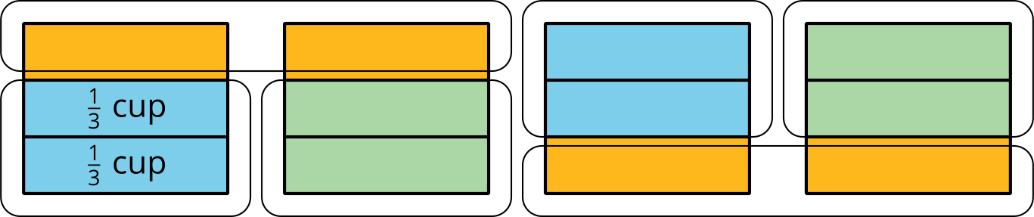
We can see each “cup” partitioned into thirds, and that there are 6 groups of $\frac{2}{3}$-cup in 4 cups. In both diagrams, we see that the unknown value (or the “?” in the equations) is 6. So we can now write:
$6⋅\frac{2}{3}=4$
$4÷\frac{2}{3}=6$

