Grade 6
Unit 1Lesson 18CC BY NC Illustrative Mathematics, based on IM 6–8 Math, CC BY Open Up Resources.
Unit 1, Lesson 18

Surface Area of a Cube
Let’s write a formula to find the surface area of a cube.
Grade 6
Unit 1Lesson 18CC BY NC Illustrative Mathematics, based on IM 6–8 Math, CC BY Open Up Resources.

18.1Math Talk: Expressions and Their Values
Decide mentally which expression has a greater value.
- $12+12+12+12+12$ or $4⋅12$
- $15⋅3$ or ${15}^{3}$
- ${19}^{2}$ or $18⋅18$
- $5⋅{21}^{2}$ or $\left(5⋅21\right)⋅\left(5⋅21\right)$
Grade 6
Unit 1Lesson 18CC BY NC Illustrative Mathematics, based on IM 6–8 Math, CC BY Open Up Resources.

18.2The Net of a Cube
- A cube has an edge length of 5 units.
  - Draw a net for this cube on graph paper. Label its sides with measurements.
  - What is the shape of each face?
  - What is the area of each face?
  - What is the surface area of this cube?
  - What is the volume of this cube?
- A second cube has an edge length of 17 units.
  - Sketch a net for this cube. Label its sides with measurements.
  - Explain why the area of each face of this cube is ${17}^{2}$ square units.
  - Write an expression for the surface area, in square units.
  - Write an expression for the volume, in cubic units.
Grade 6
Unit 1Lesson 18CC BY NC Illustrative Mathematics, based on IM 6–8 Math, CC BY Open Up Resources.

18.3Every Cube in the Whole World
A cube has an edge length of $s$.
- Draw a net for the cube.
- Write an expression for the area of each face. Label each face with its area.
- Write an expression for the surface area.
- Write an expression for the volume.

Lesson 18 Summary
The volume of a cube with an edge length of $s$ is $s^{3}$.
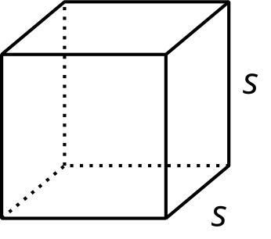
A cube has 6 faces that are all identical squares. For a cube with an edge length of $s$, the area of each square face is $s^{2}$. This means that the surface area of the cube is $6⋅s^{2}$.
