Unit 3 Lesson 9: Slopes Don't Have to be Positive

1 Which One Doesn’t Belong: Odd Line Out (Warm up)

Student Task Statement
Which line doesn’t belong?
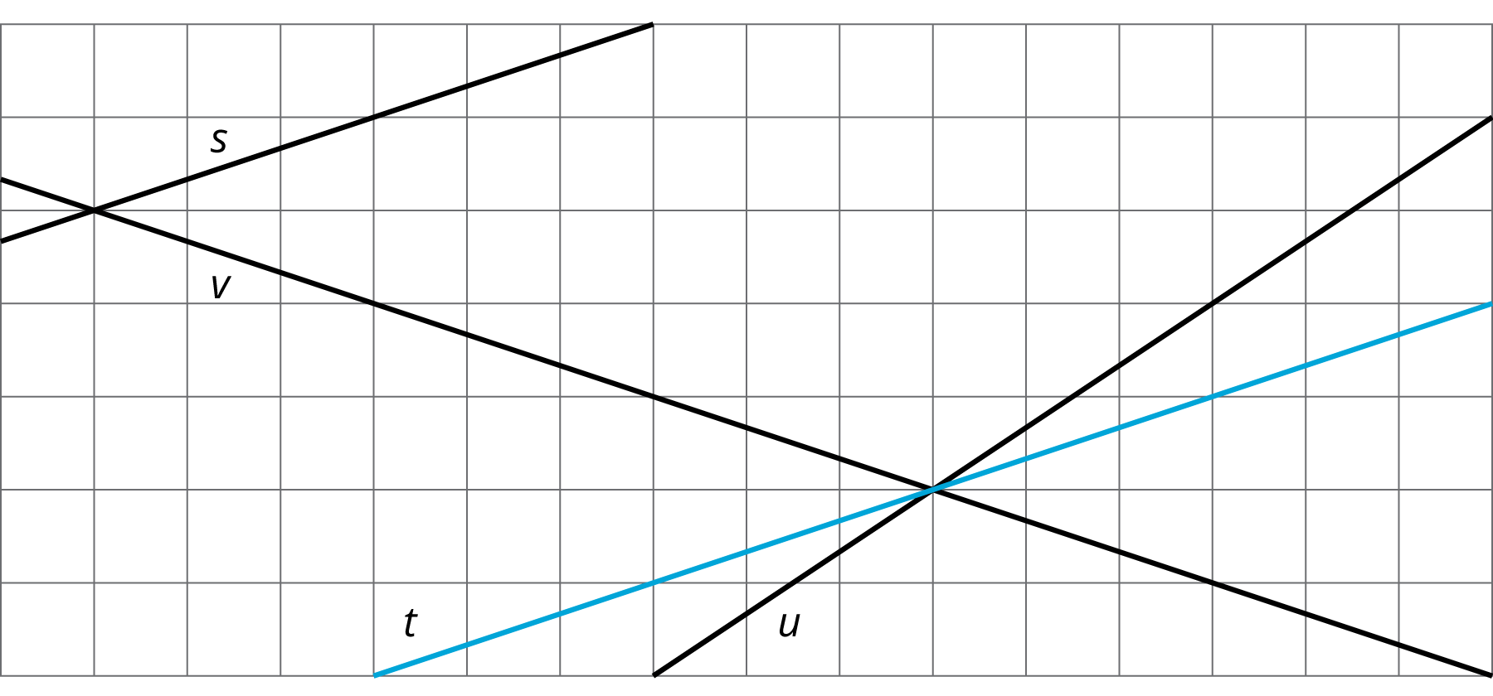

2 Stand Clear of the Closing Doors, Please

Images for Launch

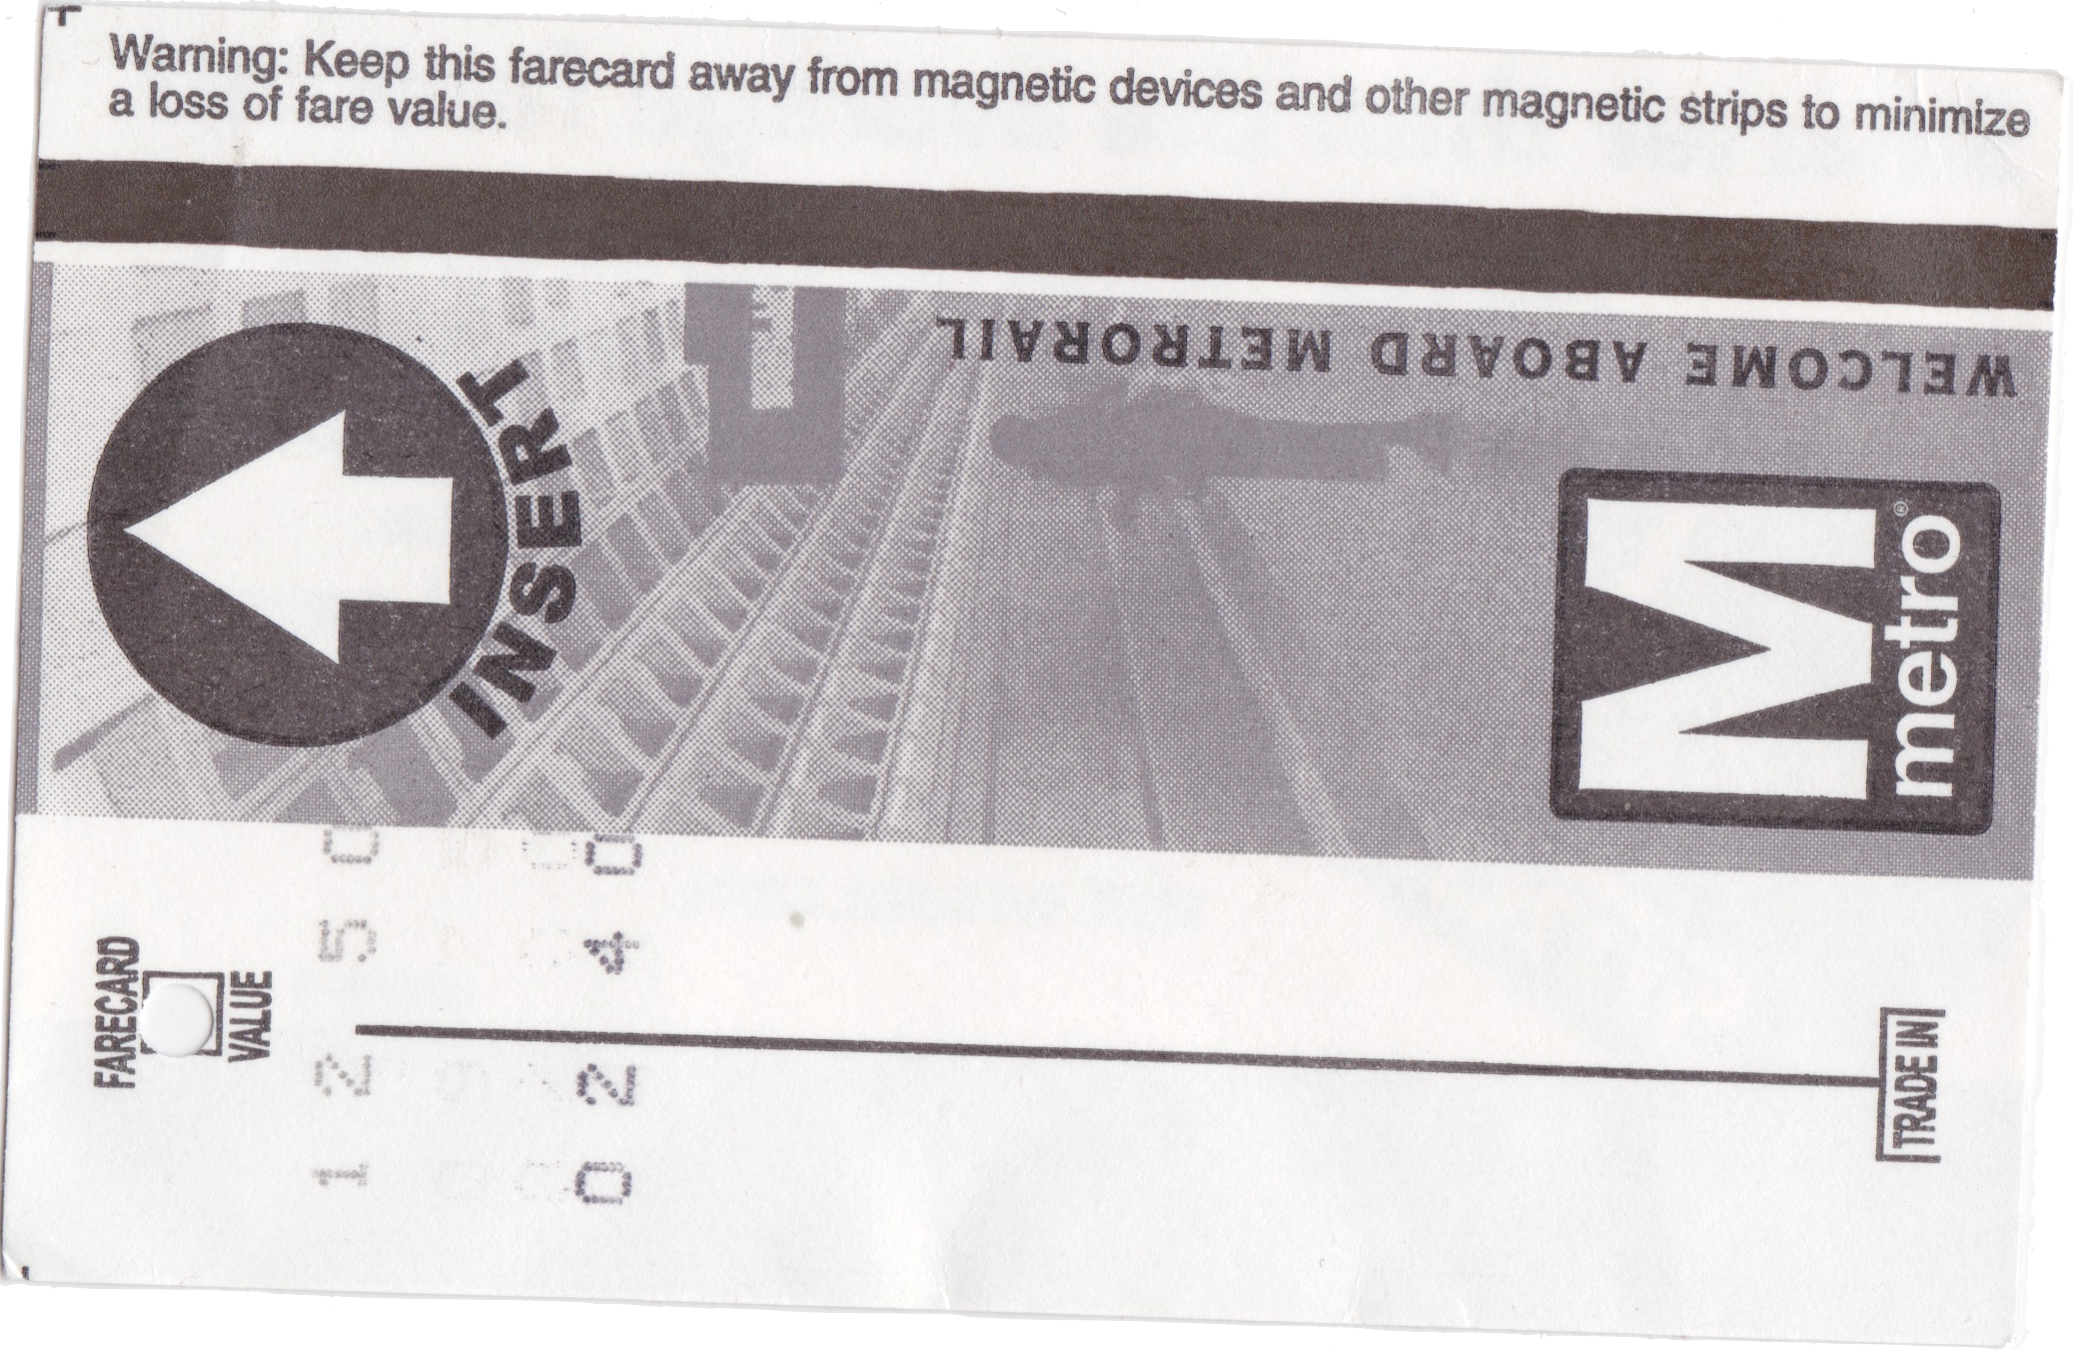

Student Task Statement
Noah put $40 on his fare card. Every time he rides public transportation, $2.50 is subtracted from the amount available on his card.
- How much money, in dollars, is available on his card after he takes
  - 0 rides?
  - 1 ride?
  - 2 rides?
  - $x$ rides?
- Graph the relationship between amount of money on the card and number of rides.
- 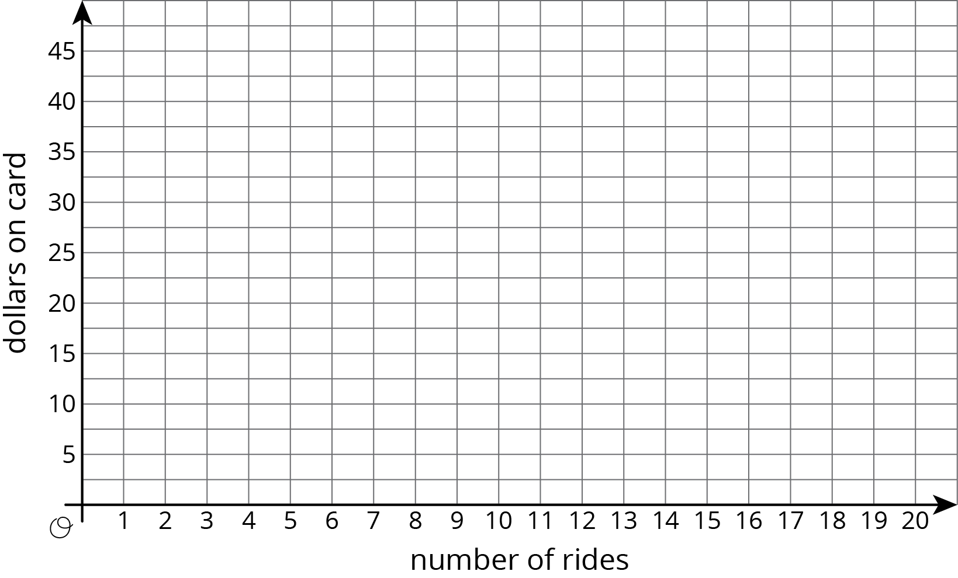
- How many rides can Noah take before the card runs out of money? Where do you see this number of rides on your graph?

Activity Synthesis
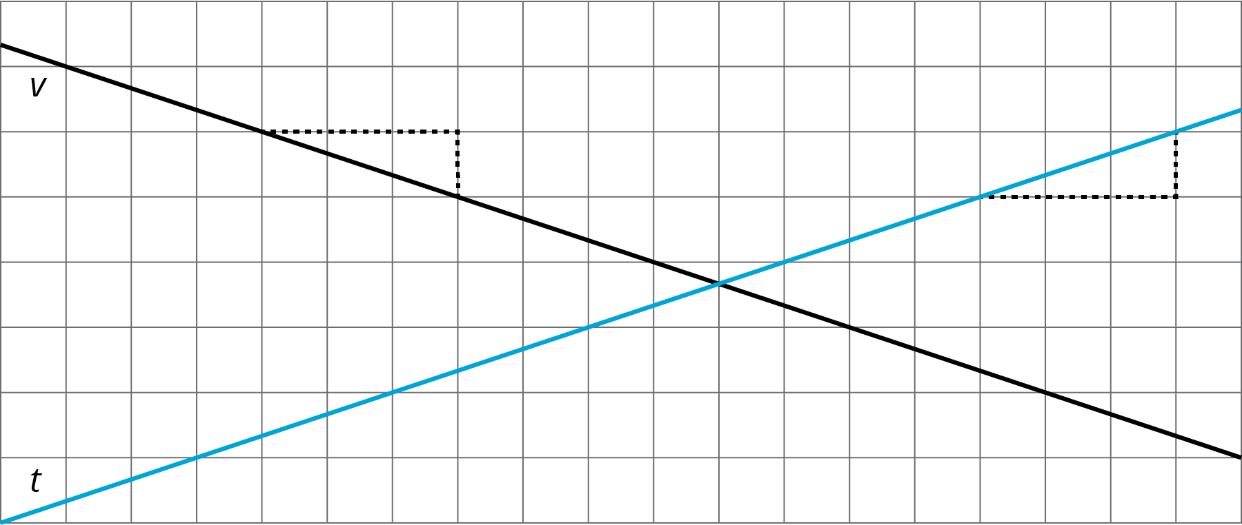

3 Travel Habits in July

Student Task Statement
Here is a graph that shows the amount on Han’s fare card for every day of last July.
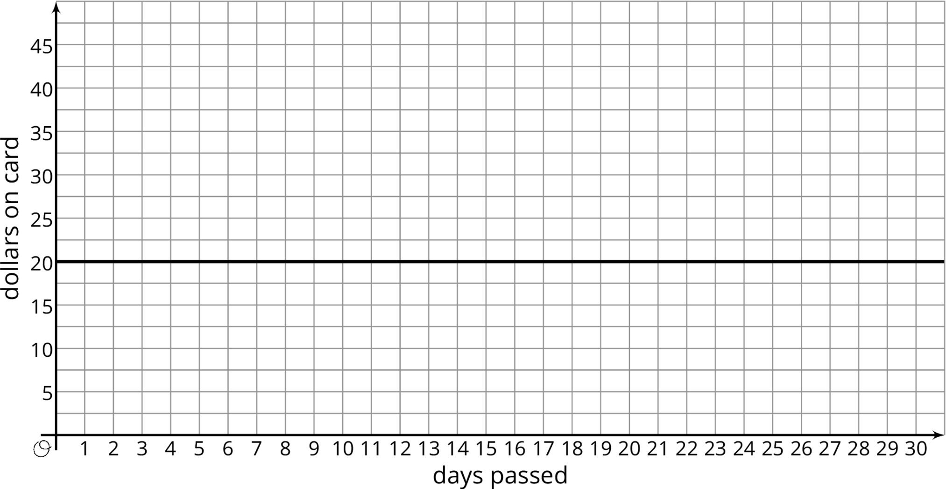
- Describe what happened with the amount on Han’s fare card in July.
- Plot and label 3 different points on the line.
- Write an equation that represents the amount on the card in July, $y$, after $x$ days.
- What value makes sense for the slope of the line that represents the amounts on Han’s fare card in July?

4 Payback Plan (Optional)

Student Task Statement
Elena borrowed some money from her brother. She pays him back by giving him the same amount every week. The graph shows how much she owes after each week.
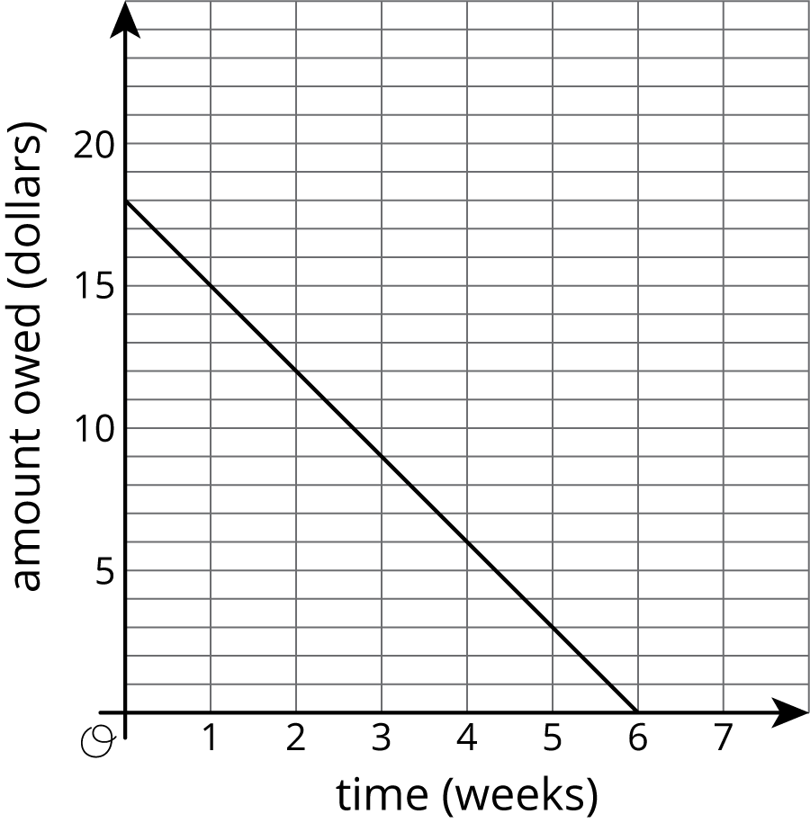
Answer and explain your reasoning for each question.
- What is the slope of the line?
- Explain how you know whether the slope is positive or negative.
- What does the slope represent in this situation?
- How much did Elena borrow?
- How much time will it take for Elena to pay back all the money she borrowed?

Images for Activity Synthesis
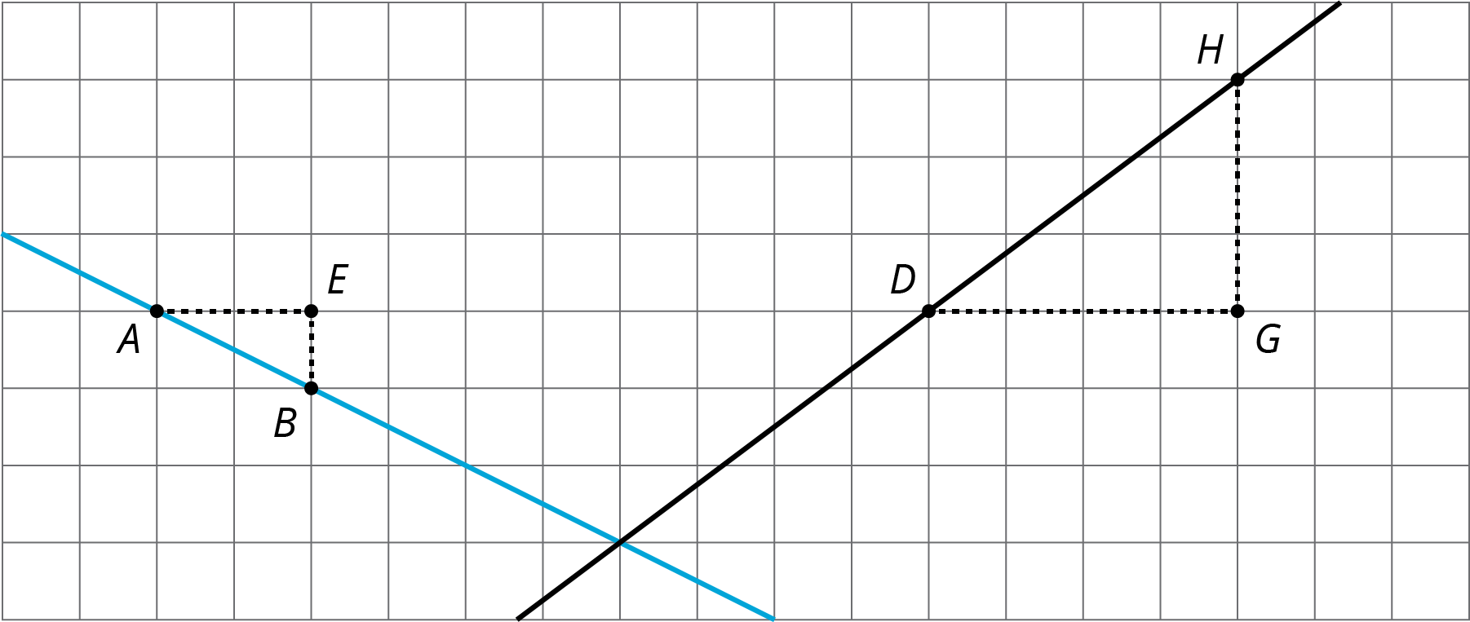
© CC BY Open Up Resources. Adaptations CC BY IM.

