Grade 6
Unit 4Lesson 13CC BY NC Illustrative Mathematics, based on IM 6–8 Math, CC BY Open Up Resources.
Unit 4, Lesson 13

Rectangles with Fractional Side Lengths
Let’s explore rectangles that have fractional measurements.
Grade 6
Unit 4Lesson 13CC BY NC Illustrative Mathematics, based on IM 6–8 Math, CC BY Open Up Resources.

13.1Notice and Wonder: Areas of Squares
What do you notice? What do you wonder?
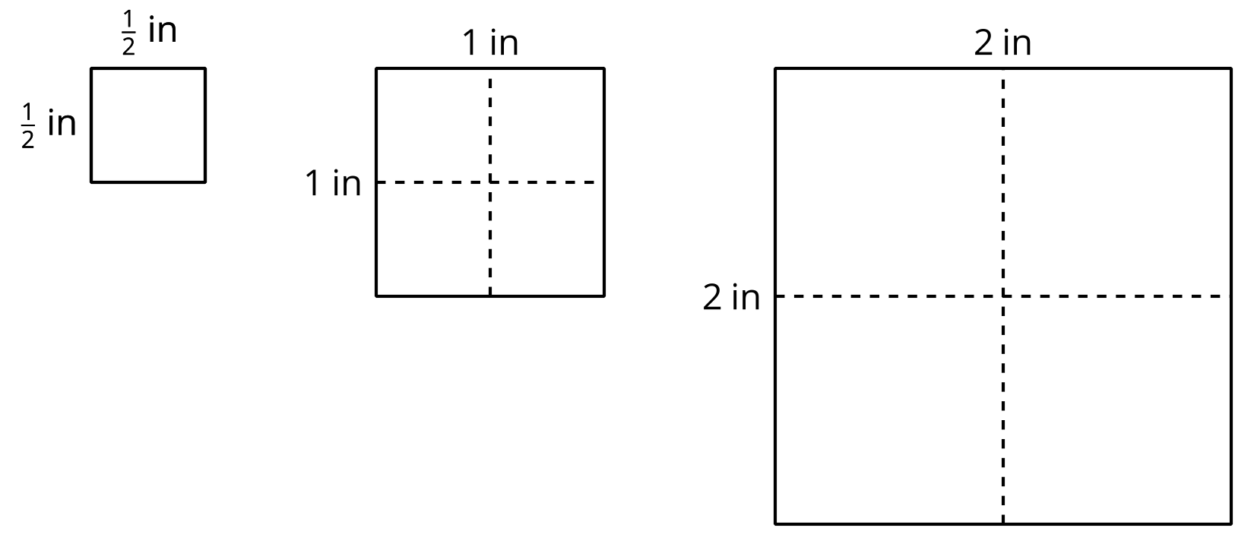
Grade 6
Unit 4Lesson 13CC BY NC Illustrative Mathematics, based on IM 6–8 Math, CC BY Open Up Resources.

13.2Areas of Squares and Rectangles
- Here is a square with side lengths of 1 inch.
  - How many squares with side lengths of $\frac{1}{4}$ inch can fit in a square with side lengths of 1 inch?
  - What is the area of a square with side lengths of $\frac{1}{4}$ inch? Explain or show your reasoning.
- 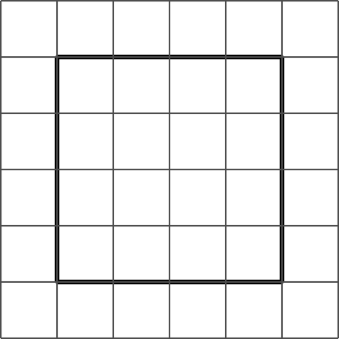
- Here is a rectangle that is $3\frac{1}{2}$ inches by $2\frac{1}{4}$ inches. The side length of each grid square is $\frac{1}{4}$ inch.
- 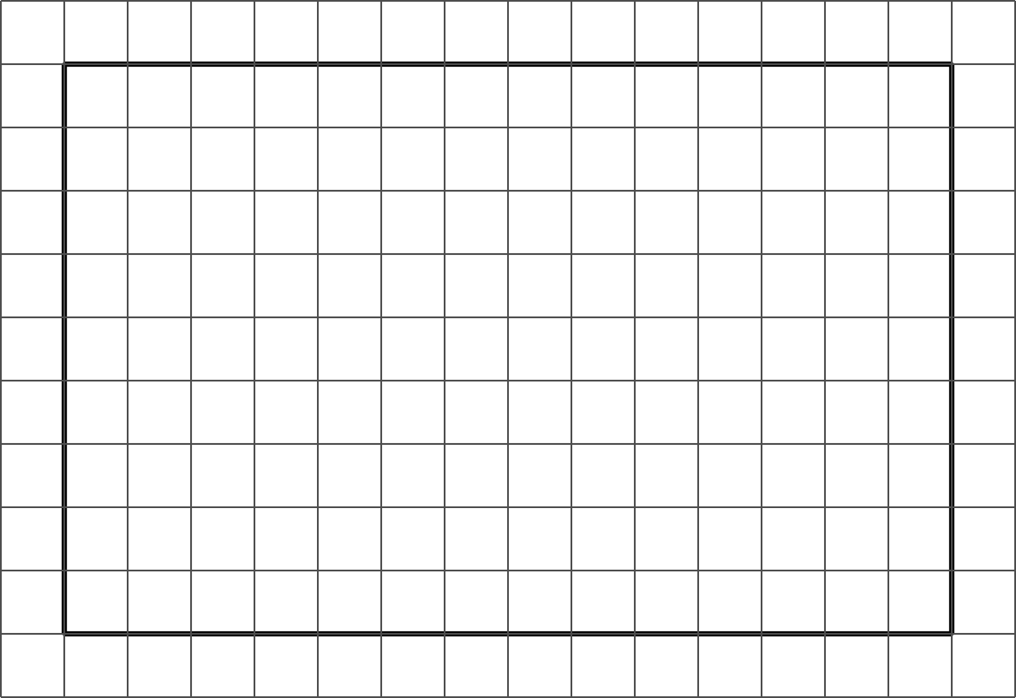
- Show that a rectangle that is $3\frac{1}{2}$ inches by $2\frac{1}{4}$ inches has an area of $7\frac{7}{8}$ square inches. You can use the drawing if you find it helpful.
Grade 6
Unit 4Lesson 13CC BY NC Illustrative Mathematics, based on IM 6–8 Math, CC BY Open Up Resources.

13.3Areas of Rectangles
Each of these multiplication expressions represents the area of a rectangle.
$2⋅4$
$2\frac{1}{2}⋅4$
$2⋅4\frac{3}{4}$
$2\frac{1}{2}⋅4\frac{3}{4}$
- All regions shaded in light blue have the same area. Match each diagram to the expression that you think represents its area. Be prepared to explain your reasoning.
- A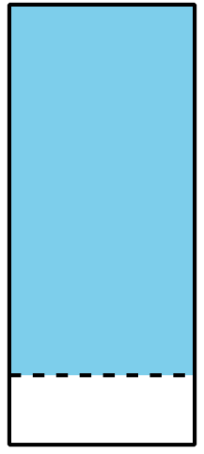
- B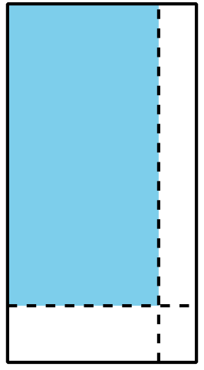
- C
- D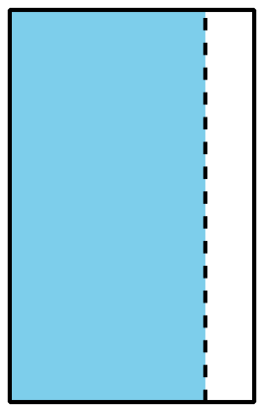
- Use the diagram that matches $2\frac{1}{2}⋅4\frac{3}{4}$ to show that the value of $2\frac{1}{2}⋅4\frac{3}{4}$ is $11\frac{7}{8}$.

Are you ready for more?
The following rectangles are composed of squares, and each rectangle is constructed using the rectangle before it. The side length of the first square is 1 unit.
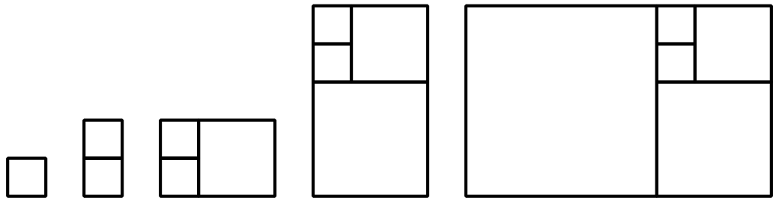
- Draw the next four rectangles that are constructed in the same way. Then complete the table with the side lengths of the rectangle and the fraction of the longer side over the shorter side.
- short side | - long side | - $\frac{\text{long side}}{\text{short side}}$
- 1
- 1
- 2
- 3
- Describe the values of the fraction of the longer side over the shorter side. What happens to the fraction as the pattern continues?
Grade 6
Unit 4Lesson 13CC BY NC Illustrative Mathematics, based on IM 6–8 Math, CC BY Open Up Resources.

13.4How Many Would It Take?
Noah would like to cover a rectangular tray with rectangular tiles. The tray has a width of $11\frac{1}{4}$ inches and an area of $50\frac{5}{8}$ square inches.
- Find the length of the tray in inches. Show your reasoning.
- The tiles are $\frac{3}{4}$ inch by $\frac{9}{16}$ inch. Draw a diagram to show one way Noah could lay the tiles. Your diagram does not need to show every tile but should show known measurements.
- How many tiles would Noah need to cover the tray completely, without gaps or overlaps? Explain or show your reasoning.

Lesson 13 Summary
If a rectangle has side lengths $a$ units and $b$ units, the area is $a⋅b$ square units. For example, if we have a rectangle with $\frac{1}{2}$-inch side lengths, its area is $\frac{1}{2}⋅\frac{1}{2}$ (or $\frac{1}{4}$) square inches.
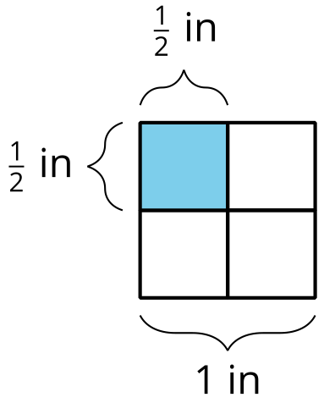
This means that if we know the area and one side length of a rectangle, we can divide to find the other side length.
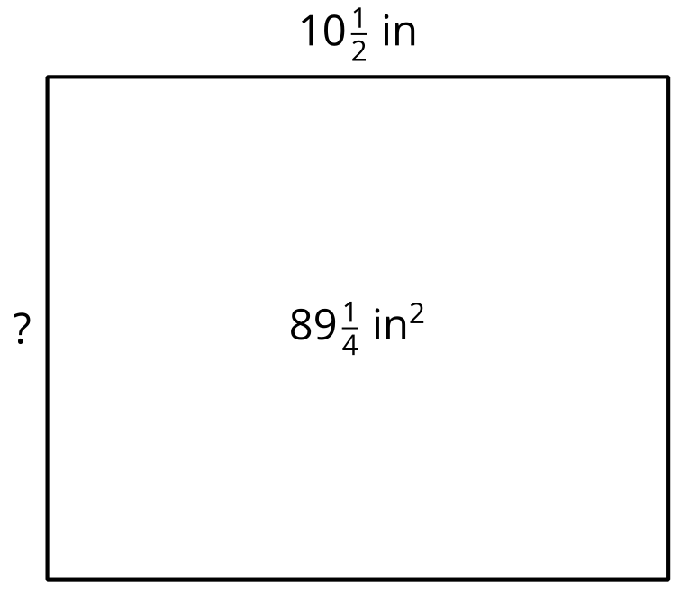
If one side length of a rectangle is $10\frac{1}{2}$ in and its area is $89\frac{1}{4}$ in², we can write this equation to show their relationship:
$10\frac{1}{2}⋅?=89\frac{1}{4}$
Then, we can find the other side length, in inches, using division:
$89\frac{1}{4}÷10\frac{1}{2}=?$

