Grade 6
Unit 1Lesson 17CC BY NC Illustrative Mathematics, based on IM 6–8 Math, CC BY Open Up Resources.
Unit 1, Lesson 17

Squares and Cubes
Let’s investigate perfect squares and perfect cubes.
Grade 6
Unit 1Lesson 17CC BY NC Illustrative Mathematics, based on IM 6–8 Math, CC BY Open Up Resources.

17.1Perfect Squares
- The number 9 is a "perfect square." Find four numbers that are perfect squares and two numbers that are not perfect squares.
- A square has side length 7 in. What is its area?
- The area of a square is 64 sq cm. What is its side length?
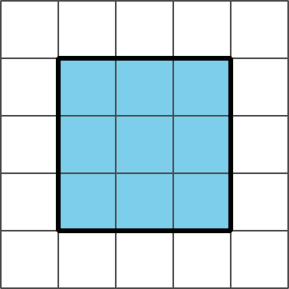
Grade 6
Unit 1Lesson 17CC BY NC Illustrative Mathematics, based on IM 6–8 Math, CC BY Open Up Resources.

17.2Building with 32 Cubes
Your teacher will give you 32 snap cubes. Use them to build the largest single cube you can. Each small cube has an edge length of 1 unit.
- How many snap cubes did you use?
- What is the edge length of the cube you built?
- What is the area of each face of the built cube? Be prepared to explain your reasoning.
- What is the volume of the built cube? Be prepared to explain your reasoning.

Are you ready for more?
Combine your 32 snap cubes with another group’s 32 snap cubes. Use them to build the largest single cube you can. Each small cube has an edge length of 1 unit.
- How many snap cubes did you use?
- What is the edge length of the cube you built?
- What is the area of each face of the built cube? Show your reasoning.
- What is the volume of the built cube? Show your reasoning.
Grade 6
Unit 1Lesson 17CC BY NC Illustrative Mathematics, based on IM 6–8 Math, CC BY Open Up Resources.

17.3Perfect Cubes
- The number 27 is a "perfect cube." Find four other numbers that are perfect cubes and two numbers that are not perfect cubes.
- A cube has a side length of 4 cm. What is its volume?
- A cube has a side length of 10 inches. What is its volume?
- A cube has a side length of $s$ units. What is its volume?
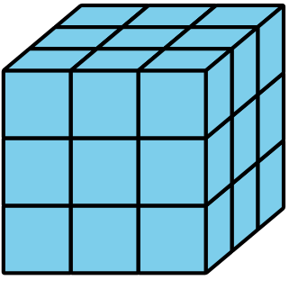
Grade 6
Unit 1Lesson 17CC BY NC Illustrative Mathematics, based on IM 6–8 Math, CC BY Open Up Resources.

17.4Introducing Exponents
Make sure to include correct units of measure as part of each answer.
- A square has side length 10 cm. Use an exponent to express its area.
- The area of a square is $7^{2}$ sq in. What is its side length?
- The area of a square is 81 m². Use an exponent to express this area.
- A cube has edge length 5 in. Use an exponent to express its volume.
- The volume of a cube is $6^{3}$ cm³. What is its edge length?
- A cube has edge length $s$ units. Use an exponent to write an expression for its volume.

Are you ready for more?
The number 15,625 is both a perfect square and a perfect cube. It is a perfect square because it equals ${125}^{2}$. It is also a perfect cube because it equals ${25}^{3}$. Find another number that is both a perfect square and a perfect cube. How many of these can you find?

Lesson 17 Summary
When we multiply two of the same numbers together, such as $5⋅5$, we say that we are squaring the number. We can write it like this:
$5^{2}$
The raised 2 in $5^{2}$ is called an exponent.
Because $5⋅5=25$, we write $5^{2}=25$ and we say, “5 squared is 25.”
When we multiply three of the same numbers together, such as $4⋅4⋅4$, we say that we are cubing the number. We can write it like this:
$4^{3}$
Because $4⋅4⋅4=64$, we write $4^{3}=64$ and we say, “4 cubed is 64.”
We also use an exponent for square units and cubic units.
- A square with a side length of 5 inches has an area of 25 in².
- A cube with an edge length of 4 cm has a volume of 64 cm³.
To read 25 in², we say “25 square inches,” just like before.
The area of a square with a side length of 7 kilometers is $7^{2}$ km². The volume of a cube with an edge length of 2 millimeters is $2^{3}$ mm³.
In general, the area of a square with a side length of $s$ is $s^{2}$, and the volume of a cube with an edge length of $s$ is $s^{3}$.

