Lesson 1: A Towering Sequence
- Let’s explore the Tower of Hanoi.

1.1: What’s Next?
Here is a rule for making a list of numbers: Each number is 1 less than twice the previous number.
Pick a number to start with, then follow the rule to build a list of 5 numbers.

1.2: The Tower of Hanoi
In the Tower of Hanoi puzzle, a set of discs sits on a peg, while there are 2 other empty pegs.
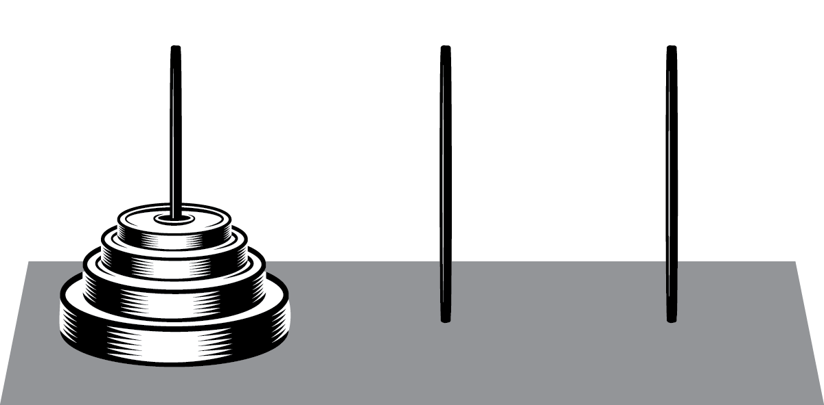
A move in the Tower of Hanoi puzzle involves taking a disc and moving it to another peg. There are two rules:
- Only move 1 disc at a time.
- Never put a larger disc on top of a smaller one.
You complete the puzzle by building the complete tower on a different peg than the starting peg.
- Using 3 discs, complete the puzzle. What is the smallest number of moves you can find?
- Using 4 discs, complete the puzzle. What is the smallest number of moves you can find?
- Jada says she used the solution for 3 discs to help her solve the puzzle for 4 discs. Describe how this might happen.
- How many moves do you think it will take to complete a puzzle with 5 discs? Explain or show your reasoning.
- How many moves do you think it will take to complete a puzzle with 7 discs?

Are you ready for more?
A legend says that a Tower of Hanoi puzzle with 64 discs is being solved, one move per second. How long will it take to solve this puzzle? Explain how you know.

1.3: Checker Jumping Puzzle
Some checkers are lined up, with blue on one side, red on the other, with one empty space between them. A move in this checker game pushes any checker forward 1 space, or jumps over any 1 checker of the other color. Jumping the same color is not allowed, moving backwards is not allowed, and 2 checkers cannot occupy the same space.

You complete the puzzle by switching the colors completely: ending up with blue on the right, red on the left, with 1 empty space between them.
- Using 1 checker on each side, complete the puzzle. What is the smallest number of moves needed?
- Using 3 checkers on each side, complete the puzzle. What is the smallest number of moves needed?
- Estimate the number of moves needed if there are 2 or 4 checkers on each side, then test your guesses.
- Noah says he used the solution for 3 checkers on each side to help him solve the puzzle for 4 checkers. Describe how this might happen.
- How many moves do you think it will take to complete a puzzle with 7 checkers on each side?

Lesson 1 Summary
A list of numbers like 3, 5, 7, 9, 11, . . . or 1, 5, 13, 29, 61, . . . is called a sequence.
There are many ways to define a sequence, but one way is to describe how each term relates to the one before it. For example, the sequence 3, 5, 7, 9, 11, . . . can be described this way: the starting term is 3, then each following term is 2 more than the one before it. The sequence 1, 5, 13, 29, 61, . . . can be described as: the starting term is 1, then each following term is the sum of 3 and twice the previous term.
Throughout this unit, we will study several types of sequences along with ways to represent them.
© CC BY 2019 by Illustrative Mathematics®

