Grade 2
Unit 7Lesson 13CC BY NC 2024 Illustrative Mathematics®
Unit 7, Lesson 13

Decompose Tens or Hundreds
- Let’s decompose a ten or a hundred to subtract.
Grade 2
Unit 7Lesson 13CC BY NC 2024 Illustrative Mathematics®

Warm-upWhich Three Go Together: Blocks and Blocks
Which 3 go together?
A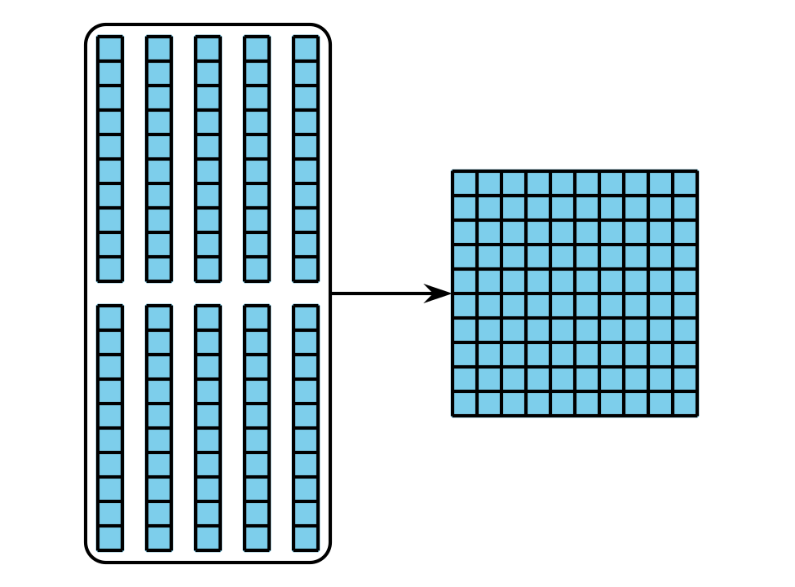
B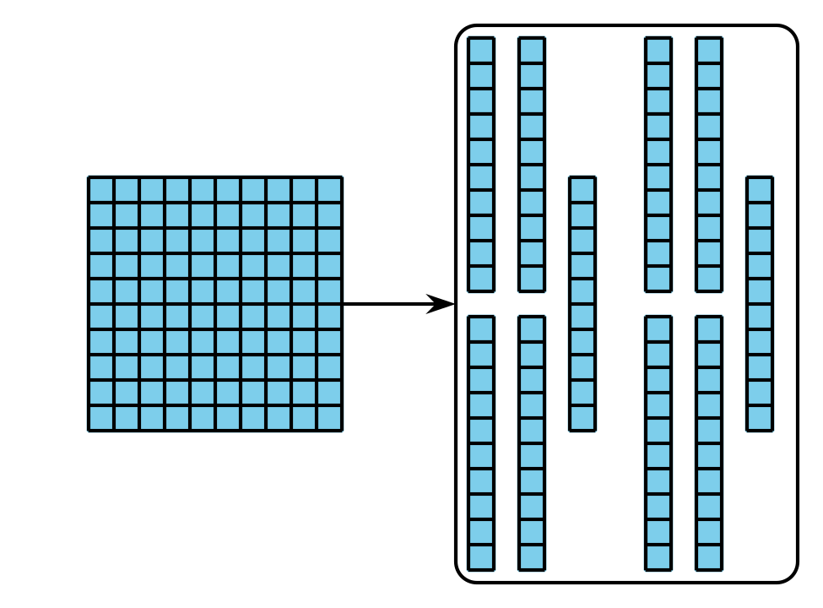
C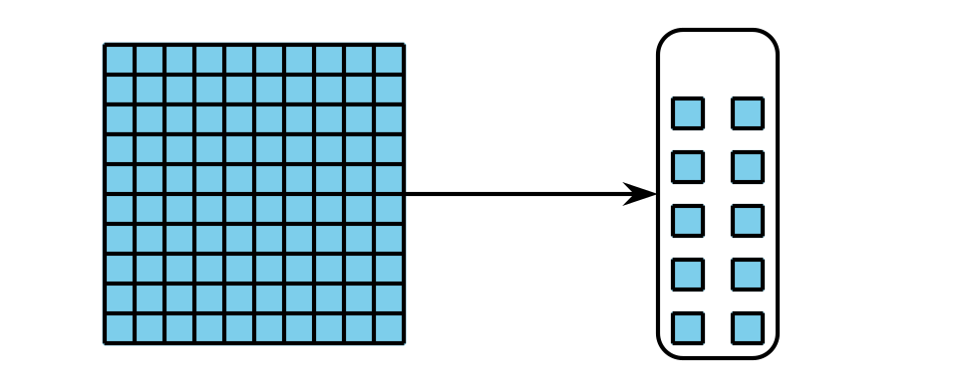
D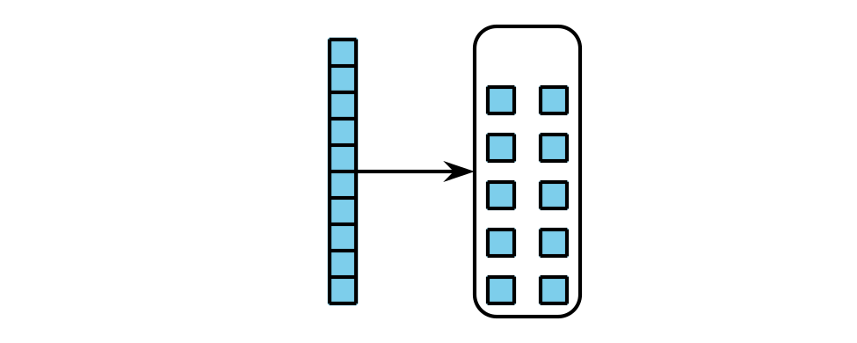
Grade 2
Unit 7Lesson 13CC BY NC 2024 Illustrative Mathematics®

Activity 1Subtract with Base-Ten Diagrams
Mai used base-ten blocks to find the value of $336−52$. Then she made a matching diagram.
What did she do in Step 2? What should she do to find the difference? Explain your reasoning.
Step 1
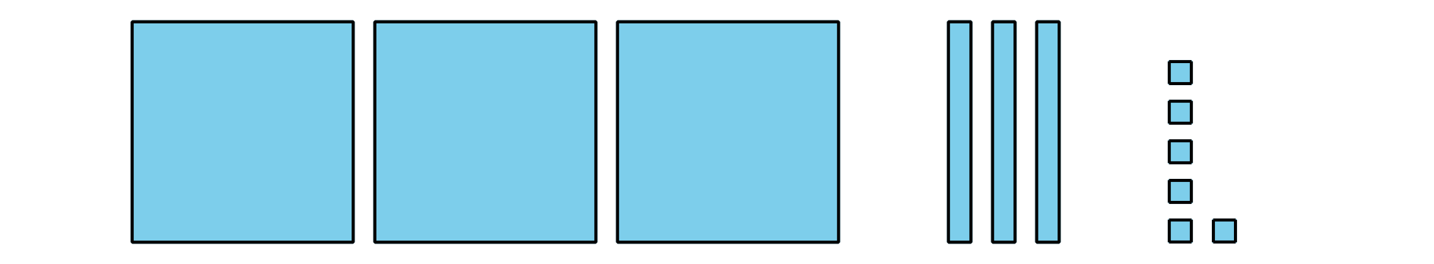
Step 2
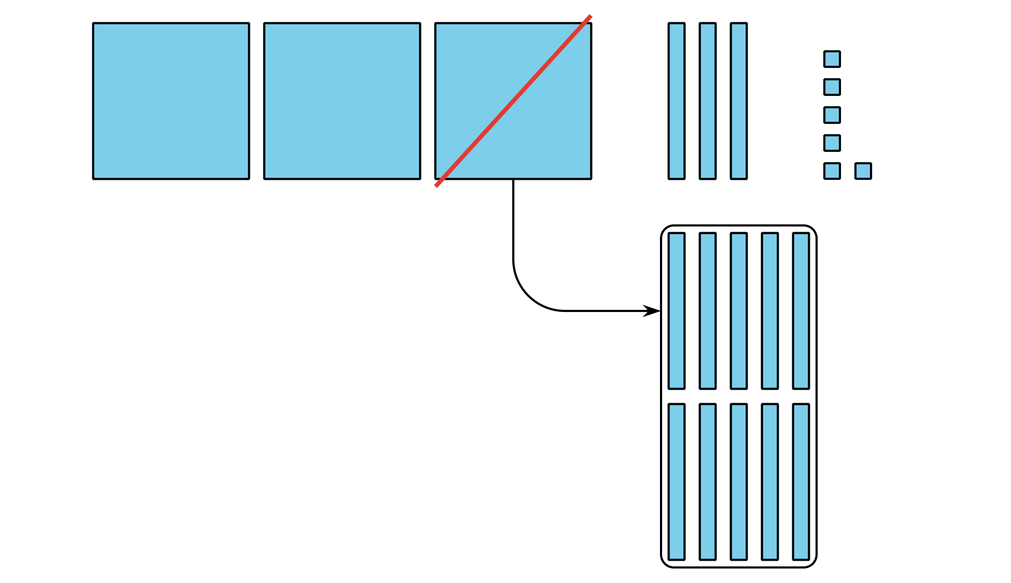
- Write each expression next to the matching diagram. Then find the value of each difference.
- $244−28$
- $256−64$
- $244−64$

  - 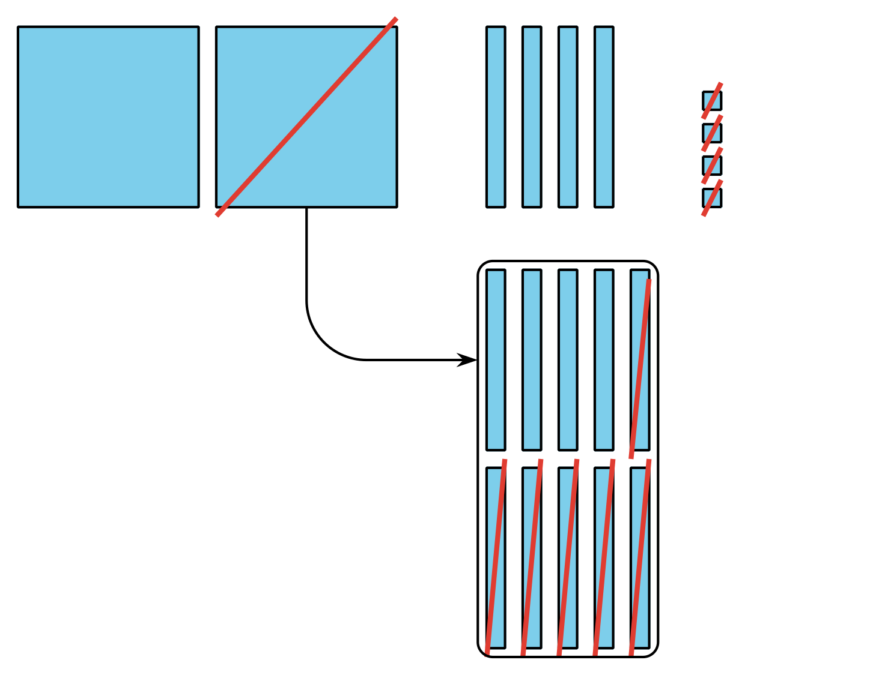

  - 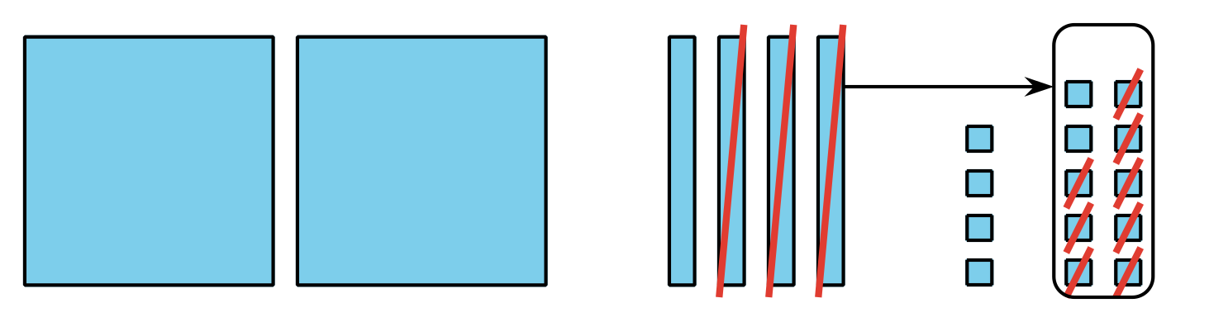

  - 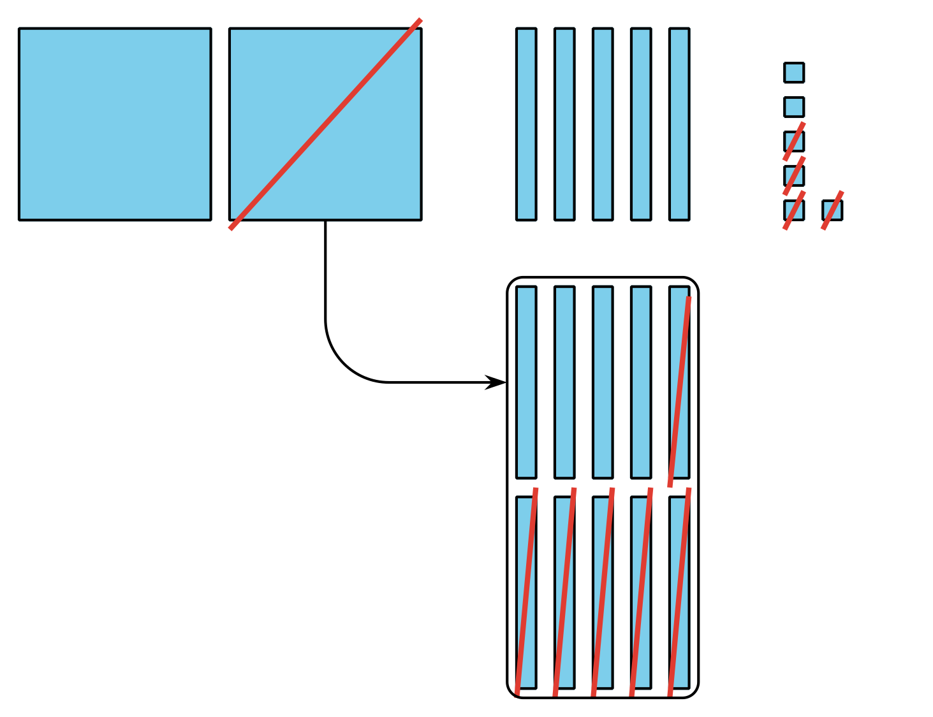
Grade 2
Unit 7Lesson 13CC BY NC 2024 Illustrative Mathematics®

Activity 2 Decompose a Ten or a Hundred
Find the value of each difference. Show your thinking, using drawings, numbers, or words. Try Mai's way for 1 expression.
- $155−26$
- $352−71$
- $364−182$
- $293−147$
- Share how you found the value of 1 expression with your partner. Use the sentence frames to explain your reasoning.
  - “First I . . . .”
  - “Next I . . . .”
  - “Then I . . . .”
  - “Last I . . . .”
