Grade 6
Unit 7Lesson 11CC BY NC Illustrative Mathematics, based on IM 6–8 Math, CC BY Open Up Resources.
Unit 7, Lesson 11

Points in the Coordinate Plane
Let’s explore the coordinate plane.
Grade 6
Unit 7Lesson 11CC BY NC Illustrative Mathematics, based on IM 6–8 Math, CC BY Open Up Resources.

11.1Guess My Line
Choose 1 set of points, and write the coordinates of each of the 3 points in the set. What do you notice about the coordinates?
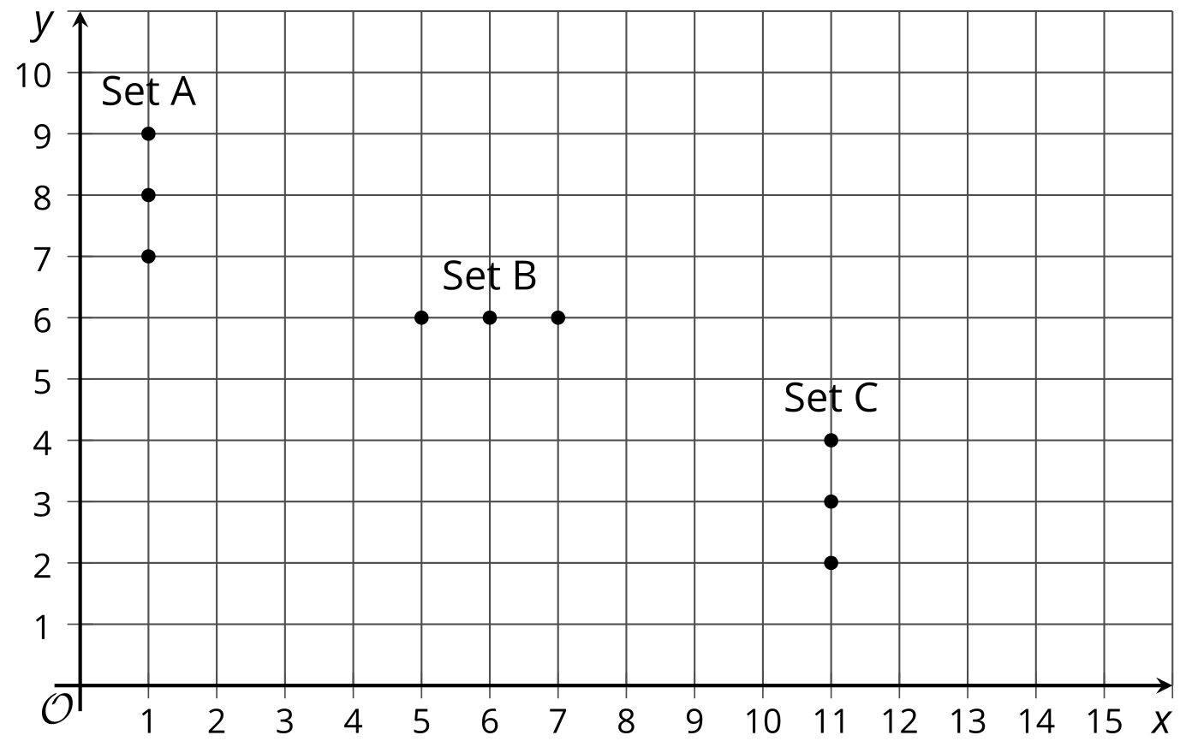
Grade 6
Unit 7Lesson 11CC BY NC Illustrative Mathematics, based on IM 6–8 Math, CC BY Open Up Resources.

11.2The Coordinate Plane
- Write the coordinates of each labeled point.
- 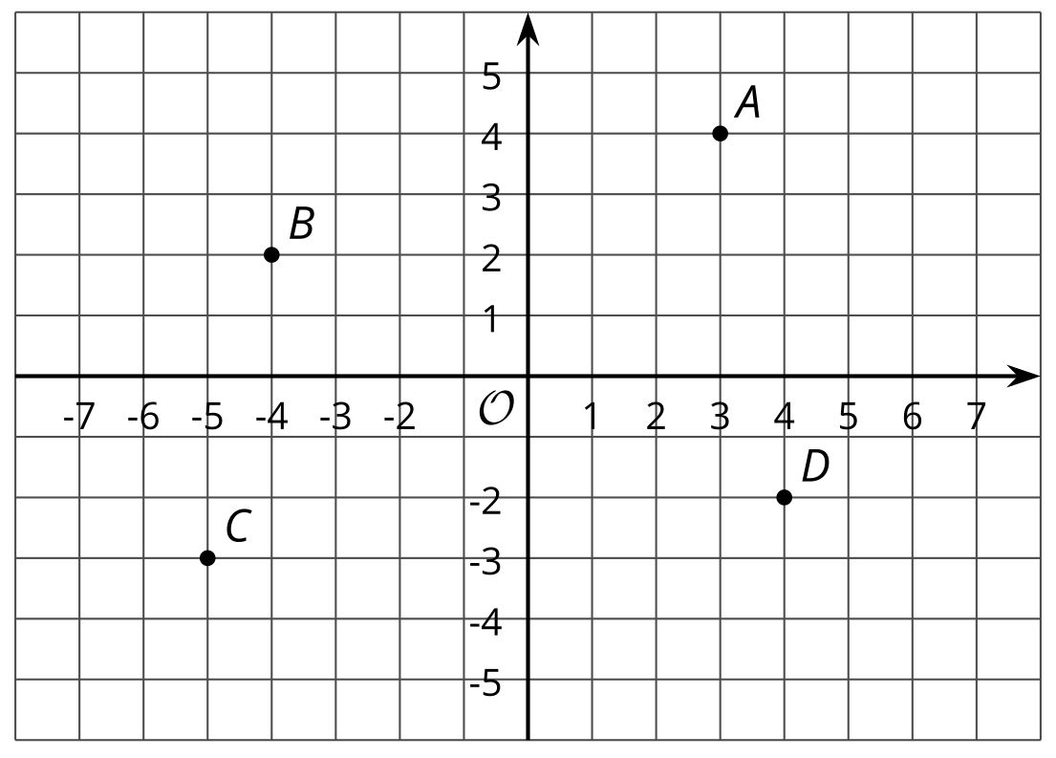
- Plot a point at $\left(\text{-}2,5\right)$. Label it $E$.
- Plot another point at $\left(3,\text{-}4.5\right)$. Label it $F$.
- The coordinate plane is divided into four quadrants: I, II, III, and IV, as shown here.
- In which quadrant is point $G$ located? Point $H$? Point $I$?
- 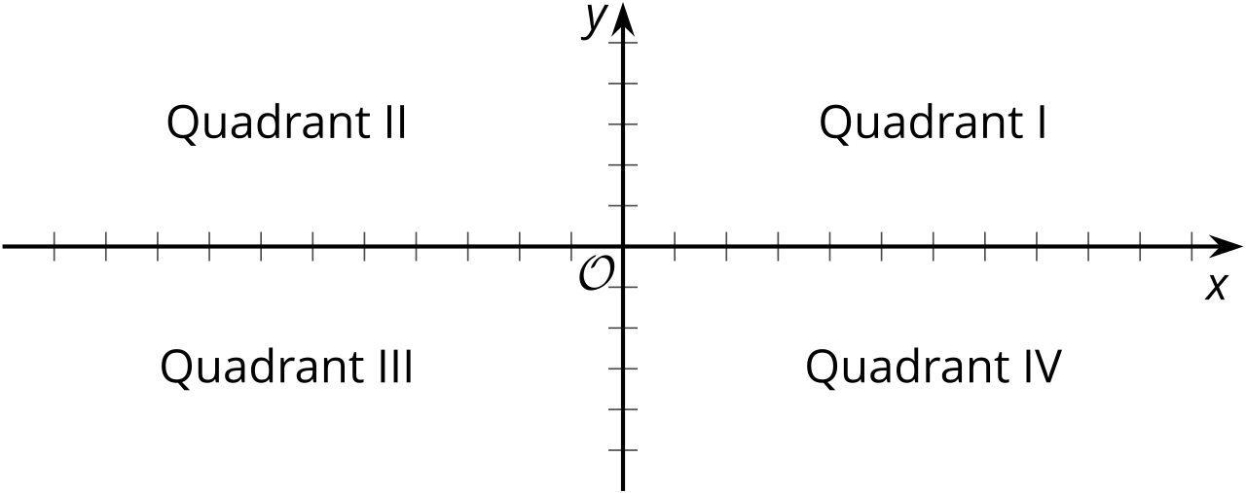

- $G \left(5,2\right)$
- $H \left(\text{-}1,\text{-}5\right)$
- $I \left(7,\text{-}4\right)$
- If a point has a positive $y$-coordinate, in which quadrants could it be?
Grade 6
Unit 7Lesson 11CC BY NC Illustrative Mathematics, based on IM 6–8 Math, CC BY Open Up Resources.

11.3Coordinated Archery
Here is an image of an archery target on a coordinate grid. The scores for landing an arrow in each of the regions are shown.
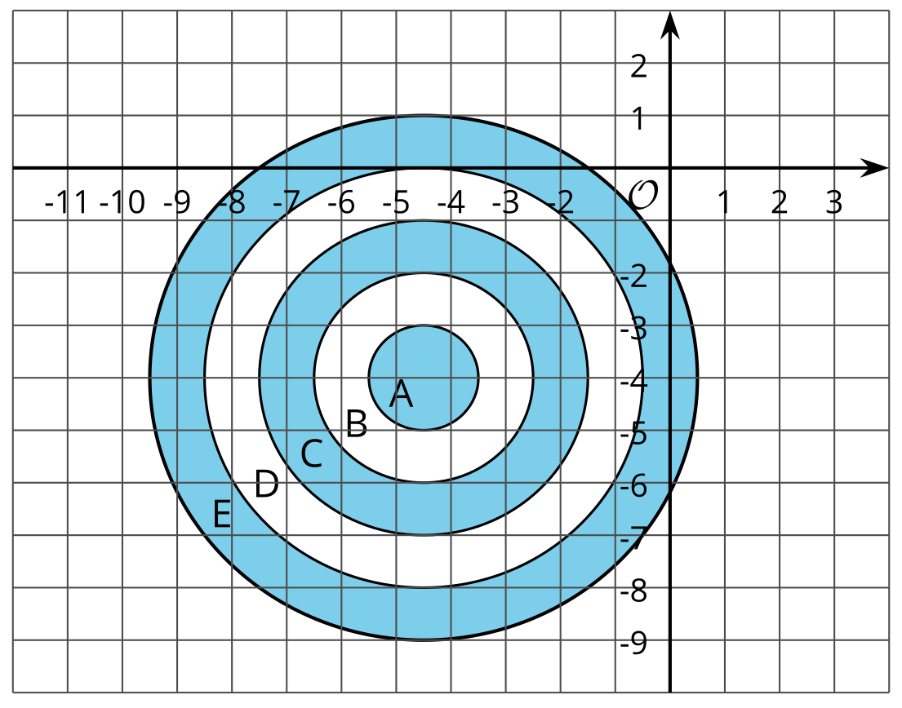
- A: 10 points
- B: 8 points
- C: 6 points
- D: 4 points
- E: 2 points
Name the possible coordinates of where one arrow could land to earn each of the following scores:
- 6 points
- 10 points
- 2 points
- no points
- 4 points
- 8 points

Are you ready for more?
Pretend you are stuck in a coordinate plane. You can only take vertical and horizontal steps that are one unit long.
- How many ways are there to get from the point $\left(\text{-3},2\right)$ to $\left(\text{-1},\text{-1}\right)$ if you will only step down and to the right?
- How many ways are there to get from the point $\left(\text{-1},\text{-2}\right)$ to $\left(4,0\right)$ if you can only step up and to the right?
- Make up some more problems like this and see what patterns you notice.

Lesson 11 Summary
Just as the number line can be extended to the left to include negative numbers, the $x$- and $y$-axes can also be extended to include negative values. This creates the coordinate plane, a system that can be used to describe the locations of points.
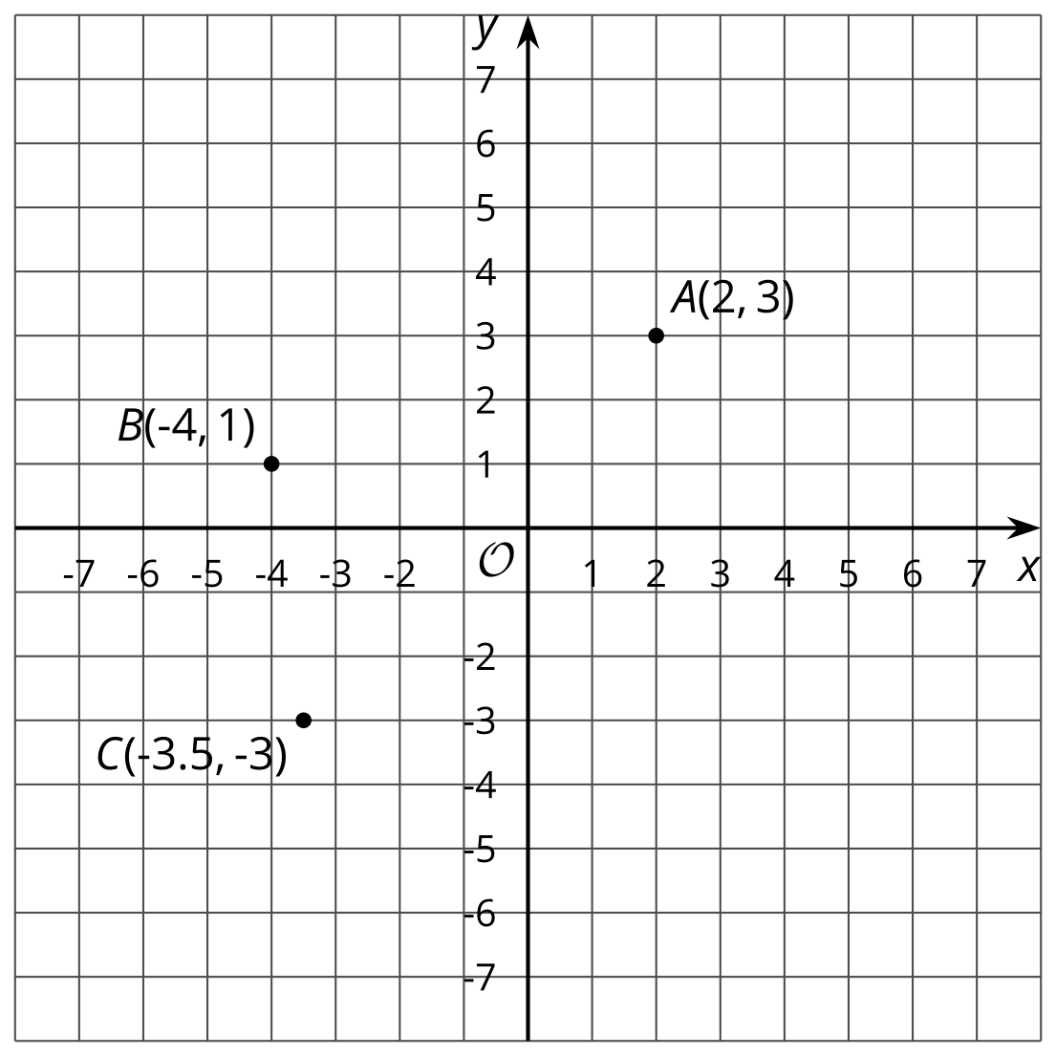
For example, point $B$ can be described by the ordered pair $\left(\text{-}4,1\right)$. The $x$-value of -4 tells us that the point is 4 units to the left of the $y$-axis. The $y$-value of 1 tells us that the point is 1 unit above the $x$-axis. Point $B$ is located in Quadrant II.
The same reasoning applies to the points $A$ and $C$. The $x$- and $y$-coordinates for point $A$ are positive, so $A$ is to the right of the $y$-axis and above the $x$-axis. Point $A$ is located in Quadrant I.
The $x$- and $y$-coordinates for point $C$ are negative, so $C$ is to the left of the $y$-axis and below the $x$-axis. Point $C$ is located in Quadrant III.
Quadrant IV contains points whose $x$-coordinates are positive and whose $y$-coordinates are negative.

