Lesson 14: Problemas sobre datos de medidas fraccionarias

Standards Alignments
Addressing | 4.MD.B.4, 4.NF.B.3.c
Building Towards | 4.MD.B.4

Teacher-facing Learning Goals
- Use information on line plots to solve problems involving addition and subtraction of fractions and mixed numbers.

Student-facing Learning Goals
- Resolvamos problemas sobre datos de medidas en diagramas de puntos

Lesson Purpose
The purpose of this lesson is for students to solve problems using information presented in line plots.
Previously, students organized and analyzed measurement data on a line plot. They also learned to express equivalent fractions (for example, they expressed 3 fourths as 6 eighths). In this lesson, they continue to use these skills, along with their knowledge of addition and subtraction of fractions with the same denominator, to solve problems involving fractional measurements.
This lesson has a Student Section Summary.

Access for:

Students with Disabilities
- Representation (Activity 1)

English Learners
- MLR8 (Activity 2)

Instructional Routines
Notice and Wonder (Warm-up)

Lesson Timeline
Warm-up | 10 min
Activity 1 | 20 min
Activity 2 | 15 min
Lesson Synthesis | 10 min
Cool-down | 5 min

Teacher Reflection Question
Which question asked during this lesson generated the most discourse? What was it about this question to motivate student thinking? How might you use the structure of this question moving forward in upcoming lessons?

Cool-down
(to be completed at the end of the lesson) 5min
Datos sobre estaturas en cuarto grado

Standards Alignments
Addressing | 4.MD.B.4

Student-facing Task Statement
Los estudiantes de una clase de cuarto grado llevan la cuenta de su estatura durante todo el año. En el diagrama de puntos se muestra el número de pulgadas que cada estudiante ha crecido en este año.
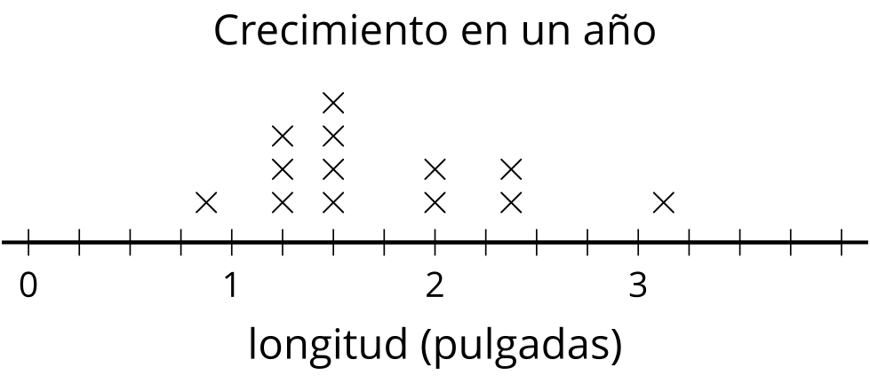
- ¿Cuántos estudiantes crecieron más de $1\frac{3}{8}$ pulgadas? Explica o muestra tu razonamiento.
- ¿Cuál es la diferencia entre la mayor cantidad de crecimiento y la menor cantidad de crecimiento, en pulgadas?

Student Responses
- Nine students grew more than $1\frac{3}{8}$ inches. Sample response: $\frac{3}{8}$ is located between $1\frac{1}{4}$ and $1\frac{2}{4}$ and there are 9 points to the right of $1\frac{3}{8}$.
- $2\frac{2}{8}$ inches. Sample response: $3\frac{1}{8}−\frac{7}{8}=2\frac{9}{8}−\frac{7}{8}=2\frac{2}{8}$.

