Lesson 5 Practice Problems
- The pictures show points on a unit circle labeled A, B, C, and D. Which point is $\left(cos\left(\frac{π}{3}\right),sin\left(\frac{π}{3}\right)\right)$?
  - 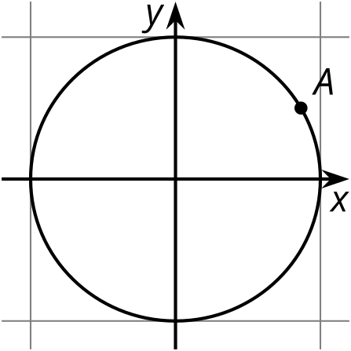
  - 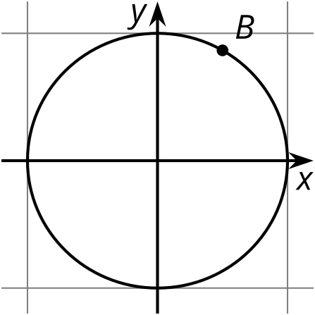
  - 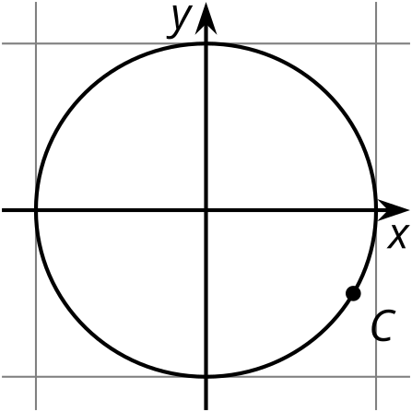
  - 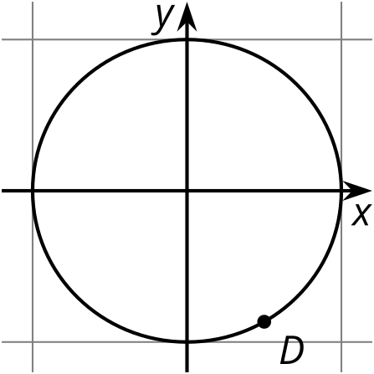
- For which angles is the cosine positive? Select all that apply.
  - 0 radians
  - $\frac{5π}{12}$ radians
  - $\frac{5π}{6}$ radians
  - $\frac{3π}{4}$ radians
  - $\frac{5π}{3}$ radians
- Mark two angles on the unit circle whose measure $θ$ satisfies $sin\left(θ\right)=\text{-}0.4$. How do you know your angles are correct?
- 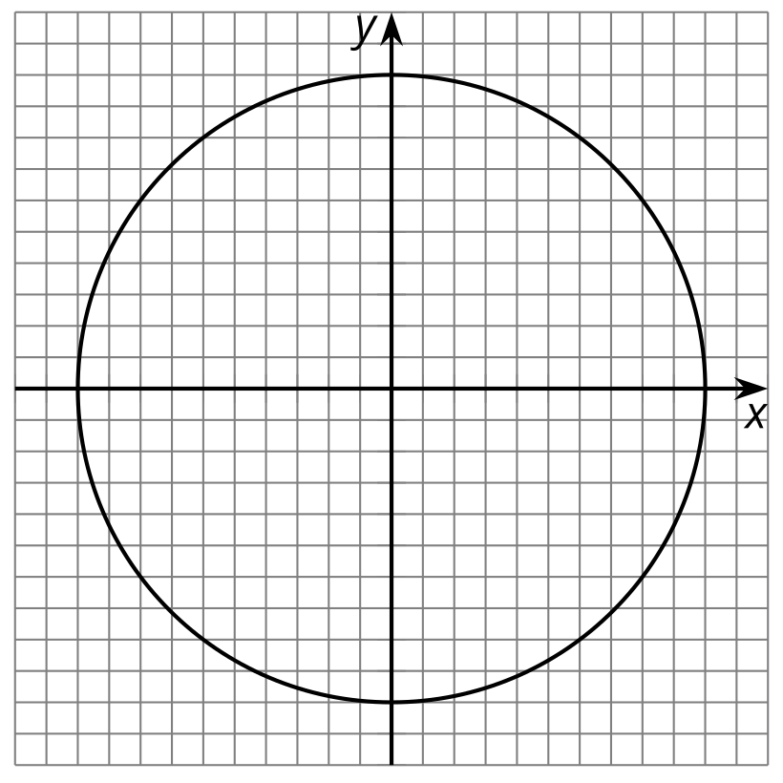

  - For which angle measures, $θ$, between 0 and $2π$ radians is $cos\left(θ\right)=0$? Label the corresponding points on the unit circle.
  - 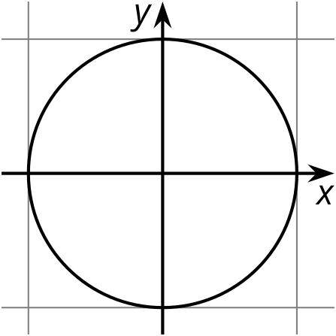
  - What are the values of $sin\left(x\right)$ for these angle measures?
- Angle $ABC$ measures $\frac{π}{4}$ radians, and the coordinates of $C$ are about $\left(0.71,0.71\right)$.
- 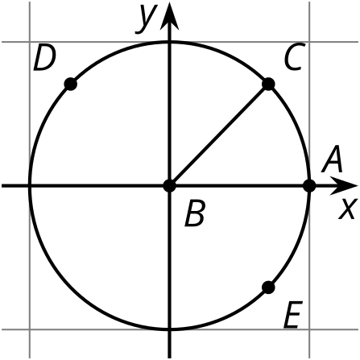
  - The measure of angle $ABD$ is $\frac{3π}{4}$ radians. What are the approximate coordinates of $D$? Explain how you know.
  - The measure of angle $ABE$ is $\frac{7π}{4}$ radians. What are the approximate coordinates of $E$? Explain how you know.
- (From Unit 6, Lesson 4.)

  - In which quadrant is the value of the $x$-coordinate of a point on the unit circle always greater than the $y$-coordinate? Explain how you know.
  - Name 3 angles in this quadrant.
- (From Unit 6, Lesson 4.)
- Lin is comparing the graph of two functions $g$ and $f$. The function $g$ is given by $g\left(x\right)=f\left(x−2\right)$. Lin thinks the graph of $g$ will be the same as the graph of $f$, translated to the left by 2. Do you agree with Lin? Explain your reasoning.
- (From Unit 5, Lesson 3.)
© CC BY 2019 by Illustrative Mathematics®

