Lesson 13: Graphing the Standard Form (Part 2)
- Let’s change some other parts of a quadratic expression and see how they affect the graph.

13.1: Equivalent Expressions
- Complete each row with an equivalent expression in standard form or factored form.
- standard form | - factored form
- $x^{2}$
 | - $x\left(x+9\right)$
- $x^{2}−18x$
 | - $x\left(6−x\right)$
- $\text{-}x^{2}+10x$
 | - $\text{-}x\left(x+2.75\right)$
- What do the quadratic expressions in each column have in common (besides the fact that everything in the left column is in standard form and everything in the other column is in factored form)? Be prepared to share your observations.

13.2: What about the Linear Term?
- Using graphing technology:
  - Graph $y=x^{2}$, and then experiment with adding different linear terms (for example, $x^{2}+4x$, $x^{2}+20x$, $x^{2}−50x$). Record your observations.
  - Graph $y=\text{-}x^{2}$, and then experiment with adding different linear terms. Record your observations.
- Use your observations to help you complete the table without graphing the equations.
- equation | - $x$-intercepts | - $x$-coordinate of vertex
- $y=x^{2}+6x$
- $y=x^{2}−10x$
- $y=\text{-}x^{2}+50x$
- $y=\text{-}x^{2}−36x$
- Some quadratic expressions have no linear terms. Find the $x$-intercepts and the $x$-coordinate of the vertex of the graph representing each equation. (Note it is possible for the graph to not intersect the $x$-axis.) If you get stuck, try graphing the equations.
  - $y=x^{2}−25$
  - $y=x^{2}+16$

13.3: Writing Equations to Match Graphs
Use graphing technology to graph a function that matches each given graph. Make sure your graph goes through all 3 points shown!

A
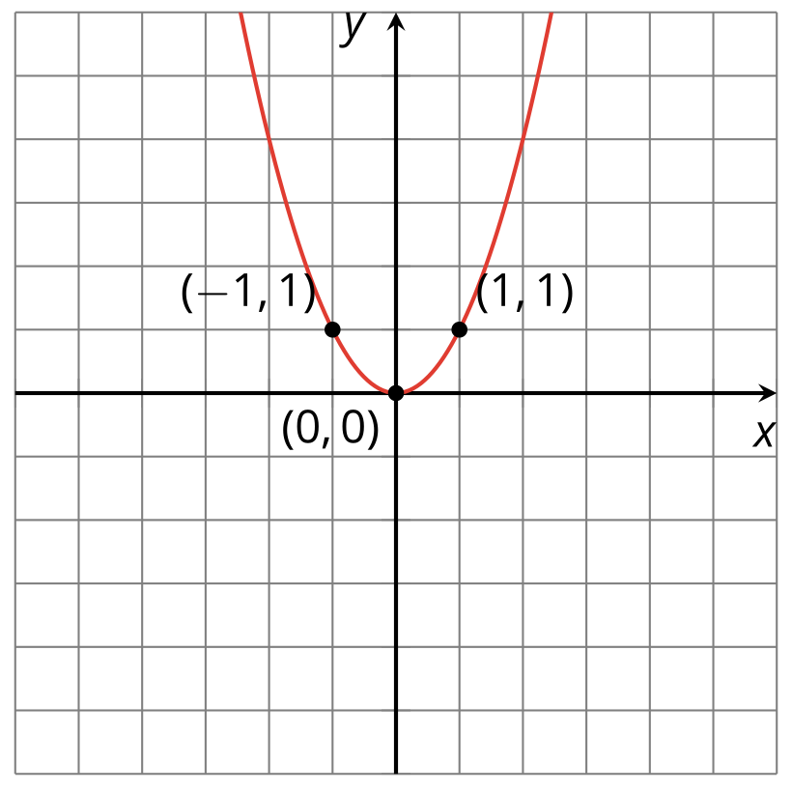
Equation:

B
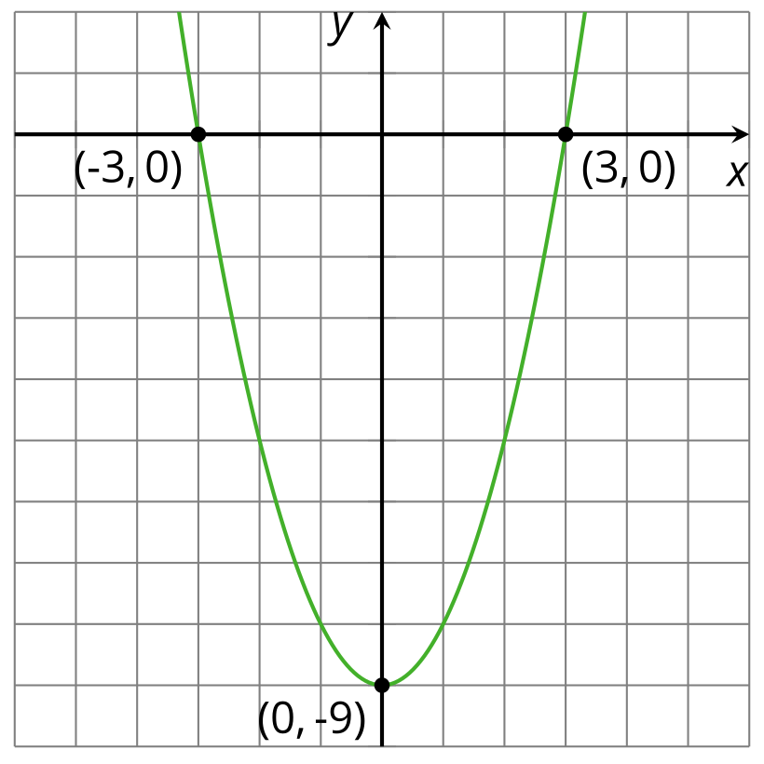
Equation:

C
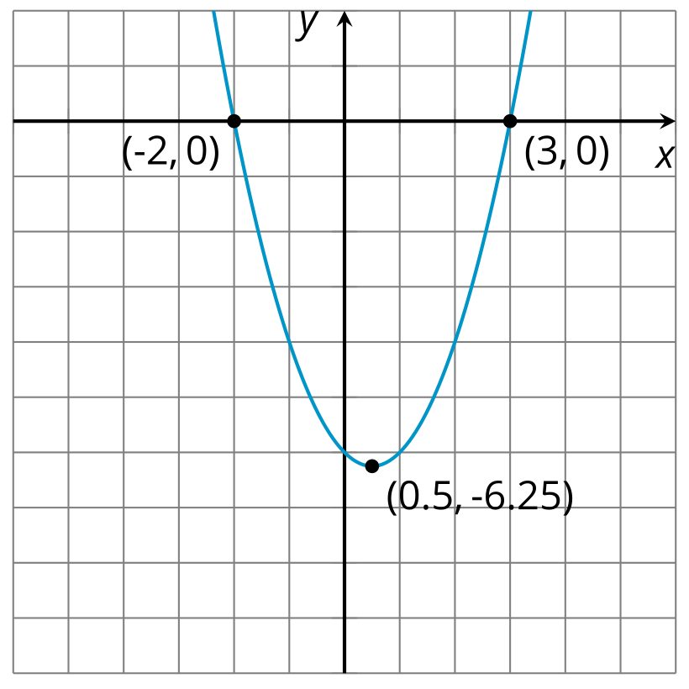
Equation:

D
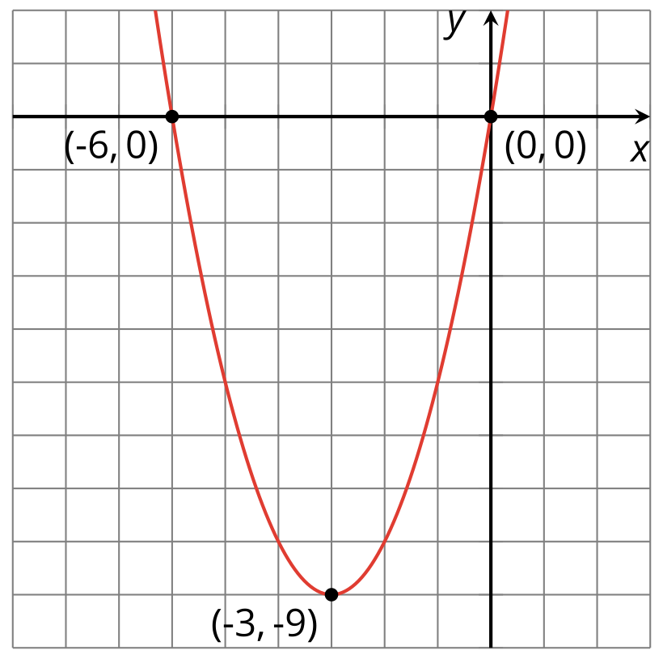
Equation:

E
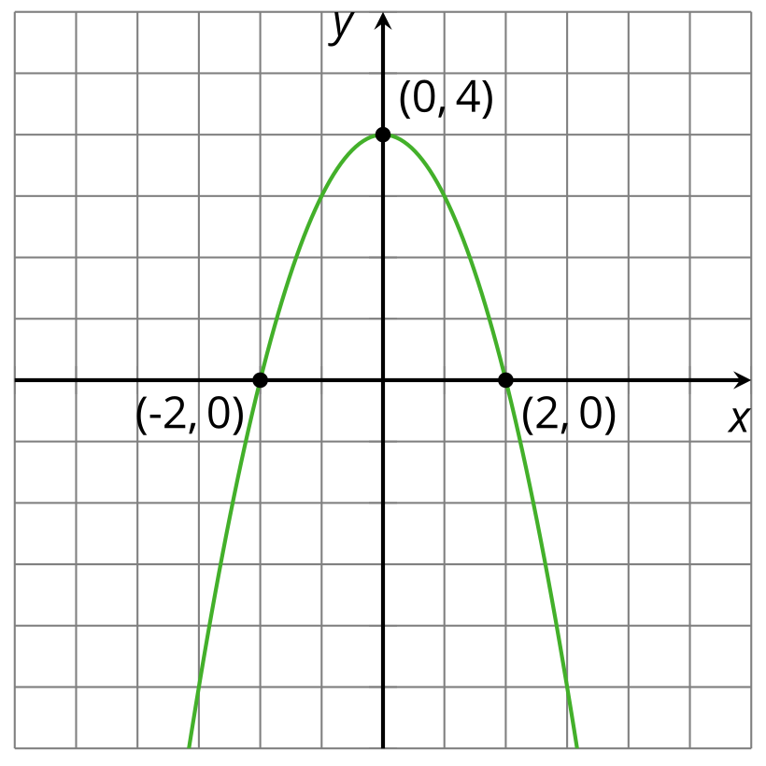
Equation:

F
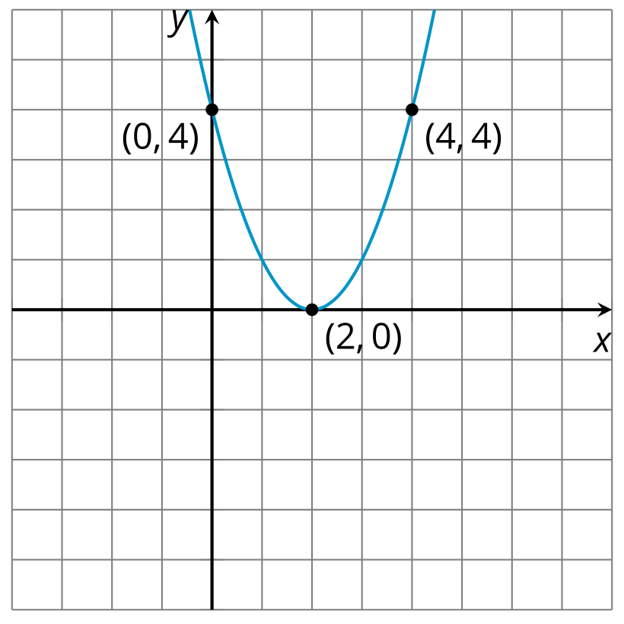
Equation:

G
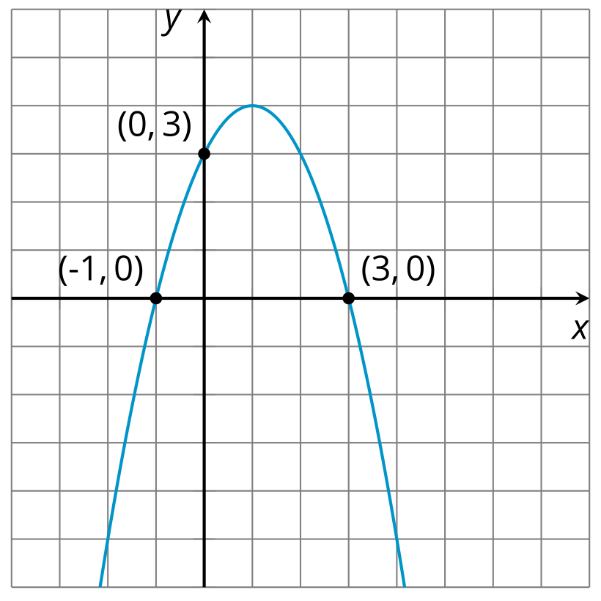
Equation:

H
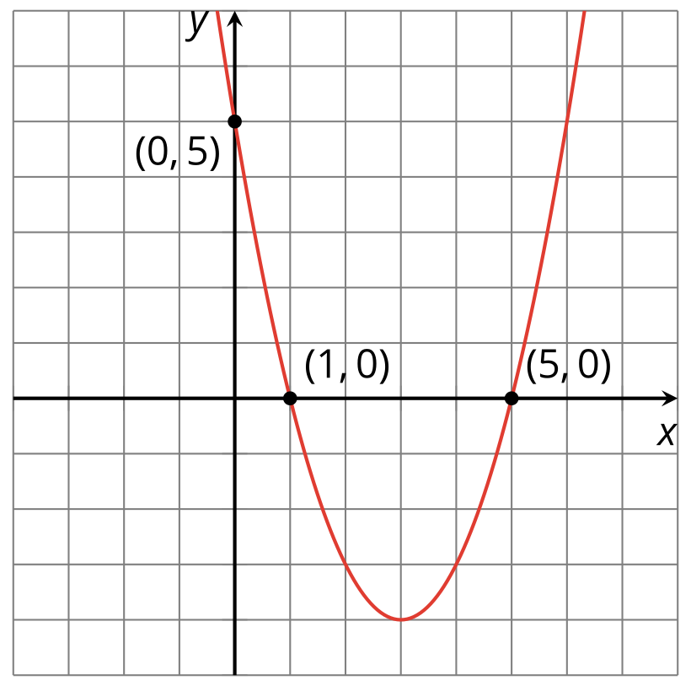
Equation:

I
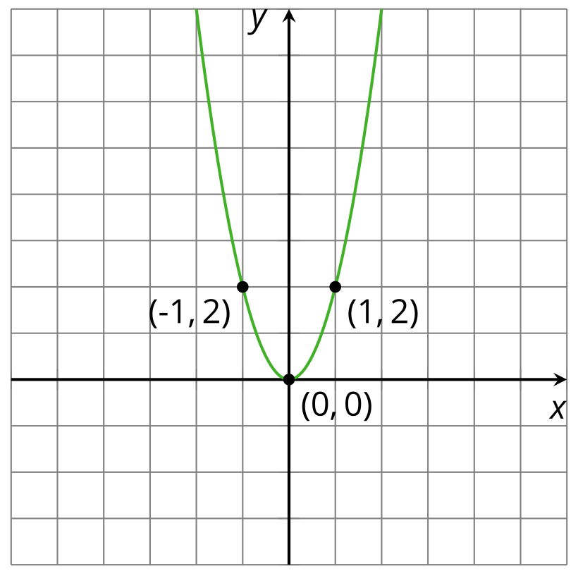
Equation:

J
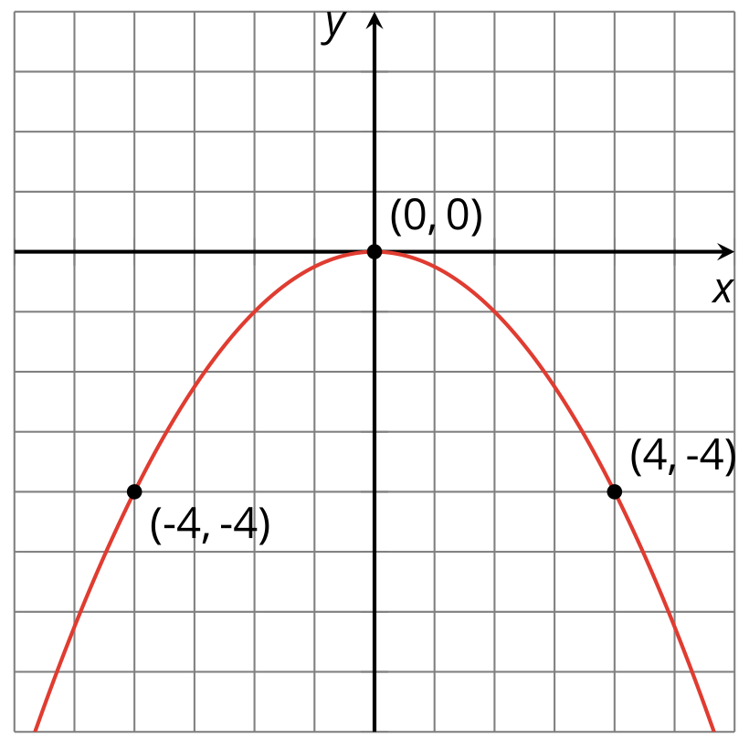
Equation:

Lesson 13 Summary
In an earlier lesson, we saw that a quadratic function written in standard form $ax^{2}+bx+c$ can tell us some things about the graph that represents it. The coefficient $a$ can tell us whether the graph of the function opens upward or downward, and also gives us information about whether it is narrow or wide. The constant term $c$ can tell us about its vertical position.
Recall that the graph representing $y=x^{2}$ is an upward-opening parabola with the vertex at $\left(0,0\right)$. The vertex is also the $x$-intercept and the $y$-intercept.
Suppose we add 6 to the squared term: $y=x^{2}+6$. Adding a 6 shifts the graph upwards, so the vertex is at $\left(0,6\right)$. The vertex is the $y$-intercept and the graph is centered on the $y$-axis.
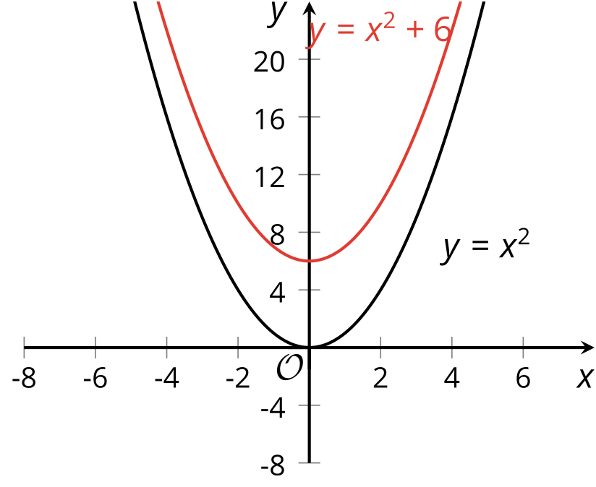
What can the linear term $bx$ tell us about the graph representing a quadratic function?
The linear term has a somewhat mysterious effect on the graph of a quadratic function. The graph seems to shift both horizontally and vertically. When we add $bx$ (where $b$ is not 0) to $x^{2}$, the graph of $y=x^{2}+bx$ is no longer centered on the $y$-axis.
Suppose we add $6x$ to the squared term: $y=x^{2}+6x$. Writing the $x^{2}+6x$ in factored form as $x\left(x+6\right)$ gives us the zeros of the function, 0 and -6. Adding the term $6x$ seems to shift the graph to the left and down and the $x$-intercepts are now $\left(\text{-}6,0\right)$ and $\left(0,0\right)$. The vertex is no longer the $y$-intercept and the graph is no longer centered on the $y$-axis.
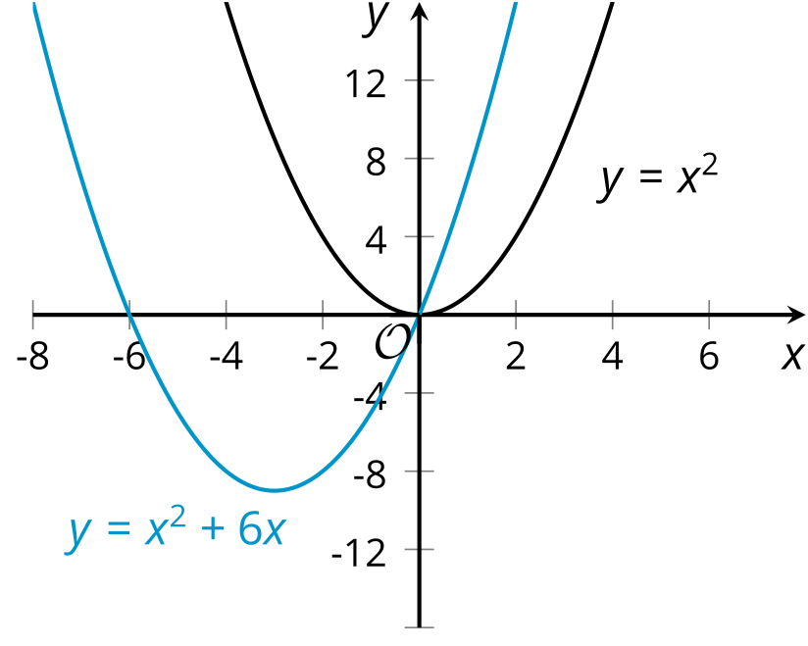
What if we add $\text{-}6x$ to $x^{2}$? $x^{2}−6x$ can be rewritten as $x\left(x−6\right)$, which tells us the zeros: 0 and 6. Adding a negative linear term to a squared term seems to shift the graph to the right and down. The $x$-intercepts are now $\left(0,0\right)$ and $\left(6,0\right)$. The vertex is no longer the $y$-intercept and the graph is not centered on the $y$-axis.
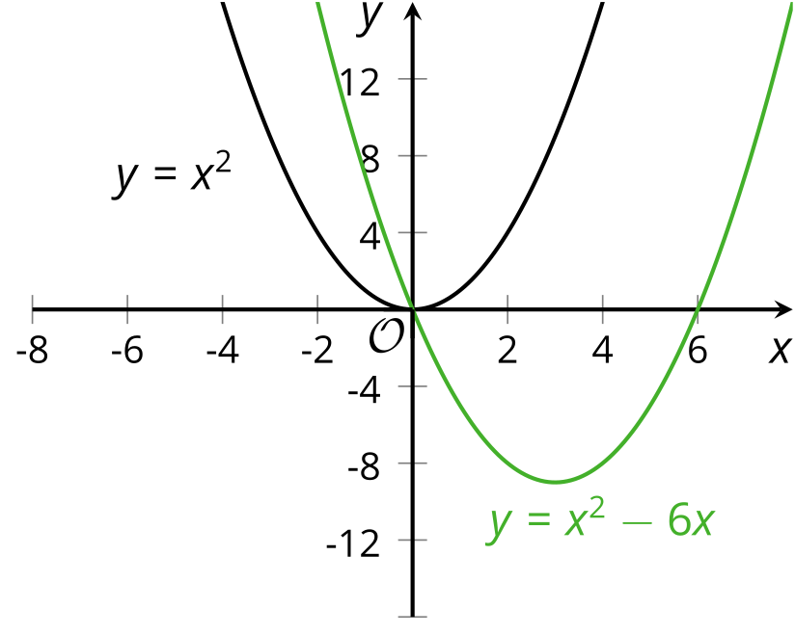
© CC BY 2019 by Illustrative Mathematics®

