Unit 6 Lesson 1: A Different Kind of Change

1 Notice and Wonder: Three Tables (Warm up)

Student Task Statement
Look at the patterns in the 3 tables. What do you notice? What do you wonder?
$x$ | $y$
1 | 0
2 | 5
3 | 10
4 | 15
5 | 20

$x$ | $y$
1 | 3
2 | 6
3 | 12
4 | 24
5 | 48

$x$ | $y$
1 | 8
2 | 11
3 | 10
4 | 5
5 | -4

2 Measuring a Garden

Student Task Statement
Noah has 50 meters of fencing to completely enclose a rectangular garden in the backyard.
- Draw some possible diagrams of Noah’s garden. Label the length and width of each rectangle.
- 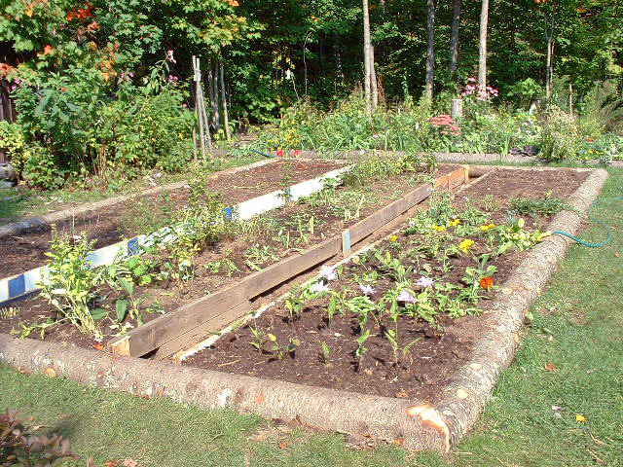
- Find the length and width of such a rectangle that would produce the largest possible area. Explain or show why you think that pair of length and width gives the largest possible area.

3 Plotting the Measurements of the Garden

Student Task Statement
- Plot some values for the length and area of the garden on the coordinate plane.
- 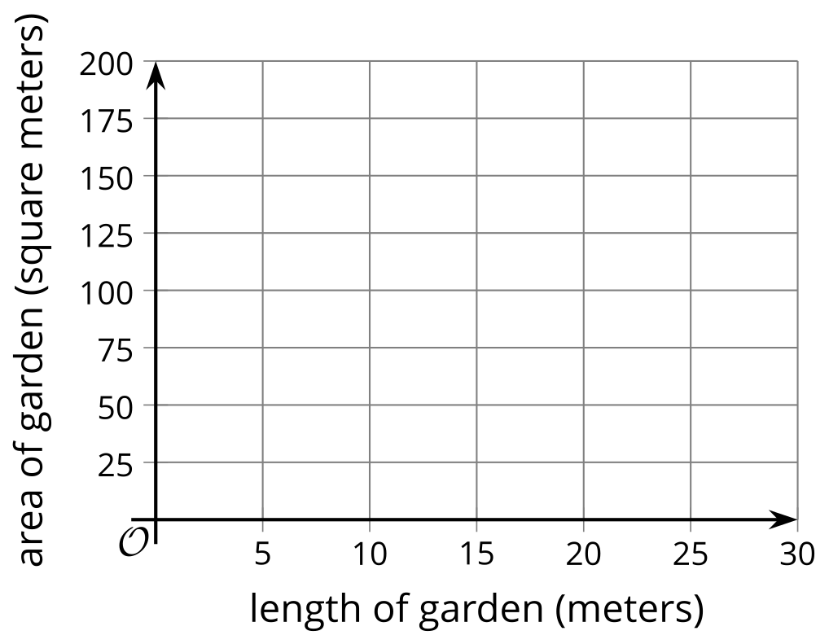
- What do you notice about the plotted points?
- The points $\left(3,66\right)$ and $\left(22,66\right)$ each represent the length and area of the garden. Plot these 2 points on coordinate plane, if you haven’t already done so. What do these points mean in this situation?
- Could the point $\left(1,25\right)$ represent the length and area of the garden? Explain how you know.
© CC BY 2019 by Illustrative Mathematics®

