Grade 2
Unit 3Lesson 16CC BY NC 2024 Illustrative Mathematics®
Unit 3, Lesson 16

Interpret Measurement Data
- Let’s represent and make sense of data in line plots.
Grade 2
Unit 3Lesson 16CC BY NC 2024 Illustrative Mathematics®

Warm-upNumber Talk: Addition within 50
Find the value of each expression mentally.
- $15+5+1$
- $25+6$
- $16+7$
- $37+6$
Grade 2
Unit 3Lesson 16CC BY NC 2024 Illustrative Mathematics®

Activity 1The Plant Project
Use the data in this table. Create a line plot.
Group B | plant heights (centimeters)
Andre | 33
Clare | 25
Diego | 27
Elena | 25
Han | 35
Jada | 33
Kiran | 26
Noah | 30
Priya | 26
Tyler | 33
Grade 2
Unit 3Lesson 16CC BY NC 2024 Illustrative Mathematics®

Activity 2Interpret Measurement Data on a Line Plot
The Plant Project
Answer the questions using your line plot.
- What is the shortest plant height?
- What is the tallest plant height?
- What is the height difference between the tallest and shortest plants? Write an equation.
- 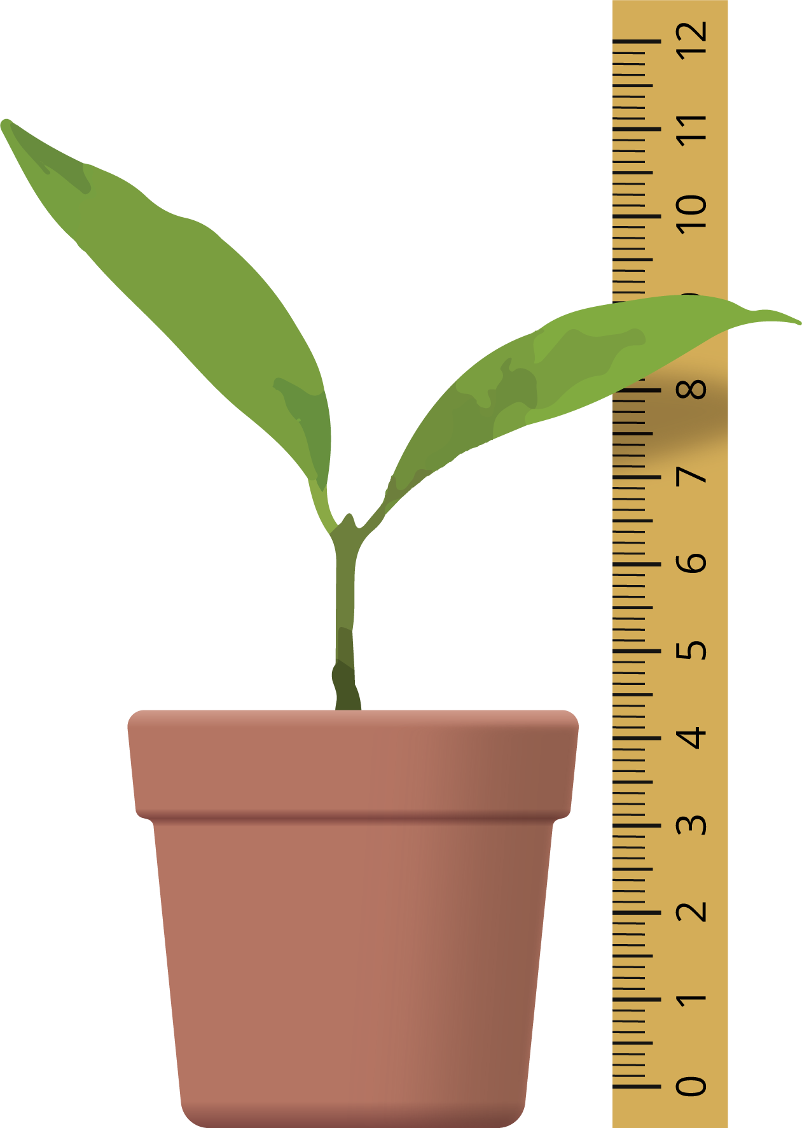
- 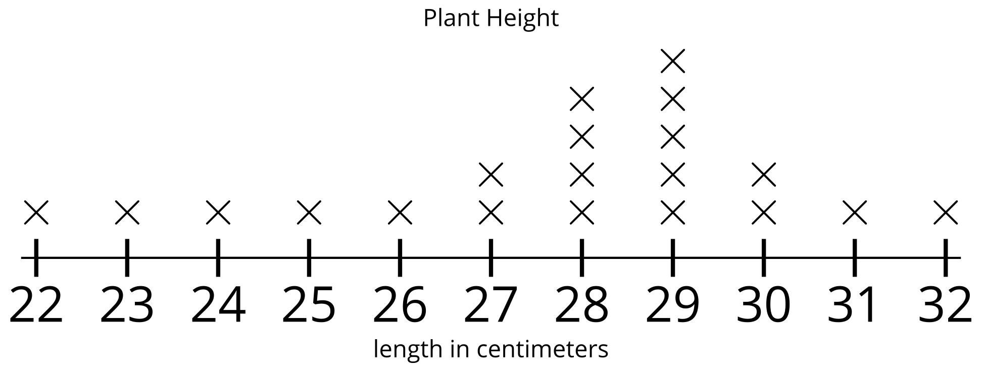
- Han looks at this line plot. He says the tallest plant is 29 centimeters. Do you agree? Explain your reasoning.
- How many plants were measured in all?
- Write a statement about Han’s line plot.

Section C Summary
We learned about a new kind of graph. A line plot shows data with Xs or other marks above a line with numbers. Each mark represents 1 number or 1 measurement. Line plots look like a ruler or a tape measure. We made our own line plots. Then we used them to answer questions about data.
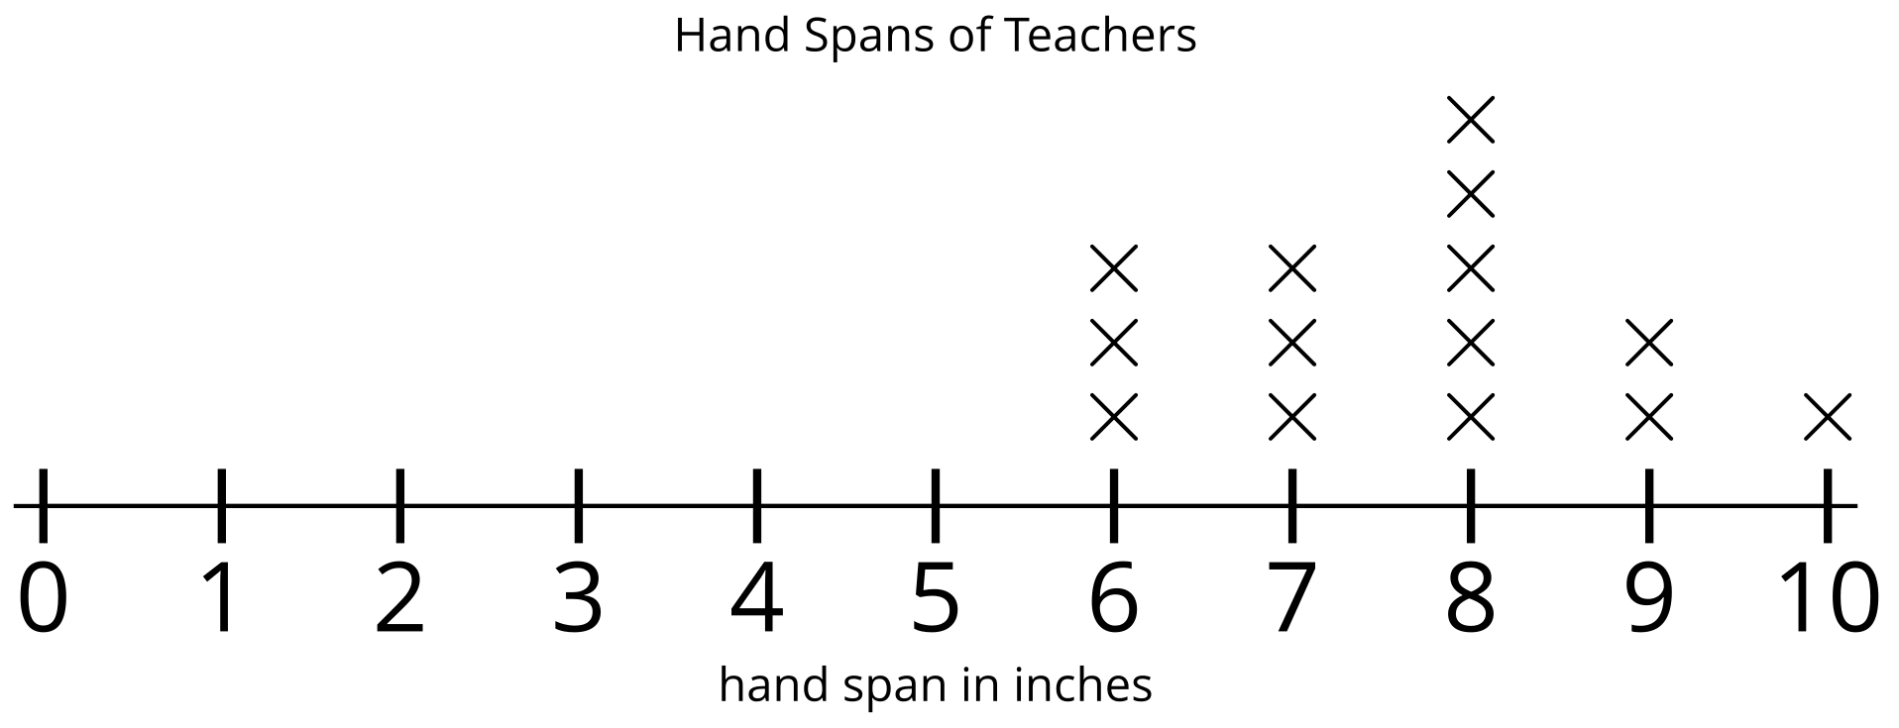
This line plot shows data about hand spans of teachers. The line with numbers shows inches, like a ruler. Each X represents the hand span of 1 teacher.
We know that 5 teachers have a hand span of 8 inches because there are 5 Xs above the 8.

