Lesson 5: Scaling and Unscaling
- Let’s examine the relationships between areas of dilated figures and scale factors.

5.1: Transamerica Building
The image shows the Transamerica Building in San Francisco. It’s shaped like a pyramid.
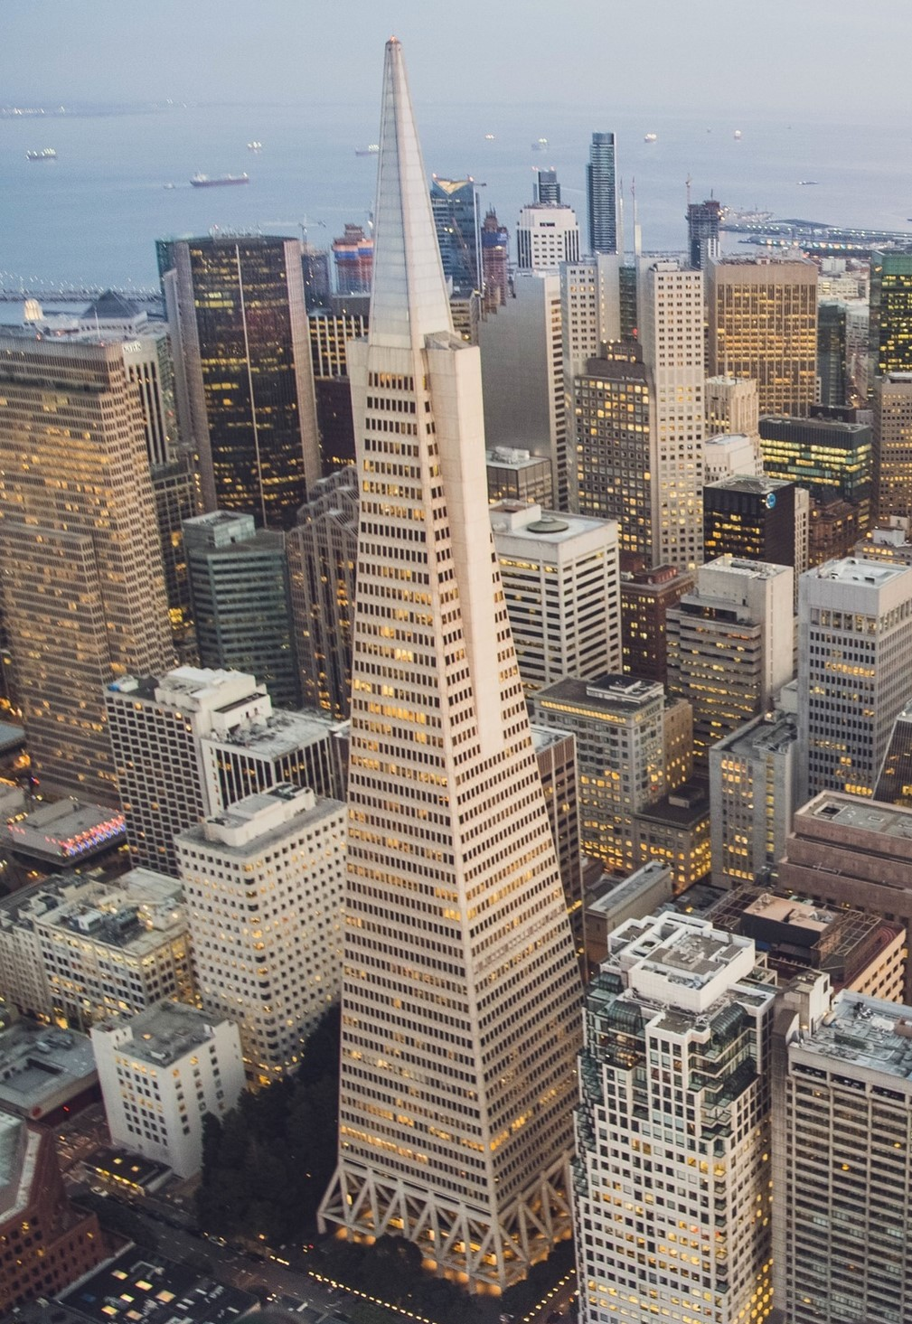
The bottom floor of the building is a rectangle measuring approximately 53 meters by 44 meters. The top floor of the building is a dilation of the base by scale factor $k=0.32$.
Ignoring the triangular “wings” on the sides, what is the area of the top floor? Explain or show your reasoning.

5.2: Two Viewpoints
A triangle has area 100 square inches. It’s dilated by a factor of $k=0.25$.
Mai says, “The dilated triangle’s area is 25 square inches.”
Lin says, “The dilated triangle’s area is 6.25 square inches.”
- For each student, decide whether you agree with their statement. If you agree, explain why. If you disagree, explain what the student may have done to arrive at their answer.
- Calculate the area of the image if the original triangle is dilated by each of these scale factors:
  - $k=9$
  - $k=\frac{3}{4}$

5.3: Graphing Areas and Scale Factors
An artist painted a 1 foot square painting. Now she wants to create more paintings of different sizes that are all scaled copies of her original painting. The paint she uses is expensive, so she wants to know the sizes she can create using different amounts of paint.
- Suppose the artist has enough paint to cover 9 square feet. If she uses all her paint, by what scale factor can she dilate her original painting?
- Complete the table that shows the relationship between the dilated area ($x$) and the scale factor ($y$). Round values to the nearest tenth if needed.
- dilated area in square feet | - scale factor
- 0
- 1
- 4
- 9
- 16
- On graph paper, plot the points from the table and connect them with a smooth curve.
- Use your graph to estimate the scale factor the artist could use if she had enough paint to cover 12 square feet.
- Suppose the painter has enough paint to cover 1 square foot, and she buys enough paint to cover an additional 2 square feet. How does this change the scale factor she can use?
- Suppose the painter has enough paint to cover 14 square feet, and she buys enough paint to cover an additional 2 square feet. How does this change the scale factor she can use?

Are you ready for more?
The image shows triangle $ABC$.
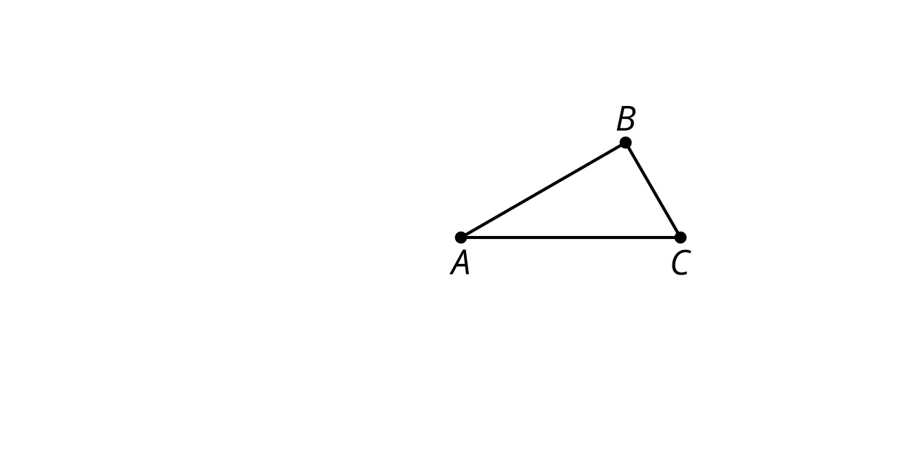
- Sketch the result of dilating triangle $ABC$ using a scale factor of 2 and a center of $A$. Label it $AB^{′}C^{′}$.
- Sketch the result of dilating triangle $ABC$ using a scale factor of -2 and a center of $A$. Label it $AB^{″}C^{″}$.
- Find a transformation that would take triangle $AB^{′}C^{′}$ to $AB^{″}C^{″}$.

Lesson 5 Summary
If we know the area of an original figure and its dilation, we can work backwards to find the scale factor. For example, suppose we have a circle with area 1 square unit, and a dilation of the circle with area 64 square units. We know the circle must have been dilated by a factor of 8, because 8² = 64. Another way to say this is $\sqrt{64}=8$.
A graph can help us understand the relationship between dilated areas and scale factors. We can make a table of values for the dilated circle, plot the points on a graph, and connect them with a smooth curve. In this table, the dilated area is the input or $x$ value, and the scale factor is the output or $y$ value. Remember that the area of the original circle is 1 square unit, so the square root of the dilated area is the same as the scale factor.
dilated area in square units | scale factor
0 | 0
1 | 1
4 | 2
9 | 3
16 | 4
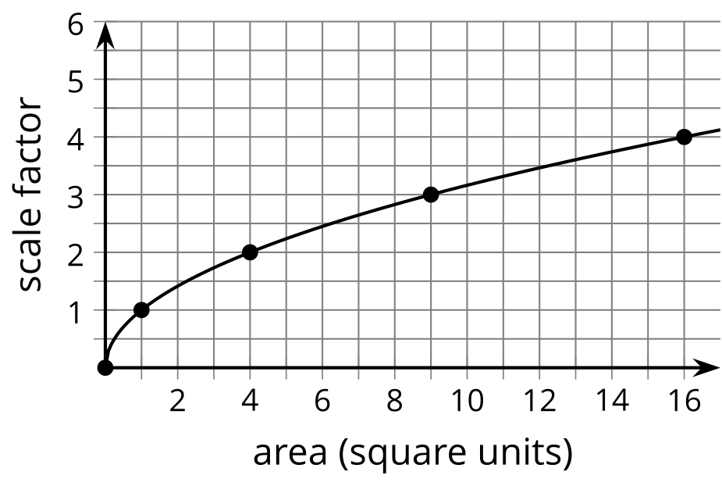
This graph represents the equation that describes the relationship between area and scale factor: $y=\sqrt{x}$. Note that the rate of change isn’t constant. On the left side, the graph is fairly steep. As the area increases, the scale factor increases quickly. But on the right side, the graph flattens out. As the area continues to increase, the scale factor still increases, but not as quickly.
© CC BY 2019 by Illustrative Mathematics®

