Grade 2
Unit 4Lesson 11CC BY NC 2024 Illustrative Mathematics®
Unit 4, Lesson 11

Different Ways to Add and Subtract
- Let’s add and subtract by using a ten.
Grade 2
Unit 4Lesson 11CC BY NC 2024 Illustrative Mathematics®

Warm-up Number Talk: Use Tens
Find the value of each expression mentally.
- $32−6$
- $43−8$
- $51−5$
- $52−7$
Grade 2
Unit 4Lesson 11CC BY NC 2024 Illustrative Mathematics®

Activity 1 Compare Methods
Diego and Tyler find the value of $53−29$. Their work is shown.
Diego’s method:
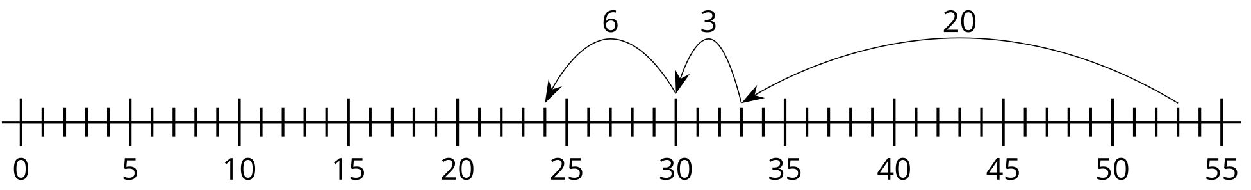
Tyler’s method:
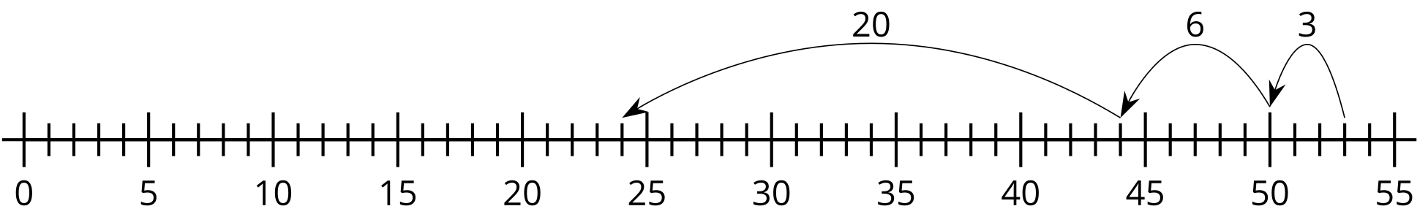
- Use Diego’s method to find the value of $82−35$.
- Use Tyler’s method to find the value of $66−28$.
Grade 2
Unit 4Lesson 11CC BY NC 2024 Illustrative Mathematics®

Activity 2 More Methods
Partner A
- Find the value of $59+27$.
- Find the value of $65−18$.
Partner B
- Find the value of $68−39$.
- Find the value of $22+49$.


