Lesson 13: Whole Numbers and Fractions
- Let’s find fractions and whole numbers that are equivalent.

Warm-up: Notice and Wonder: Four Number Lines
What do you notice? What do you wonder?
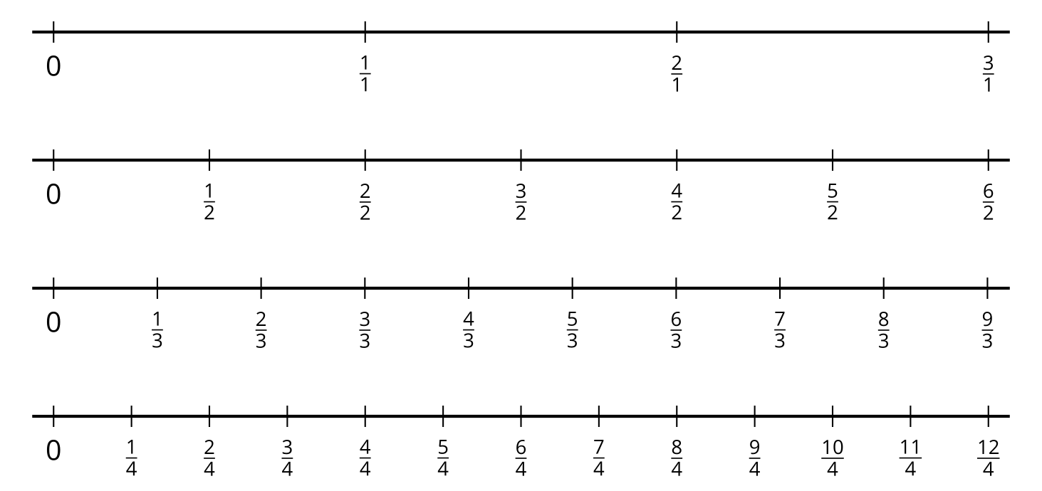

13.1: Hidden Whole Numbers
- On each number line, circle the fractions that are equivalent to whole numbers. Explain how you know.
- 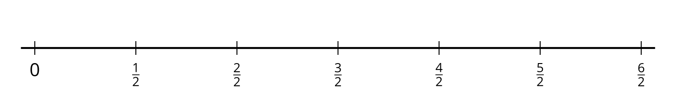
- 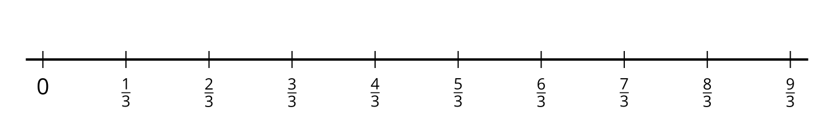
- 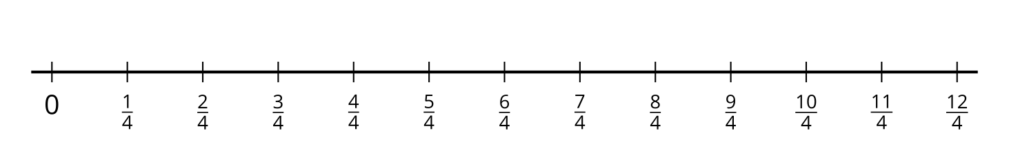
- We can write $\frac{4}{2}=2$ to show that $\frac{4}{2}$ and 2 are at the same location on the number line, so they are equivalent.
- Write 5 other equations that show fractions that are equivalent to whole numbers. Use the number lines if they are helpful.
- 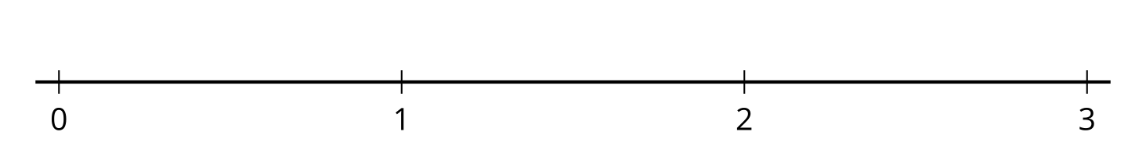
- Decide if each fraction is equivalent to a whole number. Use number lines if they are helpful.
  - $\frac{11}{2}$
  - $\frac{5}{1}$
  - $\frac{12}{6}$
  - $\frac{10}{3}$
  - $\frac{12}{8}$
  - $\frac{16}{4}$

13.2: Write Them as Fractions
Work with your group to complete the table. In each column, write fractions that are equivalent to the whole number in the top row.
- Step 1: Write two fractions that are equivalent to each whole number (six fractions in all). Pass your paper to your right.
- Step 2: When you receive your neighbor’s paper, write a new fraction that is equivalent to a whole number.
- Repeat Step 2 until the table is complete.
4 | 5 | 6
$\frac{4}{1}$
 | 0002
 |  | 0003
0004
 | $\frac{30}{6}$
 |  | $\frac{48}{8}$
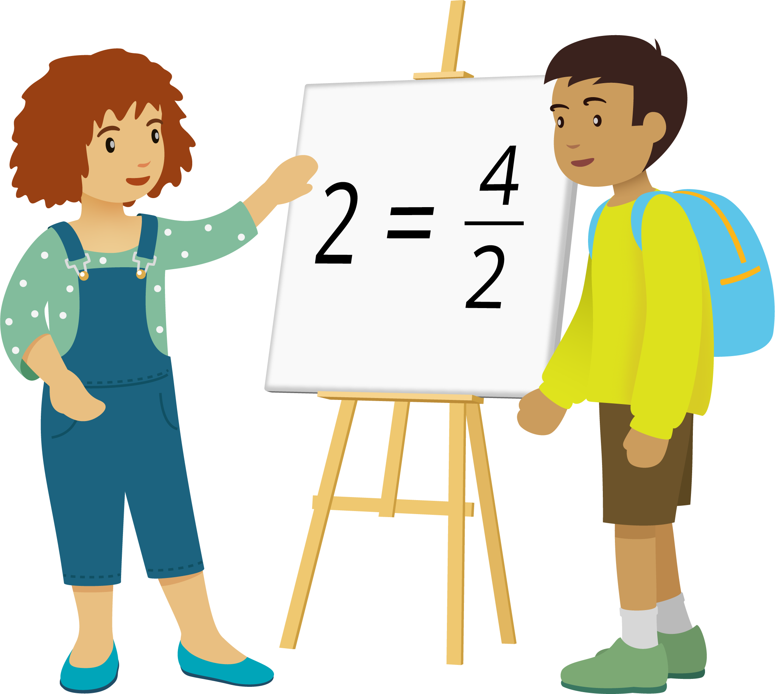

Section Summary
Section Summary In this section, we learned that different fractions can be equivalent. We know fractions are equivalent if they are the same size or located at the same location on the number line.


$\frac{1}{3}=\frac{2}{6}$
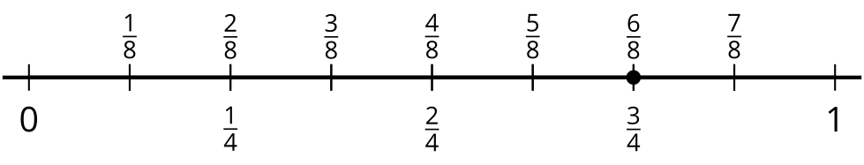
$\frac{6}{8}=\frac{3}{4}$
We also learned that some fractions are whole numbers, and that we can write whole numbers as fractions.
$4=\frac{12}{3}$
© CC BY 2021 Illustrative Mathematics®

