Grade 2
Unit 5Lesson 13CC BY NC 2024 Illustrative Mathematics®
Unit 5, Lesson 13

Center Day 2
- Let’s work on place value.
Grade 2
Unit 5Lesson 13CC BY NC 2024 Illustrative Mathematics®

Warm-up How Many Do You See: Place Value
How many do you see? How do you see them?
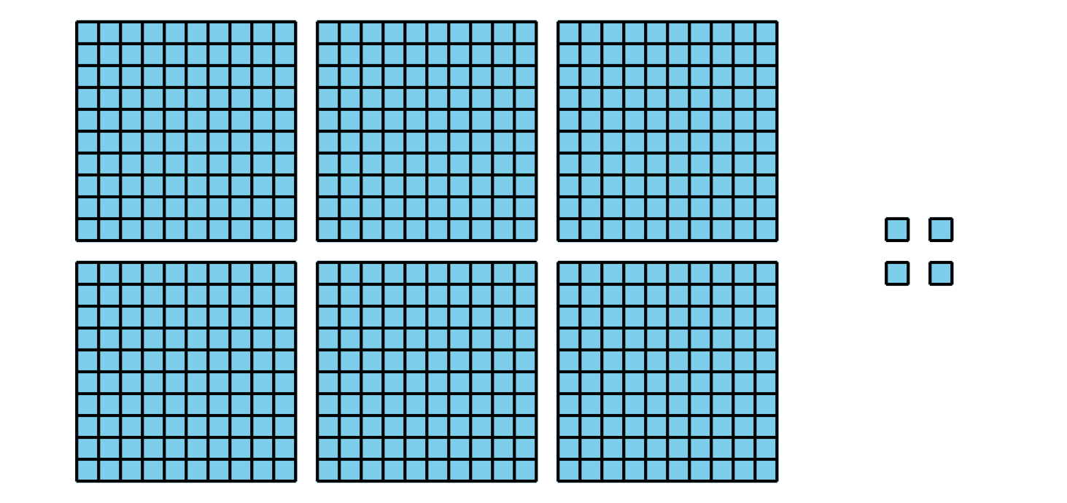
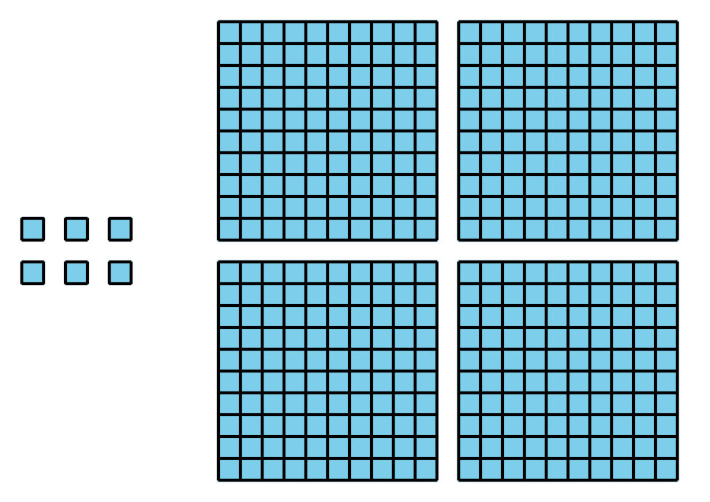
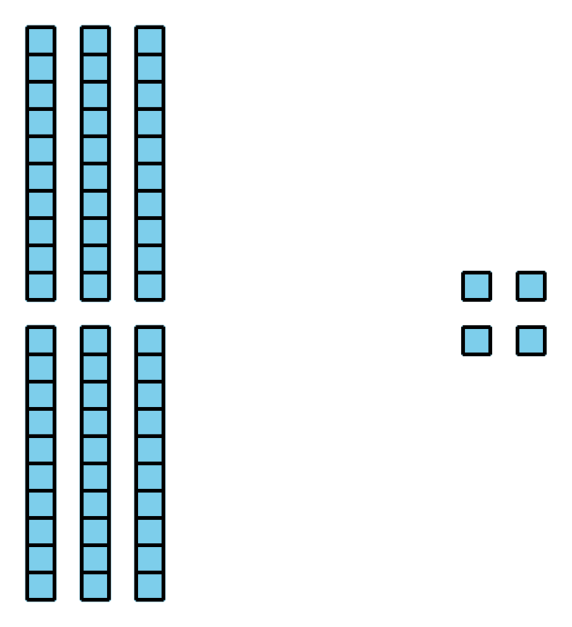
Grade 2
Unit 5Lesson 13CC BY NC 2024 Illustrative Mathematics®

Activity 2 Centers: Choice Time
Choose a center.
Get Your Numbers in Order
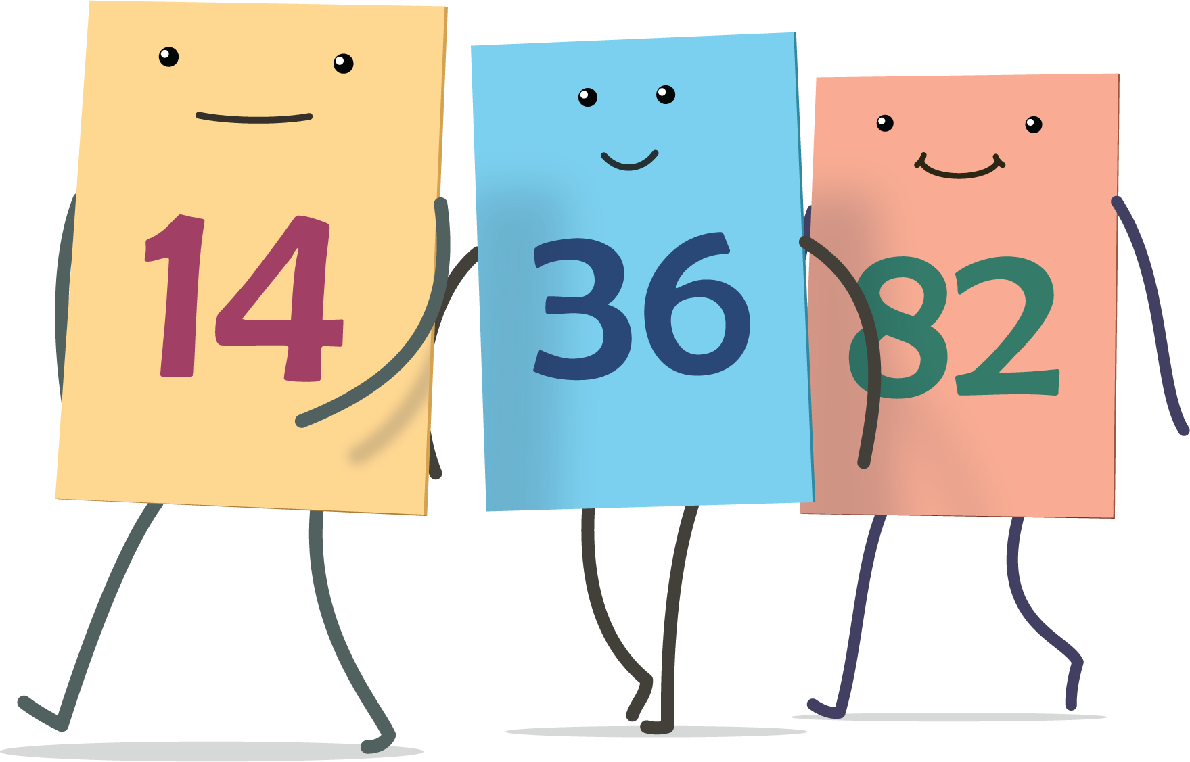
Greatest of Them All

Mystery Number
