Lesson 3: Count 2 Groups of Scattered Images

Standards Alignments
Addressing | K.CC.A.1, K.CC.B.5

Teacher-facing Learning Goals
- Count to find the total number of images given two groups of organized or scattered images, up to 10.

Student-facing Learning Goals
- Let’s find out how many things there are in two scattered groups.

Lesson Purpose
The purpose of this lesson is for students to count to find the total number of images in 2 scattered groups.
In previous lessons, students have counted to find the total number of objects in 2 groups and the total number of images in 2 organized groups. In this lesson, students continue to put together 2 groups in order to find the total. The focus of the lesson synthesis is on keeping track of images that have been counted so each image is counted once and only once. This is the first lesson where students participate in a cool-down after the lesson synthesis.

Access for:

Students with Disabilities
- Representation (Activity 2)

English Learners
- MLR8 (Activity 2)

Instructional Routines
Choral Count (Warm-up)

Materials to Gather
- Materials from previous centers: Activity 3

Lesson Timeline
Warm-up | 10 min
Activity 1 | 10 min
Activity 2 | 10 min
Activity 3 | 20 min
Lesson Synthesis | 5 min
Cool-down | 5 min

Teacher Reflection Question
How does the work of this lesson and the previous lesson lay a foundation for solving addition story problems?

Cool-down
(to be completed at the end of the lesson) 5min
How Many Dots?

Standards Alignments
Addressing | K.CC.B.5

Student-facing Task Statement
How many dots are there?

There are
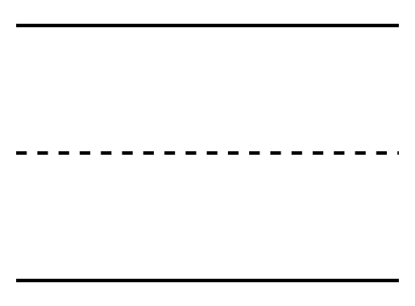
dots.

Student Responses
8

