Algebra 1
Unit 7Lesson 3CC BY NC 2024 Illustrative Mathematics®
Unit 7, Lesson 3

Building Quadratic Functions from Geometric Patterns
- Let’s describe some other geometric patterns.
Algebra 1
Unit 7Lesson 3CC BY NC 2024 Illustrative Mathematics®

3.1Quadratic Expressions and Area
Figure A is a large square. Figure B is a large square with a smaller square removed. Figure C is composed of two large squares with one smaller square added.

Figure A


Figure B
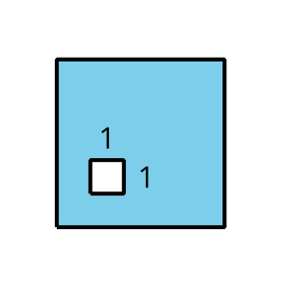

Figure C
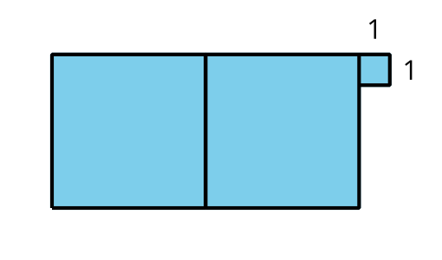
Write an expression to represent the area of each shaded figure when the side length of the large square is as shown in the first column.
side length of  large square | area of A | area of B | area of C
4
$x$
$4x$
$\left(x+3\right)$
Algebra 1
Unit 7Lesson 3CC BY NC 2024 Illustrative Mathematics®

3.2Expanding Squares
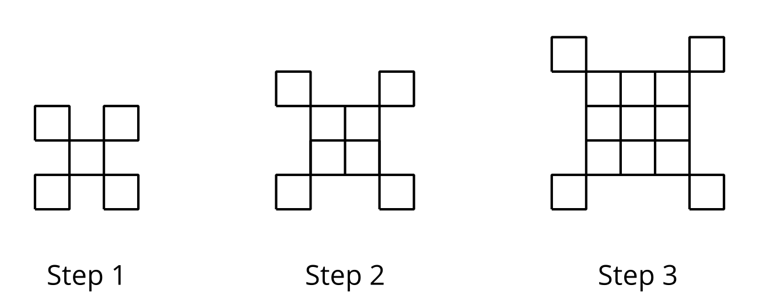
- If the pattern continues, what will we see in Step 5 and Step 18?
  - Sketch or describe the figure in each of these steps.
  - How many small squares are in each of these steps? Explain how you know.
- Write an equation to represent the relationship between the step number, $n$, and the number of squares, $y$. Be prepared to explain how each part of your equation relates to the pattern. (If you get stuck, try making a table.)
- Sketch the first 3 steps of a pattern that can be represented by the equation $y=n^{2}−1$.

Are you ready for more?
- For the original step pattern in the statement, write an equation to represent the relationship between the step number, $n$, and the perimeter, $P$.
- For the step pattern you created in part 3 of the activity, write an equation to represent the relationship between the step number, $n$, and the perimeter, $P$.
- Are these linear functions?
Algebra 1
Unit 7Lesson 3CC BY NC 2024 Illustrative Mathematics®

3.3Growing Steps
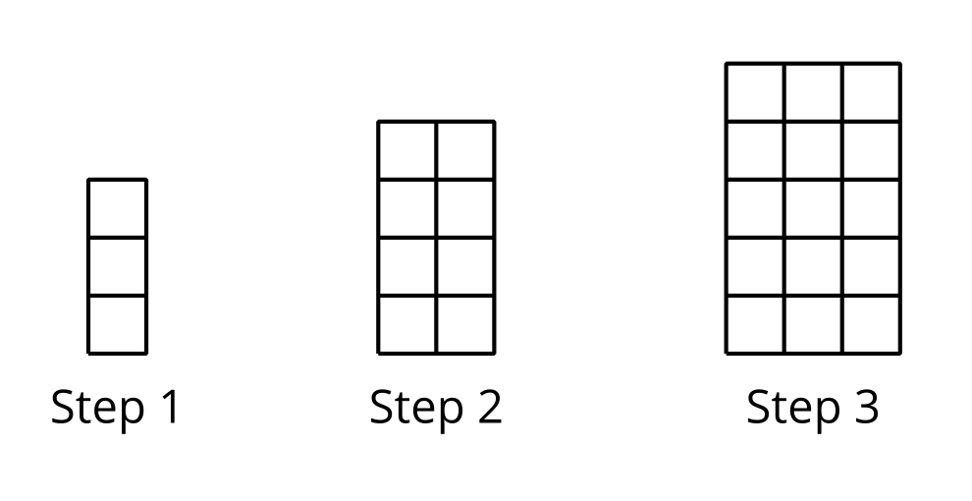
- Sketch the next step in the pattern.
- Kiran says that the pattern is growing linearly because as the step number goes up by 1, the number of rows and the number of columns also increase by 1. Do you agree? Explain your reasoning.
- To represent the number of squares after $n$ steps, Diego and Jada wrote different equations. Diego wrote the equation $f\left(n\right)=n\left(n+2\right)$. Jada wrote the equation $f\left(n\right)=n^{2}+2n$. Are either Diego or Jada correct? Explain your reasoning.

Lesson 3 Summary
Sometimes a quadratic relationship can be expressed without writing a squared term that appears as a variable raised to the second power (like $n^{2}$ or $x^{2}$). Let’s take this pattern of squares, for example.
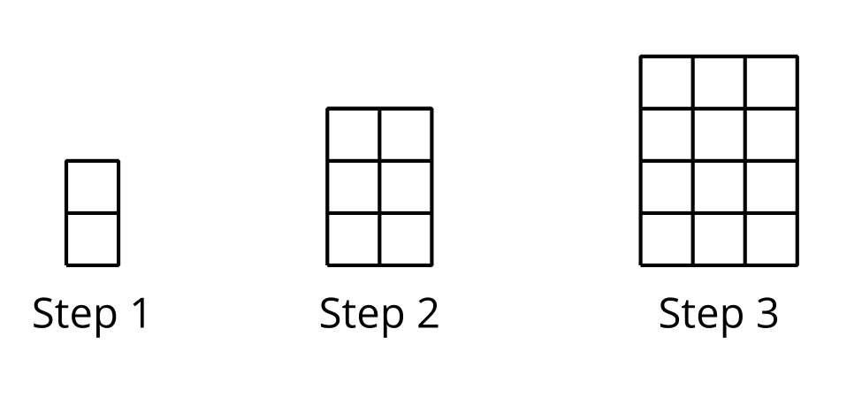
From the first 3 steps, we can see that both the length and the width of the rectangle increase by 1 at each step. Step 1 is a 1-by-2 rectangle, Step 2 is a 2-by-3 rectangle, and Step 3 is a 3-by-4 rectangle. This suggests that Step $n$ is a rectangle with side lengths of $n$ and $n+1$, so the number of squares at Step $n$ is $n\left(n+1\right)$.
This expression may not look like quadratic expressions with a squared term, which we saw in earlier lessons, but if we apply the distributive property, we can see that $n\left(n+1\right)$ is equivalent to $n^{2}+n$.
We can also visually show that these expressions are the equivalent by breaking each rectangle into an $n$-by-$n$ square (the $n^{2}$ in the expression) and an $n$-by-$1$ rectangle (the $n$ in the expression).
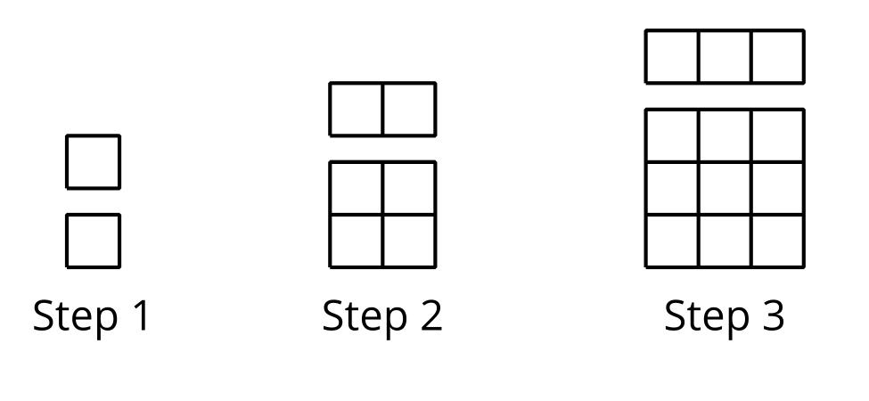
The relationship between the step number and the number of squares can be described by a quadratic function, $f$, whose input is $n$ and whose output is the number of squares at Step $n$. We can define $f$ with $f\left(n\right)=n\left(n+1\right)$ or with $f\left(n\right)=n^{2}+n$.

