Lesson 2 Practice Problems
- A cyclist rode 3.75 miles in 0.3 hours.
  - How fast was she going in miles per hour?
  - At that rate, how long will it take her to go 4.5 miles?
- A recipe for sparkling grape juice calls for $1\frac{1}{2}$ quarts of sparkling water and $\frac{3}{4}$ quart of grape juice.
  - How much sparkling water would you need to mix with 9 quarts of grape juice?
  - How much grape juice would you need to mix with $\frac{15}{4}$ quarts of sparkling water?
  - How much of each ingredient would you need to make 100 quarts of sparkling grape juice?
- At a deli counter,
  - Someone bought $1\frac{3}{4}$ pounds of ham for $14.50.
  - Someone bought $2\frac{1}{2}$ pounds of turkey for $26.25.
  - Someone bought $\frac{3}{8}$ pounds of roast beef for $5.50.
- Which meat is the least expensive per pound? Which meat is the most expensive per pound? Explain how you know.

  - Draw a scaled copy of the circle
using a scale factor of 2.
  - 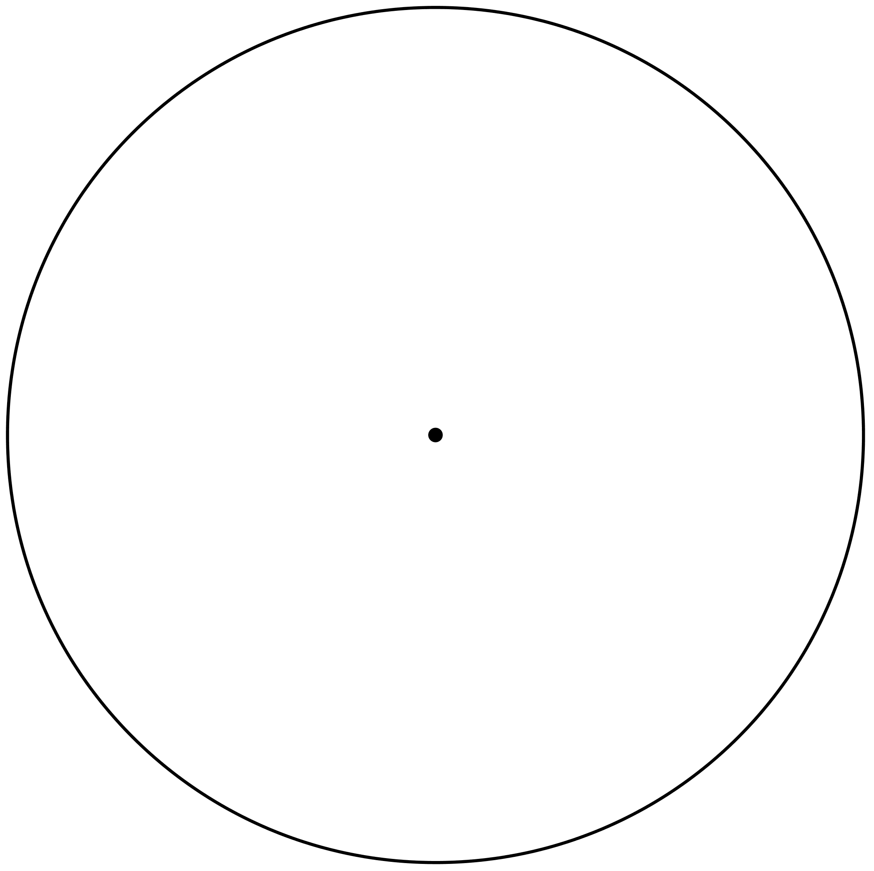
  - How does the circumference of the scaled copy compare to the circumference of the original circle?
  - How does the area of the scaled copy compare to the area of the original circle?
- (From Unit 3, Lesson 10.)
- Jada has a scale map of Kansas that fits on a page in her book. The page is 5 inches by 8 inches. Kansas is about 210 miles by 410 miles. Select all scales that could be a scale of the map. (There are 2.54 centimeters in an inch.)
  - 1 in to 1 mi
  - 1 cm to 1 km
  - 1 in to 10 mi
  - 1 ft to 100 mi
  - 1 cm to 200 km
  - 1 in to 100 mi
  - 1 cm to 1000 km
- (From Unit 1, Lesson 11.)
© CC BY Open Up Resources. Adaptations CC BY IM.

