Lesson 1: Lines, Angles, and Curves
- Let’s define some line segments and angles related to circles.

1.1: Notice and Wonder: Lines and Angles
What do you notice? What do you wonder?




1.2: The Defining Moment
- The images show some line segments that are chords and some segments that are not chords.

- chords
- 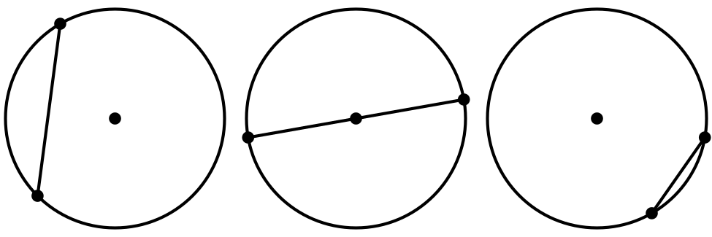

- not chords
- 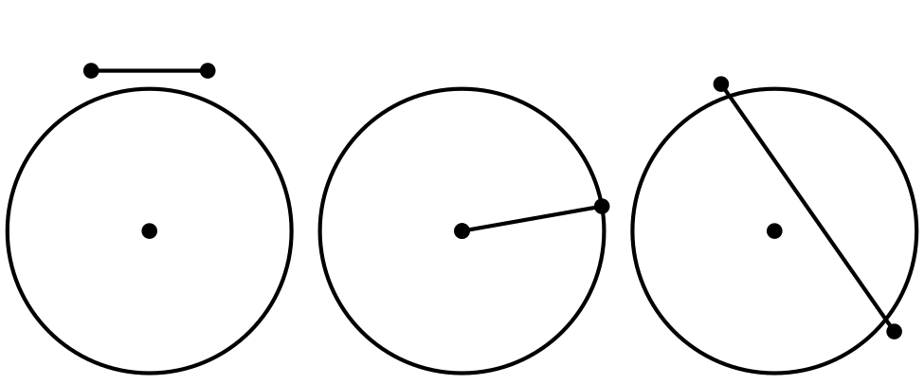
- Write a definition of a chord.
- The images show some highlighted objects that are arcs, and some highlighted objects that are not arcs.

- arcs
- 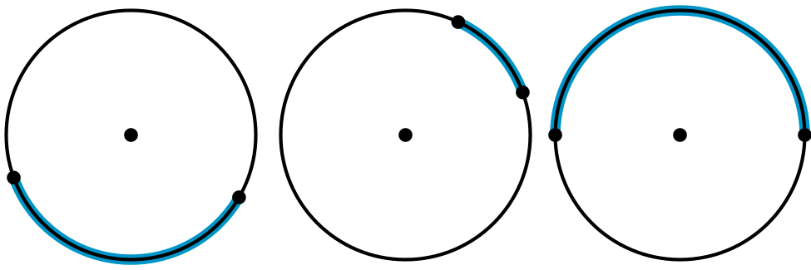

- not arcs
- 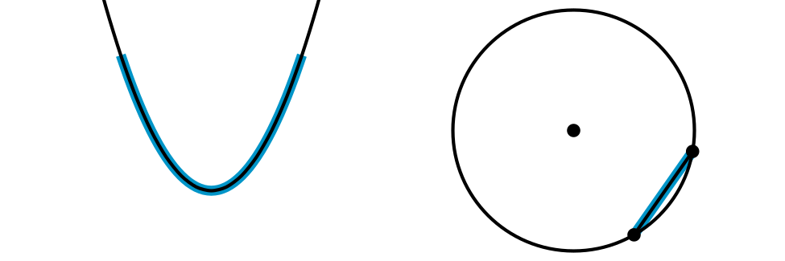
- Write a definition of an arc.
- The images show some angles that are central angles, and some that are not.

- central angles
- 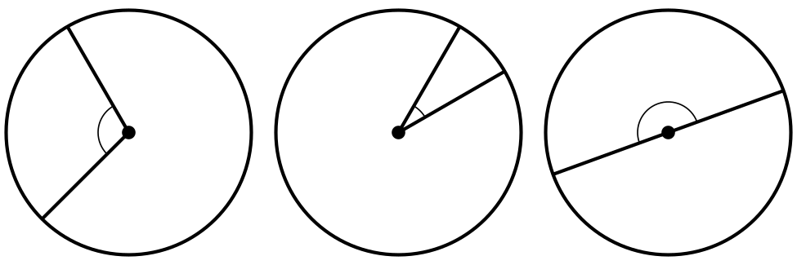

- not central angles
- 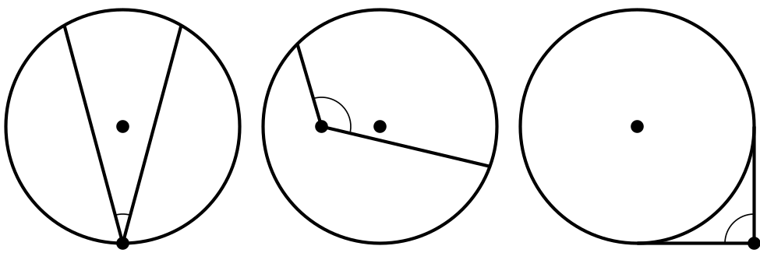
- Write a definition of a central angle.

1.3: Arcs, Chords, and Central Angles
The image shows a circle with 2 congruent chords.
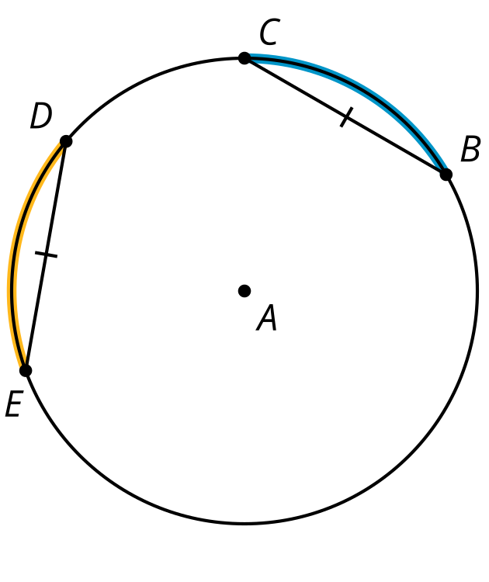
- Draw the central angles associated with the highlighted arcs from $D$ to $E$ and $B$ to $C$.
- How do the measures of the 2 central angles appear to compare? Prove that this observation is true.
- What does this tell you about the measures of the highlighted arcs from $D$ to $E$ and $B$ to $C$? Explain your reasoning.

Are you ready for more?
Prove that the perpendicular bisector of a chord goes through the center of a circle.

Lesson 1 Summary
Diameters and radii are 2 types of line segments that appear in circles. Here are some additional geometric objects associated with circles.
A chord is a line segment whose endpoints are on the circle. A central angle in a circle is an angle whose vertex is at the center of the circle. An arc is the portion of a circle between 2 points on the circle. The measure of an arc is defined as the measure of the central angle formed by the radii drawn to the endpoints of the arc. For example, in the image, the highlighted arc between points $D$ and $E$ measures 45 degrees because the central angle $DAE$ measures 45 degrees.

chord $GH$
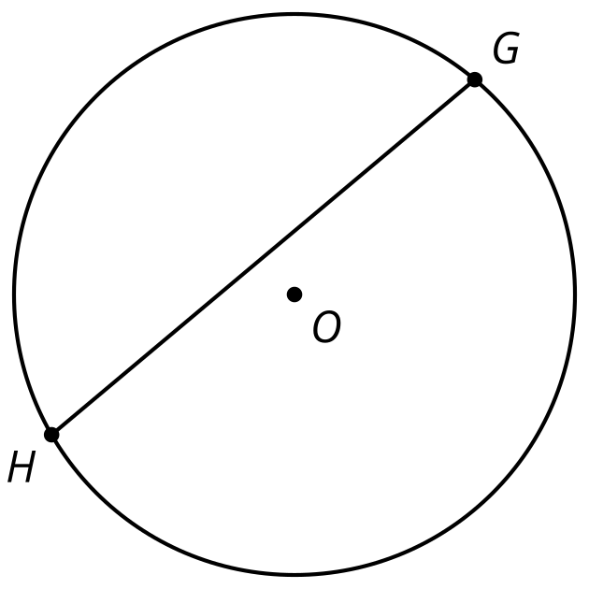

central angle $PQR$
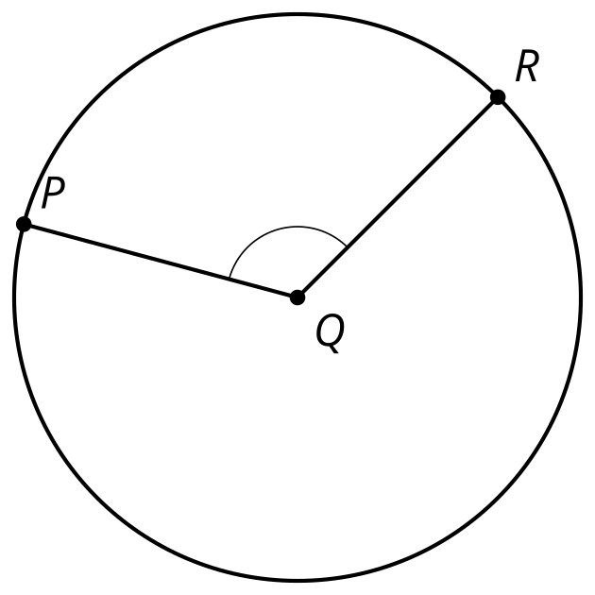

arc $DE$
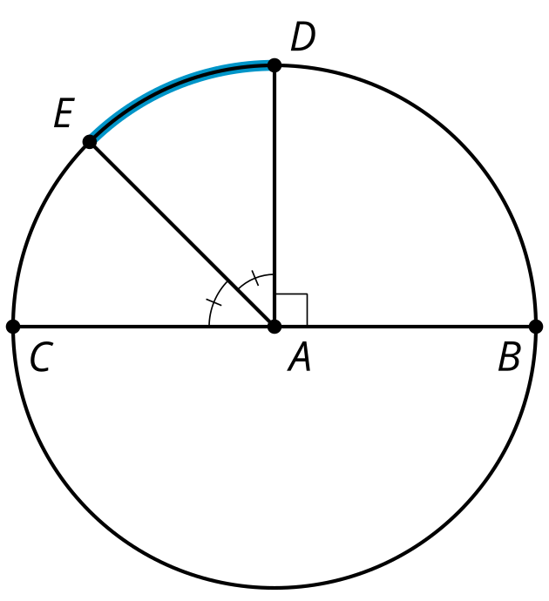
© CC BY 2019 by Illustrative Mathematics®

