## Unit 6 Lesson 12: Ways to Represent Measurement Situations

### WU Notice and Wonder: The Fair (Warm up)

#### Student Task Statement

What do you notice? What do you wonder?

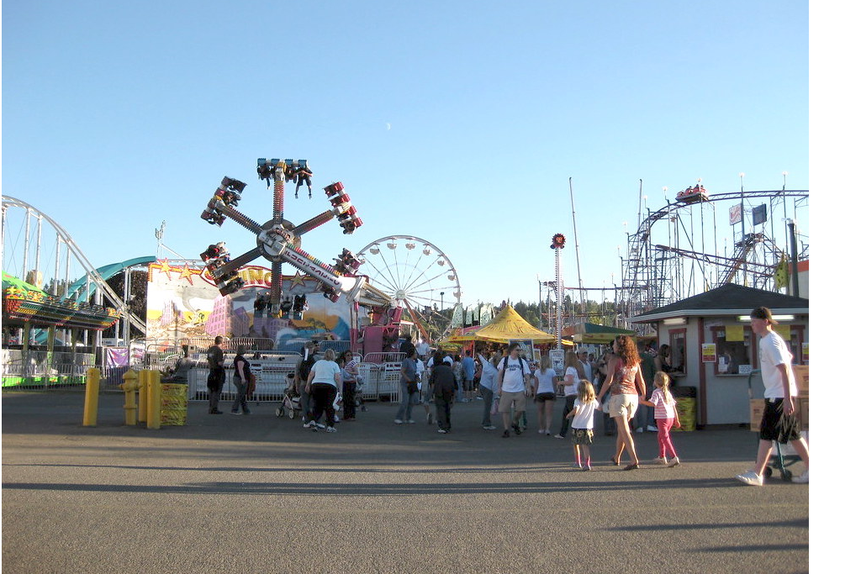

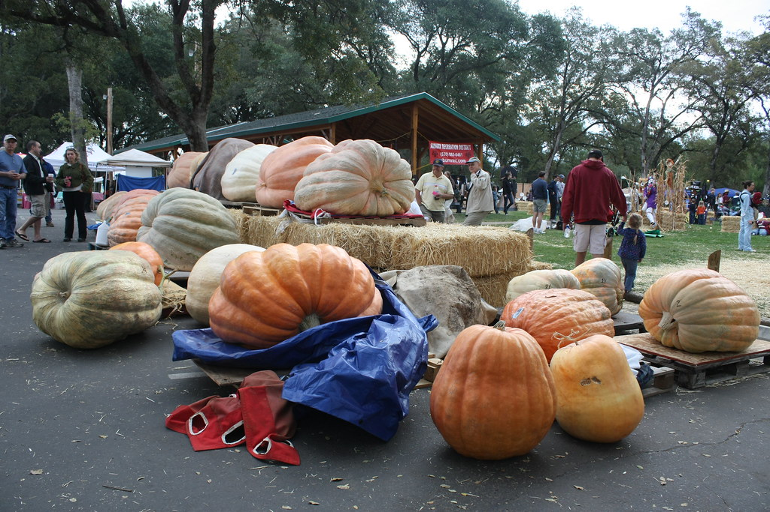

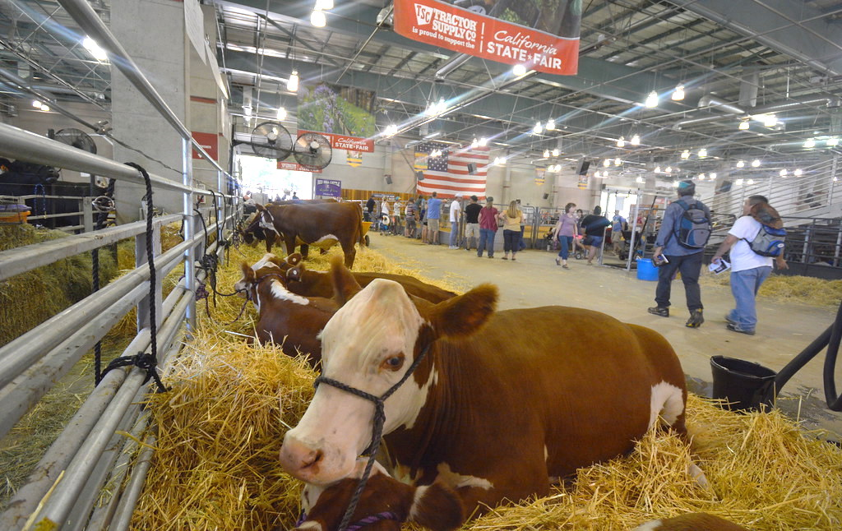

### 1 Giant Pumpkin Event

#### Student Task Statement

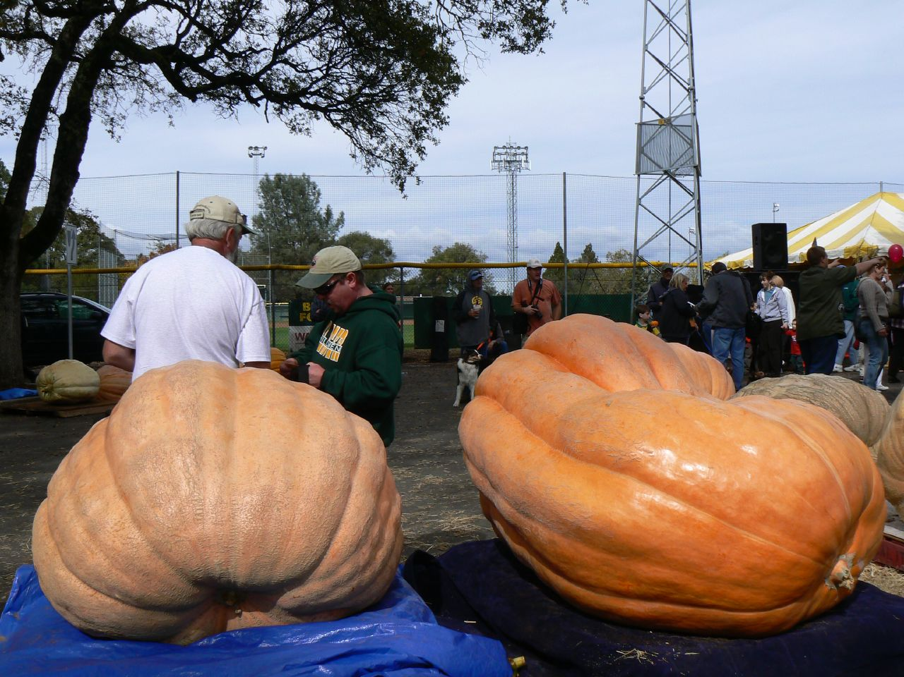

1. Write a list of mathematical questions that could be asked about this image.
2. Work with your partner to solve the problem you were given by your teacher and show your thinking on a poster. Be sure to write down on your poster the problem you are solving.

### 2 Card Sort: Giant Pumpkins

#### Student Task Statement

Your teacher will give you a set of cards with descriptions and diagrams.

Match each description with a diagram that represents the same situation.

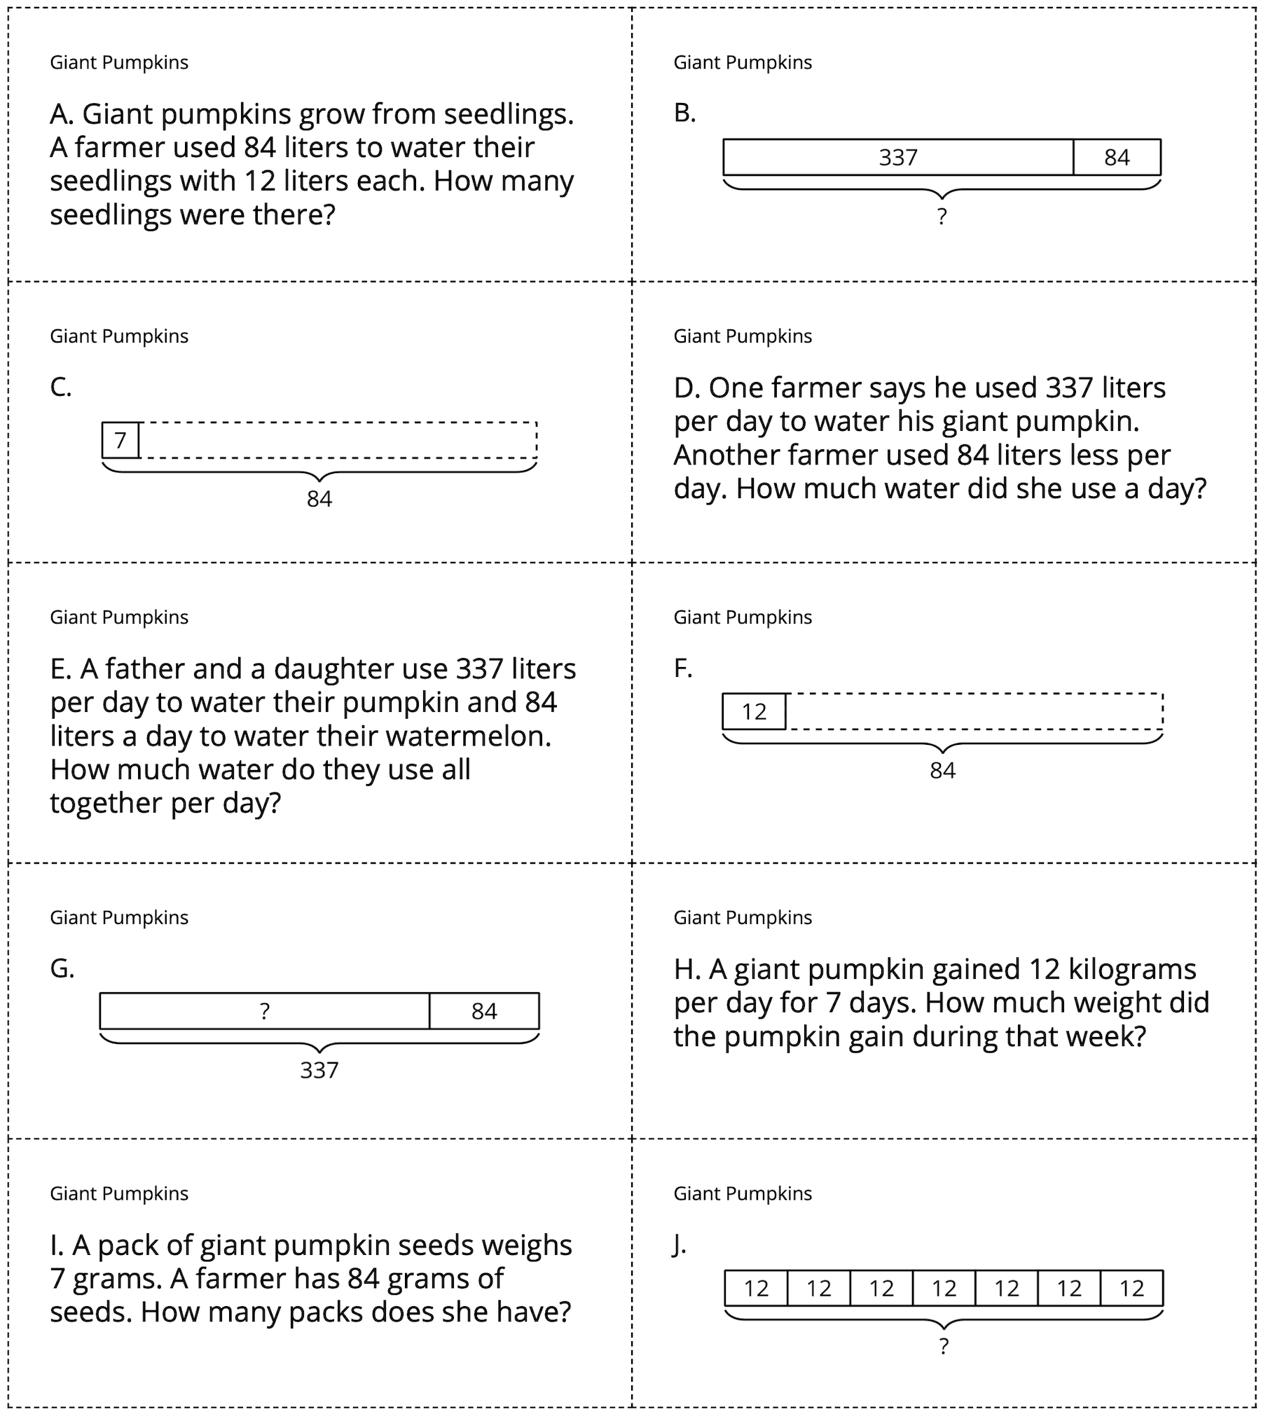



© CC BY 2021 Illustrative Mathematics®