Lesson 2 Practice Problems
- Select all the true equations.
  - $5+0=0$
  - $15⋅0=0$
  - $1.4+2.7=4.1$
  - $\frac{2}{3}⋅\frac{5}{9}=\frac{7}{12}$
  - $4\frac{2}{3}=5−\frac{1}{3}$
- Mai's water bottle had 24 ounces in it. After she drank $x$ ounces of water, there were 10 ounces left. Select all the equations that represent this situation.
  - $24÷10=x$
  - $24+10=x$
  - $24−10=x$
  - $x+10=24$
  - $10x=24$
- Priya has 5 pencils, each $x$ inches in length. When she lines up the pencils end to end, they measure 34.5 inches. Select all the equations that represent this situation.
  - $5+x=34.5$
  - $5x=34.5$
  - $34.5÷5=x$
  - $34.5−5=x$
  - $x=\left(34.5\right)⋅5$
- Match each equation with a solution from the list of values.
  - $2a=4.6$
  - $b+2=4.6$
  - $c÷2=4.6$
  - $d−2=4.6$
  - $e+\frac{3}{8}=2$
  - $\frac{1}{8}f=3$
  - $g÷\frac{8}{5}=1$
  - $\frac{8}{5}$
  - $1\frac{5}{8}$
  - 2.3
  - 2.6
  - 6.6
  - 9.2
  - 24
- The daily recommended allowance of vitamin C for a sixth grader is 45 mg. 1 orange has about 75% of the recommended daily allowance of vitamin C. How many milligrams are in 1 orange? If you get stuck, consider using the double number line.
- 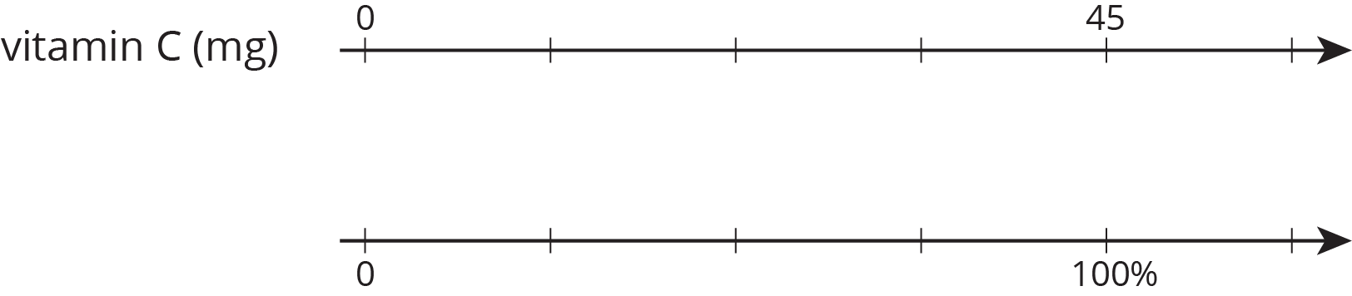
- (From Unit 2, Lesson 20.)
- There are 90 kids in the band. 20% of the kids own their own instruments, and the rest rent them.
  - How many kids own their own instruments?
  - How many kids rent instruments?
  - What percentage of kids rent their instruments?
- (From Unit 2, Lesson 21.)
- Find each product.
  - $\left(0.25\right)⋅\left(1.4\right)$
  - $\left(0.061\right)⋅\left(0.43\right)$
  - $\left(1.017\right)⋅\left(0.072\right)$
  - $\left(5.226\right)⋅\left(0.037\right)$
- (From Unit 3, Lesson 17.)
© CC BY Open Up Resources. Adaptations CC BY IM.

