Lesson 21: Compose and Decompose Numbers 11–19
- Let’s make groups of 10.

Warm-up: Which One Doesn’t Belong: Numbers 11–20
Which one doesn’t belong?
A
B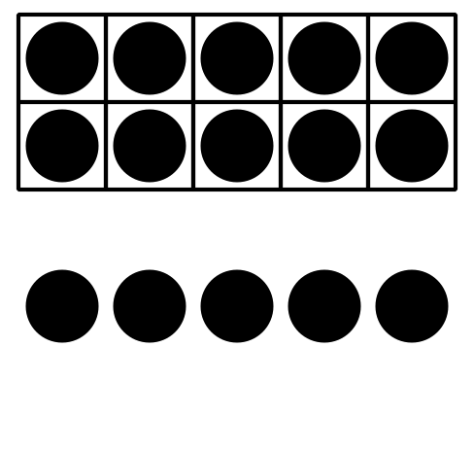
C

D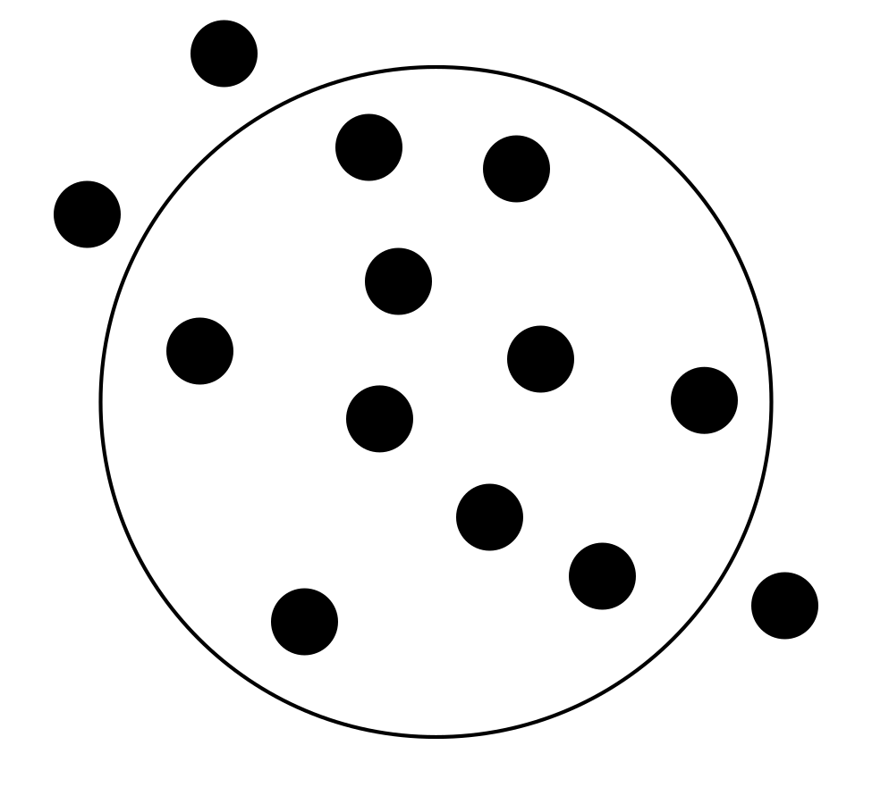

21.1: Where Will They Sit?
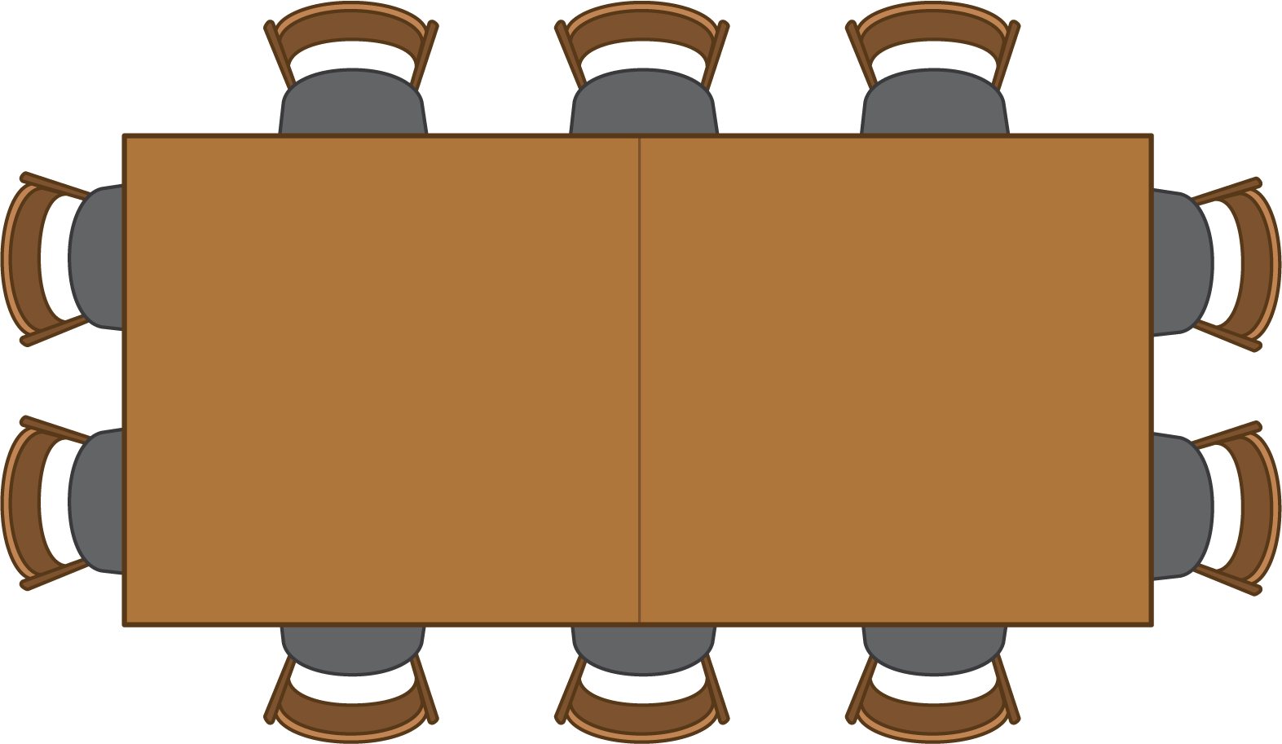


- $\underset{_}{}$
- $+$
- $\underset{_}{}$
- =la _

- $\underset{_}{}$
- $+$
- $\underset{_}{}$
- =la _

- $\underset{_}{}$
- $+$
- $\underset{_}{}$
- =la _

- $\underset{_}{}$
- $+$
- $\underset{_}{}$
- =la _

- $\underset{_}{}$
- $+$
- $\underset{_}{}$
- =la _

- $\underset{_}{}$
- $+$
- $\underset{_}{}$
- =la _

21.2: Finish the Equations
- $17=10+\underset{_}{}$
- $19=\underset{_}{}+9$
- $10+\underset{_}{}=14$
- $\underset{_}{}+2=12$
- $11=\underset{_}{}+1$
- $15=10+\underset{_}{}$

21.3: Centers: Choice Time
Choose a center.
Shake and Spill

Number Race
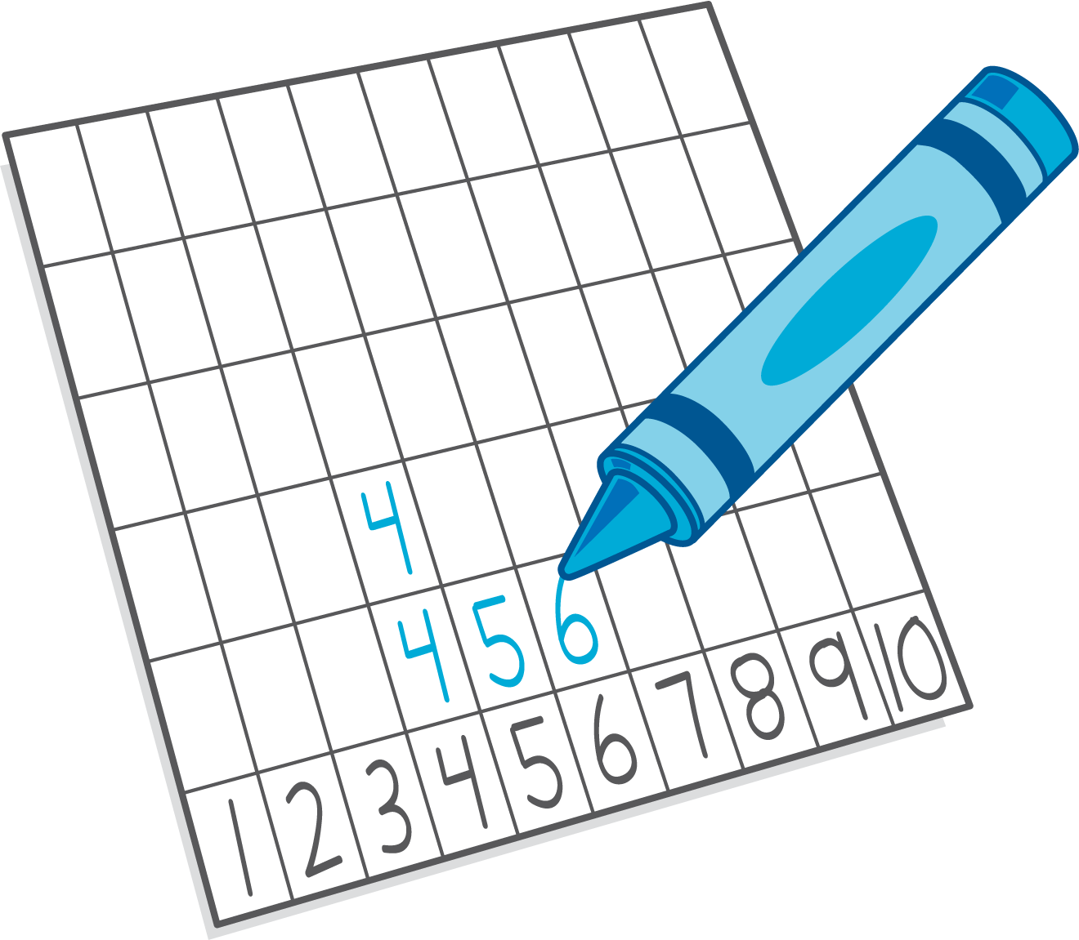
Grab and Count
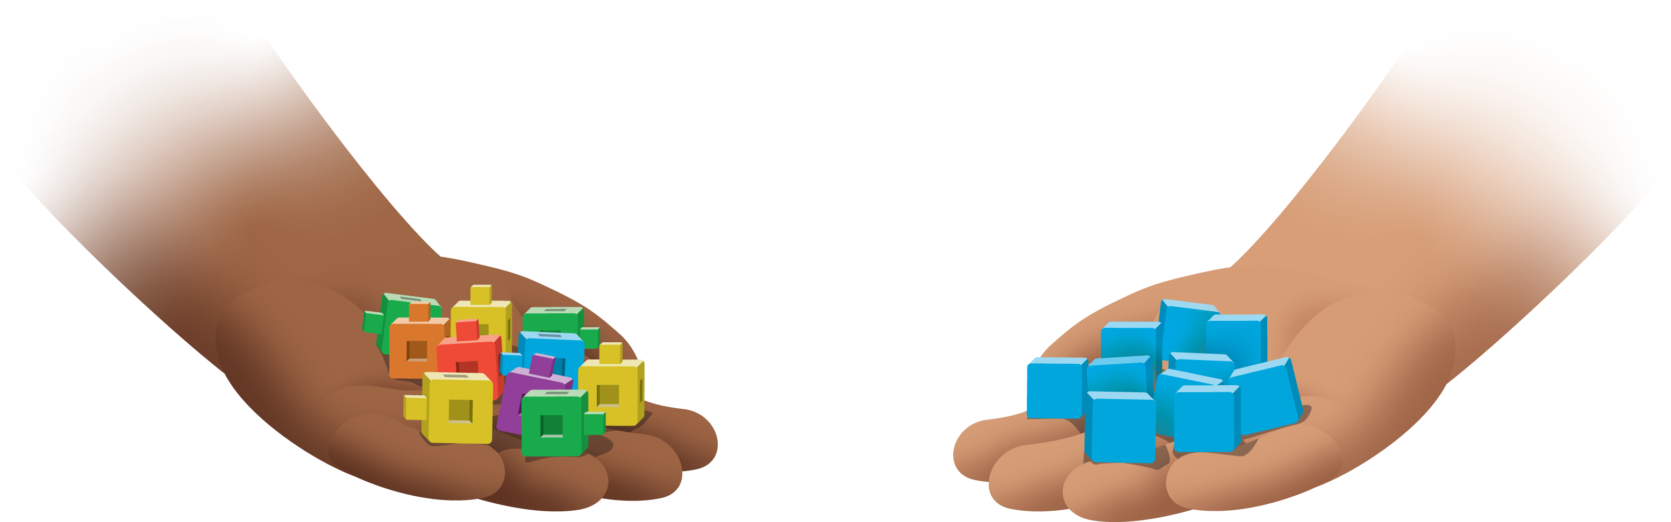
What's Behind My Back?
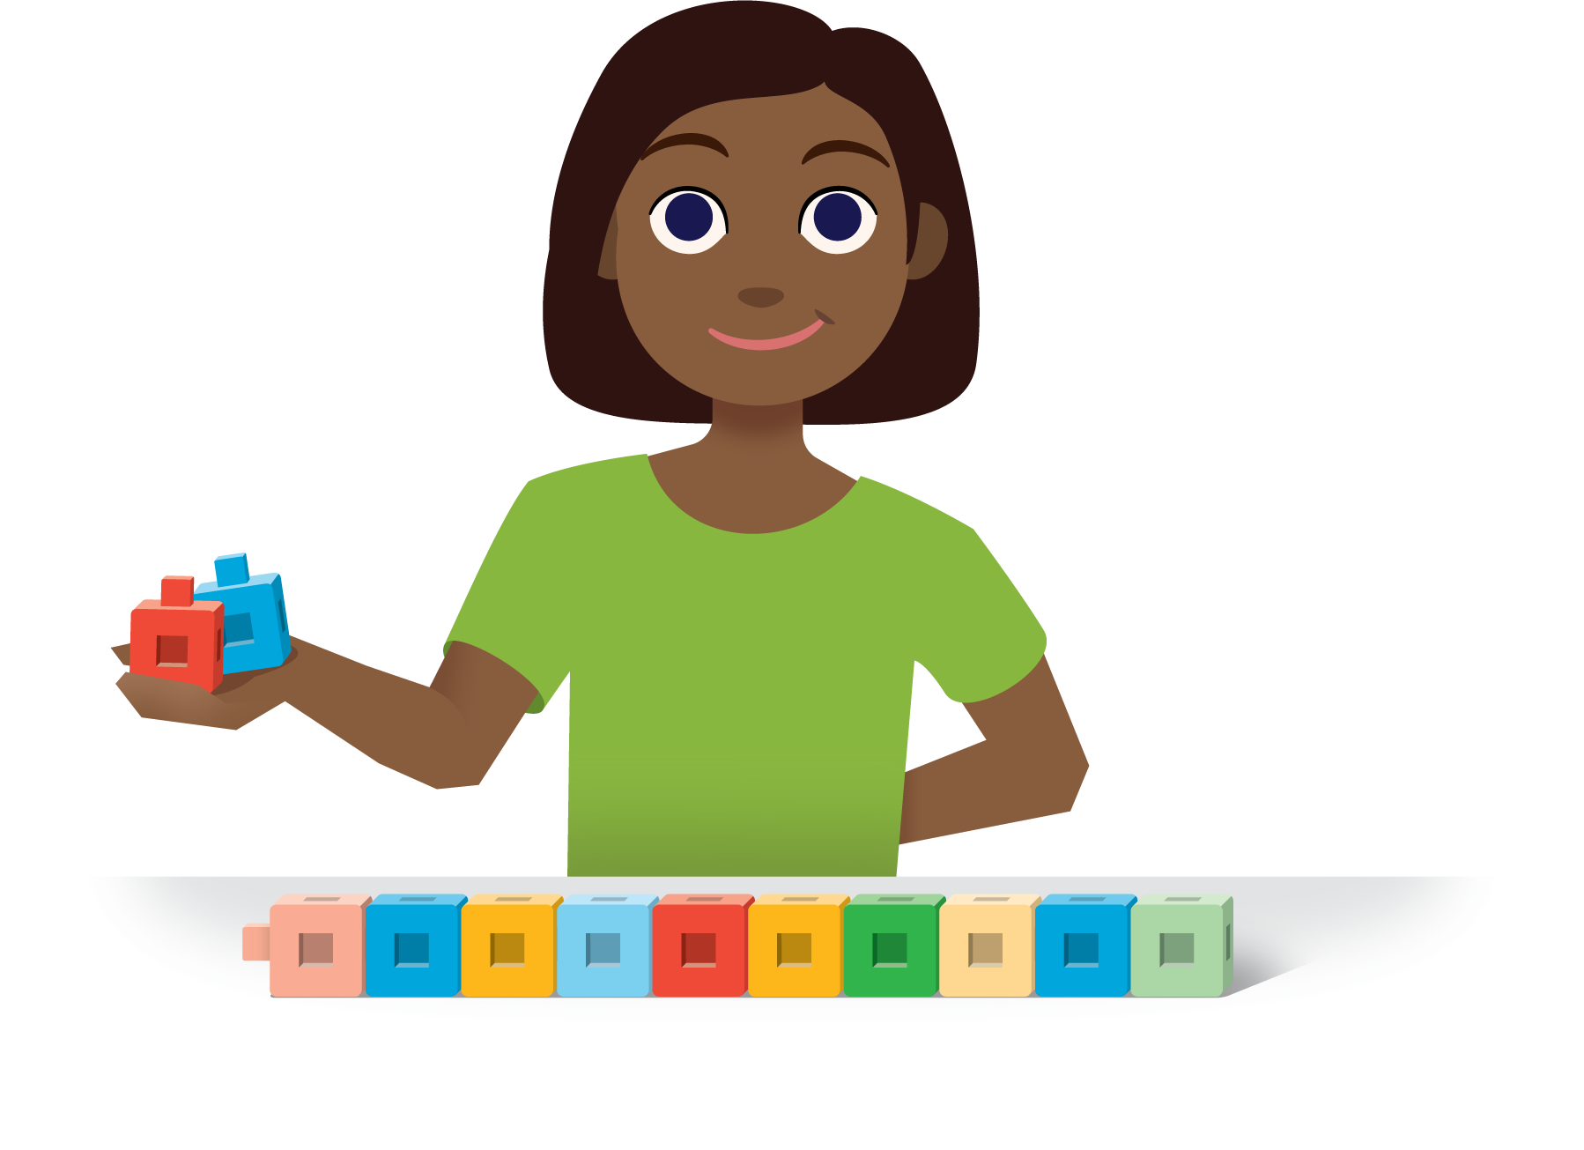
Pattern Blocks
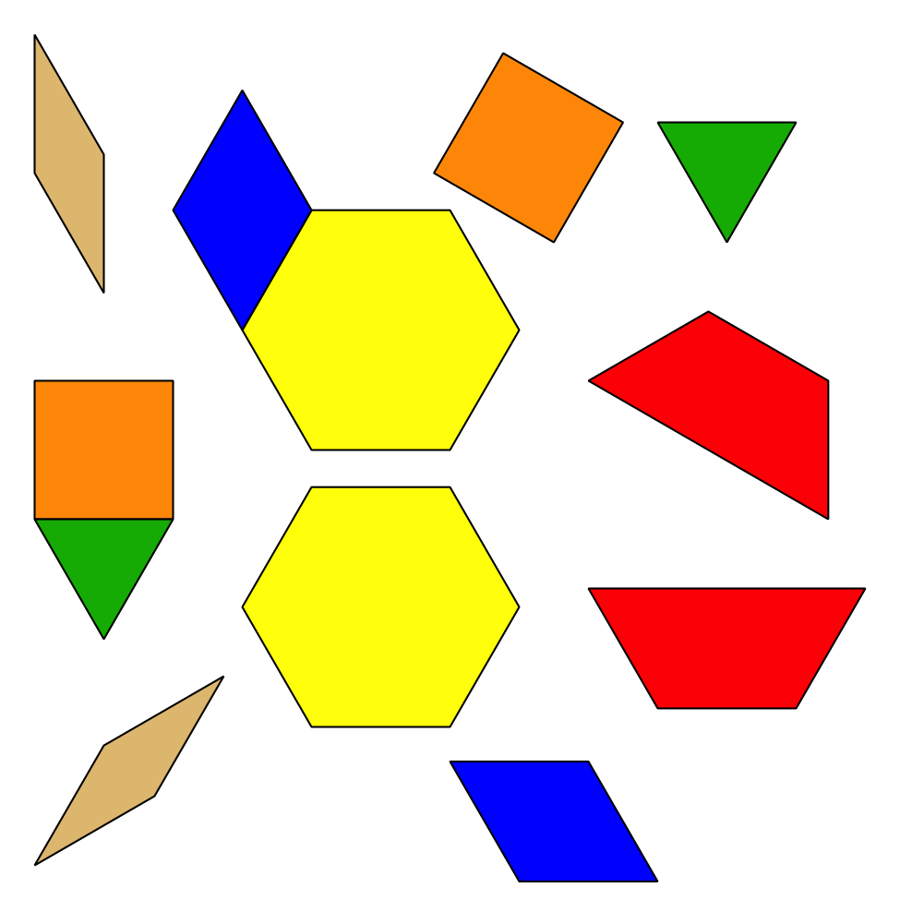

Section Summary
Section Summary
In this section, we used our fingers, objects, 10-frames, and drawings to find all of the ways to make 10.
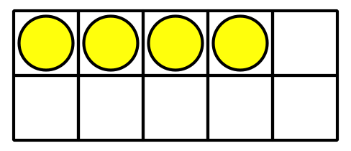
$10=4+6$

$10=9+1$
We figured out how many more are needed to make 10.
$10=8+\underset{_}{}$
$10=8+\underset{_}{2}$
We showed numbers 11–19 as 10 and some more.
$15=10+5$
$10+3=13$
© CC BY 2021 Illustrative Mathematics®

