Lesson 1: Tape Diagrams and Equations
Let's see how tape diagrams and equations can show relationships between amounts.

1.1: Which Diagram is Which?
- Here are two diagrams. One represents $2+5=7$. The other represents $5⋅2=10$. Which is which? Label the length of each diagram.
- 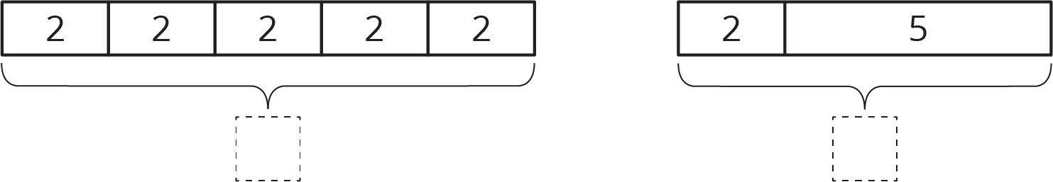
- Draw a diagram that represents each equation.
- $4+3=7$
- $4⋅3=12$

1.2: Match Equations and Tape Diagrams
Here are two tape diagrams. Match each equation to one of the tape diagrams.
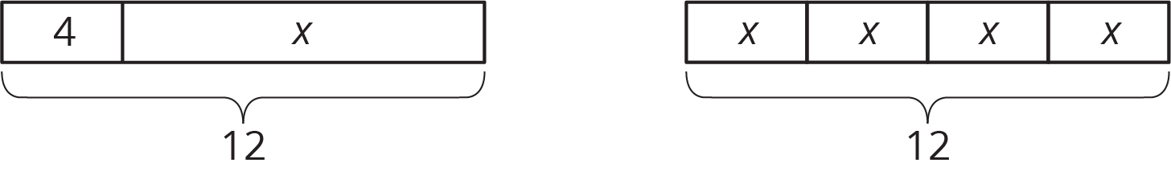
- $4+x=12$
- $12÷4=x$
- $4⋅x=12$
- $12=4+x$
- $12−x=4$
- $12=4⋅x$
- $12−4=x$
- $x=12−4$
- $x+x+x+x=12$

1.3: Draw Diagrams for Equations
For each equation, draw a diagram and find the value of the unknown that makes the equation true.
- $18=3+x$
- $18=3⋅y$

Are you ready for more?
You are walking down a road, seeking treasure. The road branches off into three paths. A guard stands in each path. You know that only one of the guards is telling the truth, and the other two are lying. Here is what they say:
- Guard 1: The treasure lies down this path.
- Guard 2: No treasure lies down this path; seek elsewhere.
- Guard 3: The first guard is lying.
Which path leads to the treasure?

Lesson 1 Summary
Tape diagrams can help us understand relationships between quantities and how operations describe those relationships.
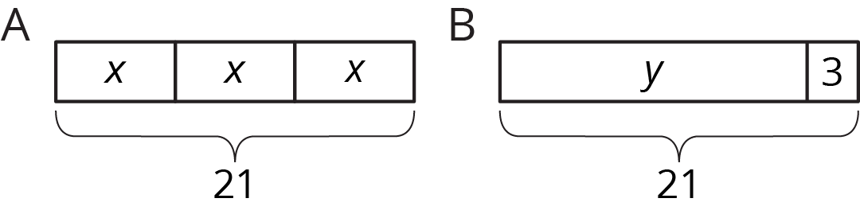
Diagram A has 3 parts that add to 21. Each part is labeled with the same letter, so we know the three parts are equal. Here are some equations that all represent diagram A:
$x+x+x=21$
$3⋅x=21$
$x=21÷3$
$x=\frac{1}{3}⋅21$
Notice that the number 3 is not seen in the diagram; the 3 comes from counting 3 boxes representing 3 equal parts in 21.
We can use the diagram or any of the equations to reason that the value of $x$ is 7.
Diagram B has 2 parts that add to 21. Here are some equations that all represent diagram B:
$y+3=21$
$y=21−3$
$3=21−y$
We can use the diagram or any of the equations to reason that the value of $y$ is 18.
© CC BY Open Up Resources. Adaptations CC BY IM.

